MINISTRY OF EDUCATION AND TRAINING

FPT UNIVERSITY
Capstone Project Document
MusicLounge — Live-Music Venue Ticketing, Livestream & Donation Platform (Backend)

<<fill in your official group code, e.g. SU26SE039-G##>>
Group Members | <<Name> <RollNo> <Student code> — one per line, one per member>>
Supervisor | <<Supervisor full name>>
Ext. Supervisor | <<if applicable>>
Capstone Project code | SU26SE039

– Hanoi, August 2026 –
Table of Contents

Acknowledgement 4
Definition and Acronyms 4
I. Project Introduction 5
1. Overview 5
2. Product Background 5
3. Existing Systems 5
4. Business Opportunity 5
5. Software Product Vision 5
6. Project Scope & Limitations 5
II. Project Management Plan 6
1. Overview 6
2. Management Approach 6
3. Master Schedule 6
4. Project Organization 6
5. Project Communication 6
6. Configuration Management 6
III. Software Requirement Specification 7
1. Overall Description 7
2. User Requirements 7
3. Functional Requirements 7
4. Non-Functional Requirements 7
5. Other Requirements 7
IV. Software Design Description 8
1. Overall Description 8
2. System Architecture Design 8
3. System Detailed Design 8
4. Class Specification 8
5. Data & Database Design 8
V. Software Testing Documentation 9
1. Overall Description 9
2. Test Plan 9
3. Test Cases 9
4. Test Reports 9
VI. Release Package & User Guides 10
1. Deliverable Package 10
2. Installation Guides 10
3. User Manual 10
VII. Appendix 10
1. Glossary [Optional] 10
2. References [Optional] 10
3. Others [Optional] 10

Acknowledgement
<<Team: personalise this section with real thanks to your supervisor and anyone else who helped — a generic starting point is provided below.>>
We would like to thank our supervisor for their guidance throughout this capstone project, and FPT University for the opportunity to build a full-scale, production-shaped system from the ground up rather than a toy exercise. We also thank everyone who took the time to test the platform and give feedback during development.

Definition and Acronyms
Acronym / Term | Definition
Lounge / Venue | A physical live-music venue registered on the platform (table MusicLounge).
Show | One concrete performance event at a venue (table LoungeShow).
Performance | One performer's slot within one show's line-up — the unit donations attach to.
Walk-in ticket | A ticket sold for cash at the venue counter by Staff, with no buyer account.
Hold | A temporary 15-minute reservation of a ticket before payment is completed.
Settlement | A payout tranche of ticket revenue released to an Owner.
Donation | An audience tip to a performer during a livestream (distinct from a ticket payment).
DSAR | Data Subject Access Request — the export/erasure rights granted under Vietnam's personal-data-protection law (Law 91/2025/QH15).
VNPay | The licensed third-party payment gateway used for all card/e-wallet transactions.
IPN | Instant Payment Notification — VNPay's asynchronous server-to-server payment confirmation callback.
RTMP | Real-Time Messaging Protocol — the ingest protocol Owners/Staff use to broadcast a livestream to Mux.
KYC / ID Verification | Optional identity-document verification a user can submit.
ASVS | OWASP Application Security Verification Standard — the checklist used for this project's security audits.
SLA | Service-Level Agreement — a maximum allowed response/resolution time for a process (e.g. 24h content-moderation takedown).
Hangfire | The background-job scheduling library used for every recurring/triggered non-screen function in §3.1.8.

I. Project Introduction
1. Overview
1.1 Project Information
- Project name: MusicLounge — Live-Music Venue Ticketing, Livestream & Donation Platform
- Project code: SU26SE039
- Group name: GSU26SE68
- Software type: Web + Native Mobile, backed by one shared REST/SignalR API — 5 client surfaces (Audience Website, Audience Mobile F&B app, Owner Web Dashboard, Staff Mobile app, Admin Web Console); see platform-architecture.md for why it is split this way.
1.2 Project Team
Full Name | Role | Email | Mobile
Nguyễn Trong Tài | Supervisor | taint@fpt.edu.vn | <<mobile>>
Hà Đông Hải | Leader | <<email>> | <<mobile>>
Huỳnh Trung Nhiên | Member | <<email>> | <<mobile>>
Nguyễn Quang Anh Khoa | Member | <<email>> | <<mobile>>
Nguyễn Huy Phúc | Member | <<email>> | <<mobile>>

2. Product Background
Demand for live-music experiences in small, intimate venues — music lounges, acoustic cafés, mini concert spaces — has been rising, especially among young, music-enthusiast audiences. Yet the connection between venues, artists, and audiences remains fragmented: venues struggle to promote events, manage schedules, and reach the right audience, while audiences lack a centralized way to discover shows matching their taste in genre, time, and location. Blending offline performances with online experiences like livestreaming is a growing trend, but existing solutions stay disconnected and lack personalization — creating the need for one unified platform connecting lounges and audiences, improving the experience, and supporting both offline and online engagement.
3. Existing Systems
Two representative existing products, each covering part of what MusicLounge unifies into one platform.
3.1 Ticketbox (ticketbox.vn)
• Vietnam's largest general-purpose event ticketing platform — used for concerts, conferences, festivals and a wide range of paid events across the country.
• Actors: event organiser (creates and sells an event's tickets), buyer (browses and purchases), platform (payment processing, ticket delivery).
• Features: online ticket sales with QR-code entry, seat/zone selection for larger venues, organiser dashboards, multiple payment methods.
• Pros: strong brand recognition and buyer trust in the Vietnamese market, mature payment integration, handles large-scale single events well.
• Cons (relative to MusicLounge's target use case): built around a single fixed-showtime event model, not a venue that runs a different show most nights with whole-evening ticket validity and ongoing walk-in sales; no livestream product; no performer-donation or tipping feature; no F&B ordering; not designed for an owner who needs recurring, per-venue tools (seating-zone reuse across shows, staff management, a subscription relationship with the platform) rather than a one-off event listing.
3.2 Twitch + Streamlabs
• The dominant global combination for live-streamed content with real-time viewer donations — Twitch for the stream itself, Streamlabs (or an equivalent overlay tool) for the donation alert feed most viewers of a MusicLounge-style Public Donation Ticker will already recognise the pattern from.
• Actors: streamer/creator, viewer, platform.
• Features: live video with chat, real-time donation alerts with a customisable on-stream overlay, subscription-based creator monetisation.
• Pros: extremely mature real-time donation UX (this is precisely the pattern MusicLounge's own Public Donation Ticker deliberately borrows) and a huge existing viewer base.
• Cons (relative to MusicLounge's target use case): a general content platform, not tied to any physical venue or a specific in-person show — no ticketing of any kind, no concept of a physical door to check a ticket at, no F&B, and a donation goes straight to the individual streamer's own payment account with no venue-level acknowledgement, settlement or commission step, which does not match a venue-and-performer relationship where the venue is legally and financially the intermediary handling the money on the performer's behalf.
3.3 Veeps (veeps.com)
- • Ticketed livestream platform for touring artists (now owned by Live Nation); its hybrid mode — livestream a show while also playing to an in-person audience — is the closest real-world precedent to MusicLounge's own model.
- • Pros: proven hybrid livestream+in-person concept; artist-friendly economics (100% of the ticket price to the artist, a flat 15% service fee, no hidden costs).
- • Cons (relative to MusicLounge's target use case): built for major-label touring acts at large venues, not a small local lounge — no seating-zone, walk-in or box-office tools and no F&B ordering; its donation feature is a fixed charity option attached to the ticket rather than real-time audience tipping; and money flows ticket → artist directly, with no venue-side settlement or commission step.
4. Business Opportunity
Vietnam's small live-music venues — acoustic bars, "phòng trà" lounges — are seeing growing demand for both in-person and livestreamed music experiences, yet among the platforms most commonly referenced for this space (§3.1–3.3), none combines everything a venue in this segment needs: ticketing that matches whole-evening, walk-in-driven sales rather than a fixed-showtime model; a livestream gated to genuine ticket holders; a transparent, auditable performer-donation pipeline; and the in-venue operational tools (F&B ordering, door check-in, counter sales) staff need during a show.

This combination represents a market opportunity: a platform purpose-built for the small live-music-venue segment — rather than adapted from a stadium-concert or generic-streaming product — could serve a segment that existing ticketing and streaming platforms only partially address.
5. Software Product Vision
For independent live-music venue owners in Vietnam who want to sell tickets, stream shows, and be paid tips transparently without stitching together three disconnected products, and for the audiences who attend or watch those shows,
the MusicLounge platform is a ticketing, livestream and donation marketplace
that lets a venue sell both online and walk-in tickets on its own real terms, gate a livestream to genuine ticket holders, and route audience tips to performers through an auditable payout pipeline, while an audience member discovers shows, buys a ticket, watches from home if they can't attend, and tips a performer in real time from the same account.
6. Project Scope & Limitations
6.1 Major Features
FE-01: Account & identity — self-service registration (Audience/Owner), email OTP and phone verification, Google sign-in, profile and ID-document management, and self-service export or permanent erasure of one's own personal data. A single identity works across all five client surfaces.
FE-02: Venue setup — venue registration with business-licence upload, profile and photo-gallery management, and a drag-and-drop 2D/3D seating-zone editor whose zones are reused by every show at that venue (Owner Web Dashboard).
FE-03: 360° virtual venue tour — the Owner uploads a finished panorama or several ordinary room photos that the imaging microservice stitches automatically, then places navigation and info hotspots; Audience members explore the finished tour from the venue page.
FE-04: Venue approval — an Admin review queue that must approve a venue before it appears publicly or may publish any show (Admin Web Console).
FE-05: Show management — a creation wizard with performer line-up builder, ticket tiers, time-slot pricing and an AI-generated or uploaded poster, covering the full lifecycle: submit for review, publish, reschedule, change format, cancel (Owner Web Dashboard).
FE-06: Content moderation — AI risk-scoring of every show and livestream, with the final decision always taken by a human Admin, under a 24-hour review SLA (Admin Web Console).
FE-07: Discovery & personalisation — public browsing and search, show and venue detail pages, follow and wishlist, show ratings, and an opt-in AI-personalised recommendation feed (Audience Website).
FE-08: Online ticketing — tier selection held for 15 minutes behind a visible countdown, VNPay checkout, QR ticket, peer-to-peer transfer, and cancellation or refund requests (Audience Website).
FE-09: Box-office & door operations — cash walk-in sales at the counter and QR check-in at the door, both honouring whole-evening ticket validity rather than a fixed showtime (Staff Mobile app, Owner Web).
FE-10: Gated livestream — RTMP broadcast control for the venue, with viewing restricted to genuine ticket holders inside a concurrent-device limit, plus real-time chat and viewer count (Owner/Staff broadcast; Audience Website watches).
FE-11: Real-time performer donations — in-stream tipping with a public donation ticker, a transparent settled-donation feed, and an owner-acknowledgement → performer-payout pipeline with payment evidence captured at each step.
FE-12: In-venue food & drink ordering — menu browsing, cart and live order tracking from a native mobile app (Audience Mobile), with a kitchen/counter order board for staff (Staff Mobile).
FE-13: Payments & double-entry ledger — every money movement recorded as a balanced accounting journal, with two-tranche settlement payouts to venue owners and automated reconciliation against the payment gateway.
FE-14: Owner subscriptions — plan catalogue, subscribe/renew/cancel, and entitlement caps (tickets per event, AI-poster and tour-scene quotas) enforced at the point of use.
FE-15: Complaints — a channel open even to guests, filed and later looked up by reference number plus phone with no account required, feeding an Admin resolution queue with SLA tracking.
FE-16: Venue penalties & appeals — penalty issuance with evidence, Owner appeal submission, and SLA-driven automatic escalation or overturn when a review deadline passes.
FE-17: Admin back-office — user management, refund processing, bank-account verification, taxonomy and subscription-plan management, ledger-integrity checking, platform analytics and background-job monitoring (Admin Web Console).
FE-18: Notifications — an in-app inbox on every surface, Firebase push to the mobile apps, plus email and SMS for the events that must reach a user while they are off-platform.
6.2 Limitations & Exclusions
LI-01: VNPay integration runs against the sandbox environment only — there is no live production merchant relationship, consistent with this being an academic capstone project rather than a commercially operating platform.
LI-02: There is no self-service or API path to create an Admin account by design — every Admin account exists only via a direct database provisioning step, monitored by an automated drift-detection job. This is a deliberate security posture, not a missing feature.
LI-03: A Staff account may be actively assigned to exactly one venue at a time; a person who genuinely works at two venues needs two separate accounts. Confirmed as an intentional simplification, not a defect.
LI-04: Refund approval reverses the internal ledger entries and records the payout for manual transfer; it does not settle money back through the live payment provider in this environment, matching the sandbox limitation above.
LI-05: SMS delivery (OTP, notifications) targets Vietnamese phone numbers only.
LI-06: Door ticket check-in and counter walk-in sales have no offline fallback — a dropped connection blocks the action rather than silently queuing it for later sync. This is an accepted trade-off against the complexity that offline conflict-resolution would introduce.
LI-07: Bank-account verification is a manual Admin action taken after reconciling ownership outside the system; there is no live banking-API integration to verify an account holder automatically.
LI-08: The two native mobile applications are distributed as internal/review builds rather than published to the public App Store and Google Play, which is a capstone-scope decision rather than a technical constraint.
LI-09: The user interface ships in Vietnamese only; no multi-language switch is provided, since the platform targets the Vietnamese market exclusively.

II. Project Management Plan

1. Overview

1.1 Scope & Estimation
# | WBS Item | Complexity | Est. Effort  (man-days)
1 | Auth & Account Management
1.1 | Register/verify/login, Google OAuth, JWT + policy-based authorization | Complex | 12
1.2 | Forgot/reset password, profile edit, ID verification upload | Medium | 6
1.3 | DSAR data export & erasure (anonymise-in-place) | Medium | 5
2 | Venue Management
2.1 | Venue CRUD, business license/photo upload | Medium | 6
2.2 | Seating-zone drag-and-drop editor (2D/3D) | Complex | 10
2.3 | 360° virtual tour (scene/hotspot editor + Auto-Stitch integration) | Complex | 14
2.4 | Staff assignment, venue gallery, custom criteria | Medium | 7
3 | Admin Venue Approval & Content Moderation
3.1 | Venue approve/reject queue | Simple | 3
3.2 | AI-assisted (Gemini) show/livestream moderation queue | Complex | 10
4 | Show Management
4.1 | Show CRUD, performer line-up builder | Medium | 8
4.2 | Show lifecycle (submit/publish/reschedule/format-change/cancel) | Complex | 10
4.3 | Ticket tiers, pricing windows, AI poster generation | Medium | 8
4.4 | Legal & royalty declaration | Simple | 2
5 | Ticketing
5.1 | Ticket hold (15-min), quota management | Medium | 6
5.2 | VNPay payment integration, QR generation | Complex | 10
5.3 | Transfer, cancellation, refund request workflow | Medium | 8
5.4 | Walk-in sale & door check-in (Staff) | Medium | 7
6 | Livestream
6.1 | Mux/Cloudflare integration + LivestreamServiceFactory, start/end broadcast | Complex | 12
6.2 | SignalR access-gated viewing room, chat, viewer count | Complex | 12
6.3 | Concurrent-device session limiting | Medium | 5
7 | Donation & Financial Ledger
7.1 | Donate flow, owner acknowledgement, performer payout | Complex | 11
7.2 | Double-entry ledger (LedgerJournalFactory), reconciliation job | Complex | 12
7.3 | Settlement (2-tranche release), public donation ticker/feed | Complex | 11
8 | F&B Ordering
8.1 | Menu CRUD, mobile ordering flow | Medium | 6
8.2 | Staff order board (status progression) | Simple | 4
9 | Subscription & Billing
9.1 | Plan CRUD (Admin), subscribe/renew/cancel (Owner) | Medium | 7
10 | Complaints & Venue Penalties
10.1 | Complaint file/lookup/resolve (incl. guest path) | Medium | 7
10.2 | Venue penalty issue/appeal/auto-overturn workflow | Medium | 7
11 | Recommendation & Personalisation
11.1 | Behaviour logging, event scoring, AI hybrid recommender | Complex | 12
11.2 | Follow/wishlist/rating | Simple | 4
12 | Notifications
12.1 | FCM push integration, notification inbox, SpeedSMS integration | Medium | 8
13 | Admin Back-Office
13.1 | User management, bank-account verification, ledger integrity check | Medium | 8
13.2 | Taxonomy & subscription-plan management, platform analytics | Medium | 6
14 | Cross-Cutting Platform Work
14.1 | Clean Architecture scaffold, CQRS/MediatR pipeline, generic repository/UoW | Complex | 10
14.2 | 29 Hangfire background jobs (SLA/expiry/settlement/security-monitoring) | Complex | 14
14.3 | Security hardening (ASVS-based audit + fixes), legal/compliance mapping | Complex | 12
14.4 | Test suite (unit/integration), documentation | Complex | 15
15 | Frontend Implementation
15.1 | FE: Auth & Account — sign up/verify/login screens, Google OAuth button, forgot/reset password, profile edit, ID upload, DSAR export/erase UI | Medium | 10
15.2 | FE: Venue Management — venue CRUD forms, seating-zone drag-and-drop 2D/3D editor, 360° tour scene/hotspot builder, staff assignment, gallery uploader | Complex | 18
15.3 | FE: Admin Venue Approval & Moderation — approval queue, AI moderation review queue | Medium | 6
15.4 | FE: Show Management — show CRUD wizard, performer line-up builder, ticket tier/pricing editor, AI poster UI | Complex | 10
15.5 | FE: Ticketing — browse/purchase flow, hold countdown, VNPay redirect, QR ticket, transfer/cancel/refund, Staff walk-in POS + QR scanner | Complex | 14
15.6 | FE: Livestream — gated viewing room player, chat, viewer count, broadcast control panel | Complex | 12
15.7 | FE: Donation & Ledger — donate widget, public donation ticker, payout dashboard, ledger views | Medium | 9
15.8 | FE: F&B Ordering — mobile menu/cart/order tracking, Staff kitchen/counter board | Medium | 8
15.9 | FE: Subscription & Billing — plan CRUD (Admin), subscribe/renew/cancel (Owner) | Medium | 5
15.10 | FE: Complaints & Penalties — guest complaint form/lookup, resolve queue, appeal UI | Medium | 6
15.11 | FE: Recommendation & Personalisation — personalised feed, follow/wishlist, rating UI | Medium | 5
15.12 | FE: Notifications — inbox UI, push permission prompts | Simple | 4
15.13 | FE: Admin Back-Office — user management, bank-verification queue, taxonomy UI, analytics dashboard | Medium | 10
15.14 | FE: Cross-Cutting — design system/component library, routing/auth-guard scaffold, API client + state mgmt, responsive/theming | Complex | 12
16 | UI/UX Design
16.1 | Design system & style guide ("Warm Luxury Lounge") | Medium | 4
16.2 | Stitch briefs per surface (5 surfaces) + view catalog + screens-flow diagrams | Complex | 8
16.3 | High-fidelity mockups per view (iterative) | Complex | 10
17 | Deployment & Hosting
17.1 | Host + deploy (API, DB, panorama-stitcher microservice), domain/SSL setup | Medium | 6
18 | Documentation
18.1 | Domain/architecture docs (docs/01-24) | Medium | 6
18.2 | 7 SEP490 capstone reports | Complex | 10
 | Total Estimated Effort (man-days) |  | 488

1.2 Project Objectives
Deliver a working, multi-surface MusicLounge platform — backend REST/SignalR API, all 5 client surfaces (Audience Web, Owner Web, Admin Web, Staff Mobile, Audience Mobile F&B), and a deployed/hosted instance — that a review committee can exercise end-to-end across all 4 roles (Audience, Owner, Staff, Admin) by the end of the capstone semester, built to a standard that would survive a real production-readiness review, not just a demo.
Time: fit the full WBS in §1.1 inside the semester's available calendar, sequenced so that every domain's happy path (see Report 3 §2.2 Use Cases) is functional well before the final weeks, leaving the last 2–3 weeks for hardening, security/performance review, and documentation rather than first-time feature work.
Cost: effort is a fixed team-capacity budget rather than a monetary one — the WBS in §1.1 sums to ~488 man-days spanning backend, frontend, UI/UX design, deployment and documentation, delivered by the four-member team named in Report 1 §1.2 across the capstone semester (see Milestone Timeliness and Allocated Effort below for the phase split).
Quality
# | Testing Stage | Test Coverage | No. of Defects | % of Defect | Notes
1 | Reviewing | 100% of PRs | — | — | Every change reviewed against the project's own backend-code-review-sop before merge.
2 | Unit Test | Domain + Application layers | — | ≤ 5% flaky | Business logic tested with no database — see Report 5.
3 | Integration Test | Every Application handler with DB interaction | — | 0 known-broken at release | Run against SQLite in CI, and against real SQL Server before each major milestone (a real bug has already been caught this way that SQLite alone missed).
4 | Security Audit | OWASP ASVS 5.0.0 checklist, ~350 requirements | — | 0 open BLOCKER | See the project's ongoing role-security-asvs-audit trail.
5 | Release Gate | Full SDLC role-charter sweep (17 roles) | — | 0 open BLOCKER | sdlc-release-gate — first full run (2026-08-09) returned NO-GO with 7 verified blockers, all since resolved.

Milestone Timeliness (%): ≥ 90% of sprint-end milestones delivered on the date committed at sprint planning.
Allocated Effort (man-days): Requirement/Design 18% · Coding (Backend + Frontend) 62% · Testing 12% · Documentation 8% (of the ~488 man-day total in §1.1).

1.3 Project Risks
# | Risk Description | Impact | Possibility | Response Plans
1 | VNPay sandbox behaves differently from the production gateway (IPN timing/retry semantics in particular) — an integration that passes sandbox testing could still surface a bug against the real gateway. | High | Medium | Build the IPN handler to be idempotent and safe against out-of-order/duplicate delivery regardless of sandbox-observed behaviour, rather than coding to the sandbox's specific timing; treat any production VNPay integration as a distinct, separately-tested milestone if the project ever needs one.
2 | SQLite (used in the CI/integration test suite) and the real target engine (SQL Server) diverge on specific behaviours — multi-path cascade delete rules and enum-string-column constraints in particular. A test suite that is 100% green on SQLite is not proof of correctness against the real database. | High | High | Already materialised once — a real SQL-Server-only bug slipped past 287 passing SQLite-based tests. Mitigation in place: run the full suite against a real SQL Server instance before every major milestone/release, not only in the SQLite-backed CI default.
3 | Third-party AI dependency (Gemini) for content moderation, poster generation, and recommendation scoring — an API outage, quota exhaustion, or pricing/policy change is outside the team's control. | Medium | Medium | Moderation and recommendation are both designed to degrade gracefully (a Circuit Breaker pattern around the AI HTTP client falls back to a neutral score rather than blocking the request); poster generation additionally has a second provider (OpenAI) wired as an alternate adapter behind the same interface.
4 | The panorama-stitching feature depends on native OS-level image-processing binaries (OpenCV/Hugin) that can behave differently across the development machine and the eventual deployment target. | Medium | Medium | Kept as a separate out-of-process Python microservice called over HTTP specifically to isolate this native-binary risk from the main .NET host — a stitching-service failure degrades one feature, not the whole API.
5 | There is no self-service path to create an Admin account, and the system is designed so that only one or a few Admin accounts are expected to exist — an Admin's account being locked out, or the one available reviewer/grader Admin credential being lost, blocks a large surface of manual testing. | Medium | Low | Document the Admin-provisioning (direct database insert) procedure clearly for the team and the supervisor before the review/demo date; keep at least one known-good Admin credential recorded outside of any single team member's personal notes.
6 | Livestream infrastructure (Mux/Cloudflare Stream) is a paid third-party service with its own account/billing setup — running out of trial credit or hitting a rate limit close to a demo date would visibly break the platform's most impressive feature. | Medium | Low | Confirm provider account status and quota headroom explicitly ahead of the final demo, not only during regular development.
7 | Team members' familiarity with Clean Architecture, CQRS/MediatR and EF Core varies — a member new to the pattern can introduce a change that quietly breaks the dependency rule (e.g. Domain referencing Infrastructure) or bypasses the Unit-of-Work transaction boundary. | Medium | Medium | Addressed by the Training Plan in §2.3 and by mandatory PR review against the architecture's own conventions before merge.
8 | Scope creep — the domain has more genuinely useful features than one semester can safely absorb (the platform already spans 28 Application feature areas). | Medium | Medium | WBS in §1.1 is the scope contract for the semester; new feature requests during the semester are logged and prioritised against it rather than added ad hoc.
9 | Frontend implementation is significantly behind backend at the time of this plan (2 of 73+ screens built) — most of the remaining ~129 FE man-days is concentrated in the second half of the semester, creating schedule pressure if design handoff (Stitch briefs) or screen wiring takes longer than estimated. | High | Medium | Track FE progress against the WBS in §1.1 as its own burndown, separate from backend's (which is already largely complete); reprioritise screens by role-criticality (Audience ticket purchase, Owner venue/show management) over nice-to-have surfaces (recommendation/rating) if time runs short.

2. Management Approach

2.1 Project Process
Scrum, with weekly sprints aligned to the capstone's supervisor check-in cadence: sprint planning at the start of the week, a working demo at the end of it, and a short retro before the next planning session. The WBS in §1.1 is the product backlog; each WBS leaf item is broken into 1–3 sprint tasks at planning time.
Sprint 1–2: project scaffold (4-project Clean Architecture, CI, database migrations pipeline), backend Auth, UI/UX design system + Stitch briefs for all 5 surfaces. Sprint 3–6: backend Venue/Show/Ticketing (the core marketplace loop) in parallel with frontend Auth + Venue screens. Sprint 7–9: backend Livestream/Donation & Ledger — the most architecturally complex area, sequenced after the core loop is stable — in parallel with frontend Show/Ticketing screens. Sprint 10–11: backend F&B/Subscription/Complaints/Admin back-office, frontend Livestream/Donation screens. Sprint 12–13: frontend F&B/Subscription/Complaints/Admin back-office screens, cross-cutting hardening (security audit, background-job reliability). Sprint 14–15: deployment/hosting setup, final regression against real SQL Server, demo rehearsal, documentation and report writing.

2.2 Quality Management
Five practices, applied continuously through every sprint rather than only at the end of the semester:
• Defect Prevention — a fixed set of conventions per tier, enforced at review rather than discovered in testing: on the backend, repository/Unit-of-Work access only from handlers, no direct DbContext use in the Api layer, and every command covered by a FluentValidation validator; on the frontend, shared design-system components instead of one-off markup, server state owned by TanStack Query rather than hand-rolled effects, and no screen shipping without its loading, empty and error states designed.
• Reviewing — every pull request reviewed against the project's own documented code-review standard operating procedure before merge; no direct pushes to the main branch.
• Unit Testing — backend Domain and Application logic tested without a database, and frontend components tested in isolation against a mocked API with React Testing Library, so a broken business rule or a broken screen state is caught before integration testing runs.
• Integration Testing — real handler-to-database round trips, run in CI against SQLite for speed and, before every major milestone, again against a real SQL Server instance to catch the class of bug SQLite cannot reproduce (see Risk #2).
• System Testing — automated Playwright journeys plus manual walkthroughs of each actor's golden path (Audience, Owner, Staff, Admin) against the deployed Azure staging environment, together with a security pass against the OWASP ASVS 5.0.0 checklist, an accessibility pass against WCAG 2.2 Level AA, and a load pass against realistic peak shapes (ticket on-sale spikes, concurrent livestream viewers).

2.3 Training Plan
Training Area | Participants | When, Duration | Waiver Criteria
Clean Architecture & CQRS/MediatR | Any member new to the pattern | Sprint 1, ~1 day | Waived if the member has prior CQRS/MediatR project experience
EF Core + SQL Server (migrations, indexing, transactions) | Any member new to EF Core | Sprint 1–2, ~1 day | Waived if the member has prior EF Core project experience
Git / GitHub workflow (branching, PR review) | All members | Sprint 1, ~0.5 day | Mandatory
OWASP ASVS 5.0.0 basics | Whoever leads the security-review sprint task | Before Sprint 12 | Mandatory for that task's owner only
React + TypeScript + Tailwind CSS (frontend stack) | Any member new to the stack | Sprint 2-3, ~1 day | Waived if the member has prior React/TS project experience

3. Project Deliverables
# | Deliverable | Due Date | Notes
1 | Project Schedule / Tracking (Report 2 companion) | End of semester | Kept live sprint-by-sprint, finalised at submission.
2 | Product Backlog / WBS (this report §1.1) | Sprint 1, revised each sprint | Scope contract for the semester.
3 | Source Code (backend repository) | End of semester | MusicLounge-Backend — 4-project Clean Architecture solution.
4 | Database Scripts (EF Core migrations) | End of semester | Code-First — no hand-written DDL.
5 | Report 1 — Project Introduction | End of semester | This report set.
6 | Report 3 — Software Requirement Specification | End of semester | —
7 | Report 4 — Software Design Document | End of semester | —
8 | Report 5 — Test Documentation, Test Report, Unit Test | End of semester | —
9 | Report 6 — Software User Guides | End of semester | —
10 | Report 7 — Final Project Report | End of semester | Aggregates Reports 1–6.
11 | Defects List | End of semester | Tracked continuously; see Report 5 Test Report.
12 | Presentation Slide Deck | Demo date | —
13 | Source Code (frontend repository) | End of semester | fontend/Fontend_Final — Vite + React + TypeScript + Tailwind.
14 | Deployed/Hosted Platform (live instance) | End of semester | Publicly reachable URL for the review committee to exercise end-to-end.

4. Responsibility Assignments
Columns use the team members named in Report 1 §1.2. Each row names exactly one owner (D) so accountability is never split, with a named reviewer (R) for every deliverable that leaves the team.
D~Do; R~Review; S~Support; I~Informed; <blank> = Not involved
Responsibility | Hải (Leader) | Nhiên | Khoa | Phúc
Project planning & tracking (WBS, sprint plan, risk register) | D | S | S | S
Requirement analysis & specification (Report 1, Report 3) | R | D | S | S
UI/UX design system, Stitch briefs, view catalogue | S | D | R | I
Solution architecture & Report 4 (SDD) | D | R | S | S
Backend — platform scaffold, CQRS pipeline, shared infrastructure | D | S | S | R
Backend — Auth, Venue, Show, Ticketing | R | D | S | S
Backend — Livestream, Donation, Payment & Ledger | D | S | R | S
Backend — F&B, Subscription, Complaints, Admin back-office | R | S | D | S
Backend — background jobs & security hardening | R | I | S | D
Frontend — Audience Website | S | D | R | I
Frontend — Owner Web Dashboard | R | S | D | S
Frontend — Admin Web Console | S | R | S | D
Frontend — Staff Mobile & Audience Mobile F&B apps | D | S | S | R
Test design, automation & execution (Report 5) | R | S | S | D
Deployment to Azure, CI/CD pipeline, environment configuration | D | I | S | R
Documentation & user guides (Report 6) | S | R | I | D
Final integration, Report 7, demo rehearsal | D | S | S | S

5. Project Communications
Communication Item | Who/ Target | Purpose | When, Frequency | Type, Tool, Method(s)
Sprint Planning | Whole team + Supervisor | Agree the sprint's WBS items and acceptance criteria | Weekly, start of sprint | In-person/online meeting
Sprint Demo & Retro | Whole team + Supervisor | Show working software, review what did/didn't go well | Weekly, end of sprint | In-person/online meeting + a running instance
Daily Sync | Whole team | Quick blockers/progress check | Daily, ~15 min | Chat channel (async) or short call
Code Review | PR author + reviewer(s) | Catch defects and architecture-convention drift before merge | Continuous, per pull request | GitHub pull request comments
Supervisor Check-in | Leader + Supervisor | Escalate risks, confirm scope decisions | As needed, at minimum bi-weekly | Email / scheduled meeting
Incident/Defect Reporting | Whole team | Log and triage a found defect | As found | Issue tracker

6. Configuration Management

6.1 Document Management
All narrative project documentation lives in this repository's docs/ folder in Markdown, version-controlled alongside the code it describes so a documentation change and the code change it documents land in the same review — the alternative (a separate wiki or shared drive) drifts out of sync with the code far more easily.
The 7 formal SEP490 report documents (this set) are generated from that same docs/ source-of-truth into the official .docx templates and kept in spec/generated/, so every report can be regenerated after a scope or design change instead of hand-edited out of sync with the underlying docs.
Every substantive document change is recorded in that document's own "Record of Changes" table (§I of every report) — Added/Modified/Deleted, who, and why — rather than relying on git history alone, since a reviewer opening only the .docx should still see its own change log.

6.2 Source Code Management
Git, hosted on GitHub, across the platform's repositories — the backend API solution, the frontend client applications, and the panorama-stitching microservice. Trunk-based development off a single main integration branch in each, with short-lived feature branches per WBS task merged via pull request; no long-lived per-developer branches that could drift far from main. A change spanning tiers (a new endpoint plus the screen that consumes it) is raised as linked pull requests reviewed together, so the API contract and its consumer never merge out of step.
Every pull request requires at least one review before merge (see §2.2 Quality Management); the CI pipeline runs the unit/integration test suite on every PR, and merge is blocked on a red build.
Database schema changes are EF Core Code-First migrations only, committed alongside the entity/configuration change that caused them — there is no hand-written DDL and no schema drift between environments that migrations don't already capture.

6.3 Tools & Infrastructures
Category | Tools / Infrastructure
Backend Framework | ASP.NET Core 8 (C#), Clean Architecture (Domain / Application / Infrastructure / Api)
Application Patterns | MediatR (CQRS), FluentValidation, Generic Repository + Unit of Work
Database & ORM | SQL Server 2022 (Azure SQL Database in the deployed environments) · SQLite for CI-speed integration tests · Entity Framework Core 8 (Code-First migrations)
Background Jobs | Hangfire with SQL Server storage — 30 job classes, 22 of them on recurring schedules
Real-Time | SignalR — livestream chat and access gating, public donation ticker
Frontend — Web | React 18 + TypeScript 5 + Vite 5 + Tailwind CSS 3; TanStack Query for server state, React Router for navigation
Frontend — Mobile | React Native + TypeScript (Staff Mobile, Audience Mobile F&B); React Navigation; shared API client with the web surfaces
UI/UX Design | Stitch (AI-assisted UI generation) driven from per-surface design briefs; a shared “Warm Luxury Lounge” design system and component library
Payment | VNPay (sandbox environment)
Livestream | Mux and Cloudflare Stream, selected at runtime behind a provider factory
AI Services | Gemini (moderation scoring, poster generation, recommendation feature scoring); OpenAI as an alternate poster-generation provider
Notifications | Firebase Cloud Messaging (push) · SpeedSMS (SMS, Vietnam) · SMTP (email)
Auxiliary Microservice | Python / OpenCV + Hugin panorama-stitching service for venue 360° tours, called over HTTP
Cloud Platform | Microsoft Azure — App Service (API), Azure SQL Database, Container Apps (stitching microservice), Static Web Apps (three web surfaces), Blob Storage + CDN (uploads and media), Key Vault (secrets), Application Insights + Monitor (telemetry and alerting)
Source Control & CI/CD | Git / GitHub with pull-request-gated GitHub Actions — build, test, then deploy to Azure on merge
Testing | xUnit + FluentAssertions (backend) · Vitest + React Testing Library (web) · Jest + React Native Testing Library (mobile) · Playwright (end-to-end) · k6 (load)
API Documentation | Swagger / OpenAPI interactive documentation
Project & Document Tooling | Markdown documentation in docs/, generated into the official SEP490 .docx report templates

III. Software Requirement Specification

1. Product Overview
MusicLounge is a three-sided marketplace that connects independent live-music venues (“lounges”) in Vietnam with the audiences who attend their shows in person or watch them online, and with the platform operator who runs approval, moderation, and financial settlement across the whole network. The system replaces three things venues currently juggle by hand or through disconnected tools: selling tickets (both online and at the door), broadcasting and monetising a livestream of the same show, and collecting/forwarding audience tips (“donations”) to individual performers with a transparent, auditable paper trail.
Unlike a cinema-style ticketing system, MusicLounge's domain has venue-specific rules baked into the schema and workflow: a ticket is valid for the whole evening rather than a fixed seating time, walk-in sales continue after a show has started, pricing can vary by time window at the Owner's discretion, and seating-zone capacity is treated as a life-safety limit (fire-code occupancy), not just a sales quota.
Three actor groups get value from the platform: the Owner (venue operator) who lists a venue, builds a show line-up, prices tickets, and gets paid; the Audience (concert-goer / viewer) who discovers shows, buys tickets, watches livestreams, and tips performers in real time; and the platform itself, which earns a commission on ticket sales, moderates content before it goes public, and enforces Vietnamese legal obligations (payment-intermediary licensing, content takedown SLAs, personal-data protection, tax withholding) that a venue could not reasonably meet on its own.
The system is delivered as five separate client surfaces rather than one universal app, each matched to how that actor actually works (see Figure 1 and the accompanying screens-flow diagrams in §3.1): a responsive website for Audience discovery/purchase/viewing, a narrow native mobile app used only for in-venue food & drink ordering, a desktop-first web dashboard for Owners, a native mobile app for on-site Staff (door check-in, counter sales, F&B kitchen board), and a desktop back-office console for Admin. All five surfaces call the same REST API and SignalR real-time hubs — the split is a product decision (documented in platform-architecture.md), not a technical limitation.
Figure 1 shows the system context: the six human/business actors on the left (Guest, Audience, Owner, Staff, Admin, and Performer — a catalog entity with no login of its own, always acted on by an Owner or Admin on its behalf) and the seven external systems the backend integrates with on the right. VNPay is the sole payment gateway (Decree 52/2024 requires a licensed intermediary — the platform may not take card details directly); Mux provides RTMP ingest and playback for livestreams; Firebase Cloud Messaging delivers push notifications; Google OAuth/Maps provide social login and venue geolocation; SpeedSMS delivers OTP/notification SMS inside Vietnam (a prior Twilio integration could not reach VN numbers on a long code for regulatory reasons); Gemini AI powers three independent features (two-layer AI+Admin content moderation scoring, AI show-poster generation, and the recommendation feature-scoring pipeline); and a standalone Python/OpenCV microservice stitches multiple room photos into the 360° venue-tour panoramas, kept out-of-process to isolate its native-binary dependencies from the .NET host.
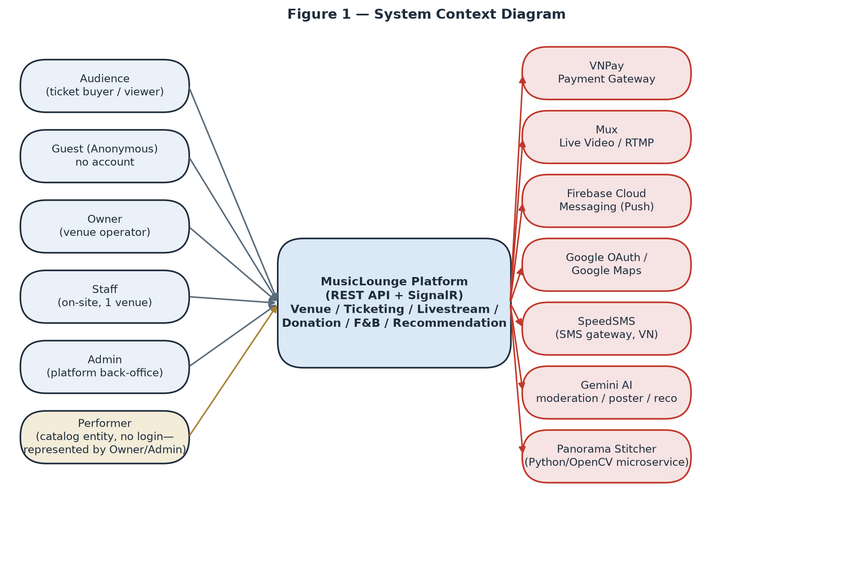
Figure 1 — System Context Diagram: human/business actors on the left, external systems on the right.

2. User Requirements

2.1 Actors
# | Actor | Description
1 | Guest (Anonymous) | A visitor with no account and no token. Can browse the public catalog (venues, shows, ticket tiers, seating layout, 360° tours, subscription-plan pricing), read the public donation transparency feed, and file/look up a complaint by reference number + phone — but cannot buy, donate, follow, wishlist, or rate anything (those require an authenticated account).
2 | Audience | A registered end-user who discovers shows, buys tickets (online or receives one as a walk-in sale from Staff), watches livestreams they hold a genuine ticket for, tips performers, rates attended shows, and manages their own account/privacy settings.
3 | Owner | Operates one or more venues: creates/edits the venue profile and seating layout, builds show line-ups and pricing, manages a subscription plan, registers bank accounts for payout, assigns Staff, handles donation acknowledgement/payout to performers, and tracks earnings. The single largest actor by screen count — almost half the system exists to serve this role.
4 | Staff | An Audience-role-adjacent worker assigned by exactly one Owner to exactly one venue at a time (never self-registered). Operates the floor during a show: sells walk-in tickets at the counter, scans QR codes at the door, and progresses F&B orders through the kitchen/bar workflow. Shares the livestream start/end controls with the Owner.
5 | Admin | The platform's internal back-office operator. There is deliberately no self-service or API path to become Admin — every Admin account today exists only via a direct database edit, and a background job (AdminRoleDriftDetectionJob) alerts if an Admin appears outside the known baseline, treating that as a possible compromise indicator. Approves venues, moderates show/livestream content, issues and reviews penalty appeals, processes refunds, verifies bank accounts, resolves complaints, and manages user accounts.
6 | Performer | A business entity, not a system actor with credentials — performers never log in. Every action on a Performer's behalf (profile edits, bank account registration, line-up assignment) is taken by the Owner who created that profile, or by Admin.
7 | VNPay (Payment Gateway) | An external system actor that calls back into MusicLounge to confirm the one transaction (ticket payment, donation, or subscription payment) it owns, via return-URL and IPN (Instant Payment Notification) callbacks. Holds no other privilege.
8 | Background Job Scheduler (Hangfire) | Runs entirely inside the process on a schedule, outside the HTTP request pipeline and outside any user identity — it has full internal write authority by design (auto-approving overdue appeals, releasing due settlements, reconciling VNPay, expiring holds, sending reminder emails/SMS/push) and cannot impersonate any human actor. See §3.1.8 for the full catalog of jobs.

2.2 Use Cases

2.2.1 Diagram(s)
Five actor-scoped use-case diagrams below group the 97 granular use cases listed in §2.2.2 into their functional areas — one diagram per primary actor.
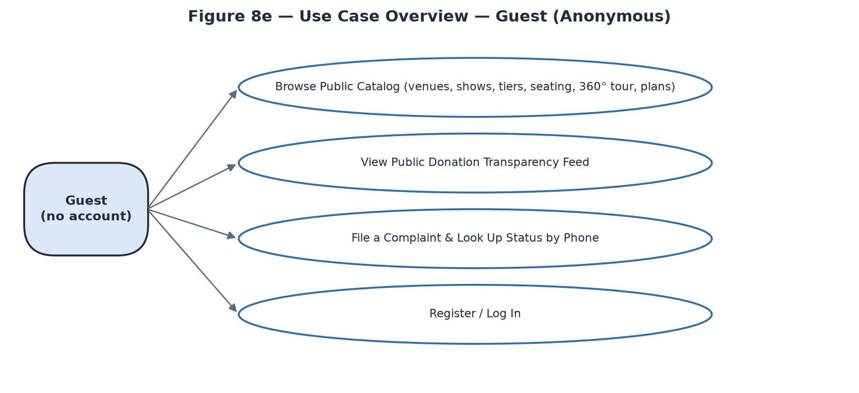
Figure 8a — Use Case Overview — Guest (Anonymous)
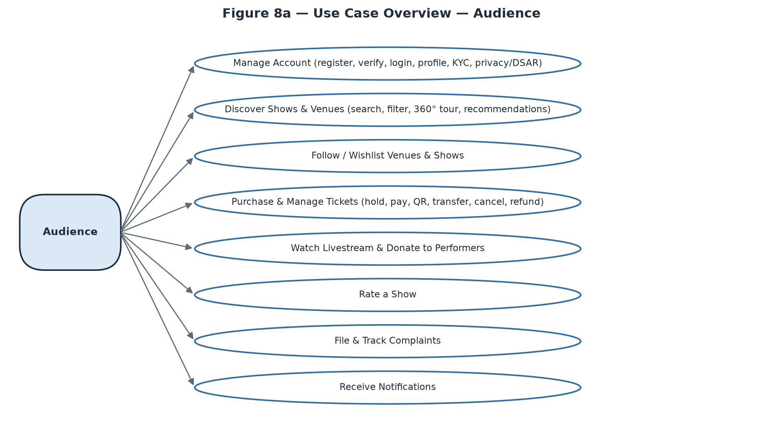
Figure 8b — Use Case Overview — Audience
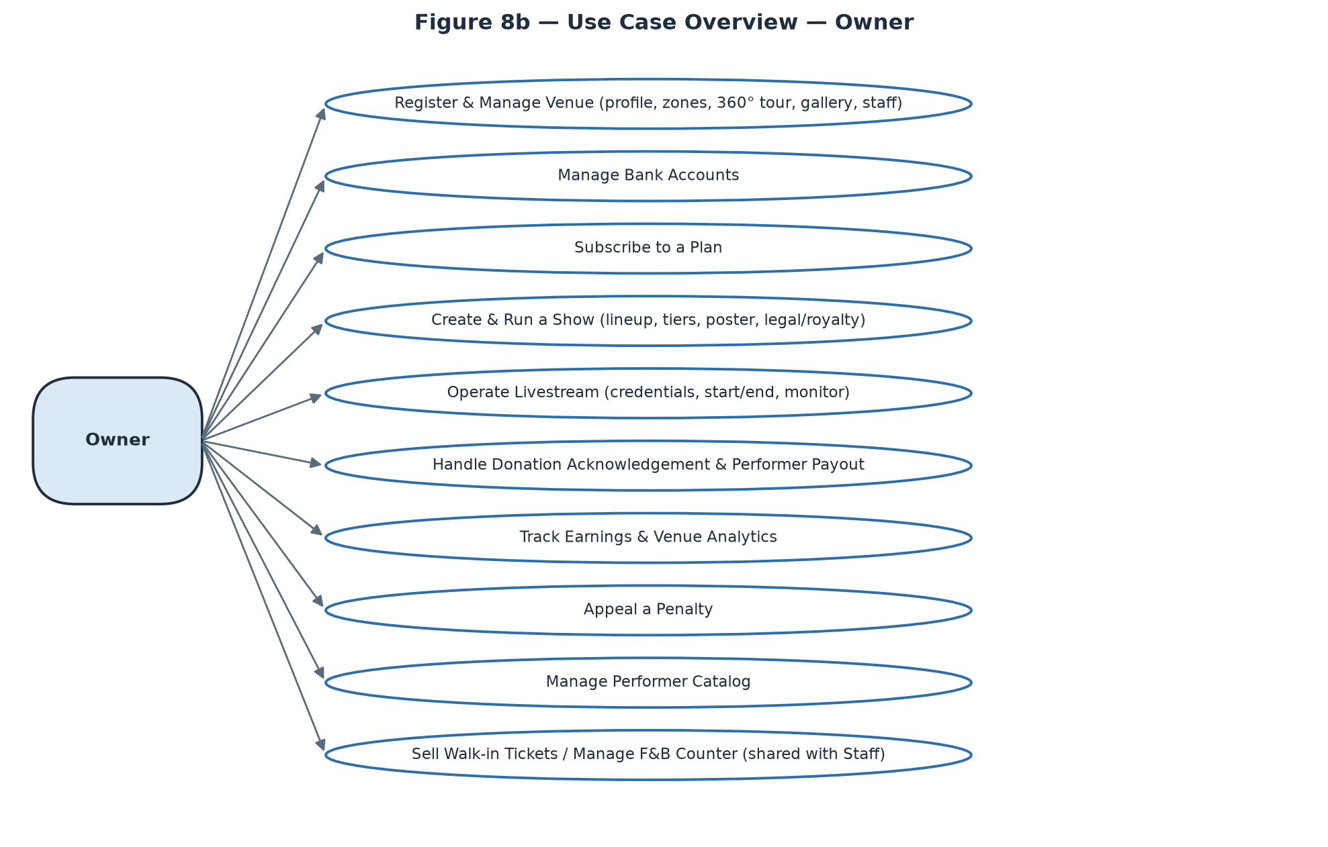
Figure 8c — Use Case Overview — Owner
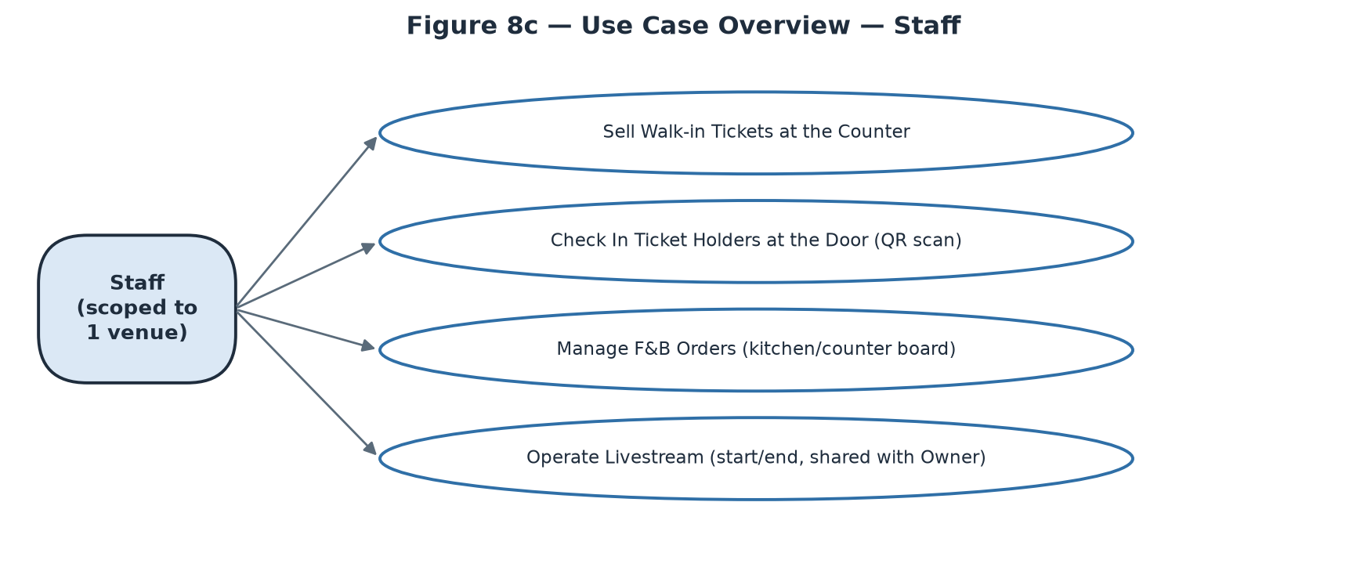
Figure 8d — Use Case Overview — Staff
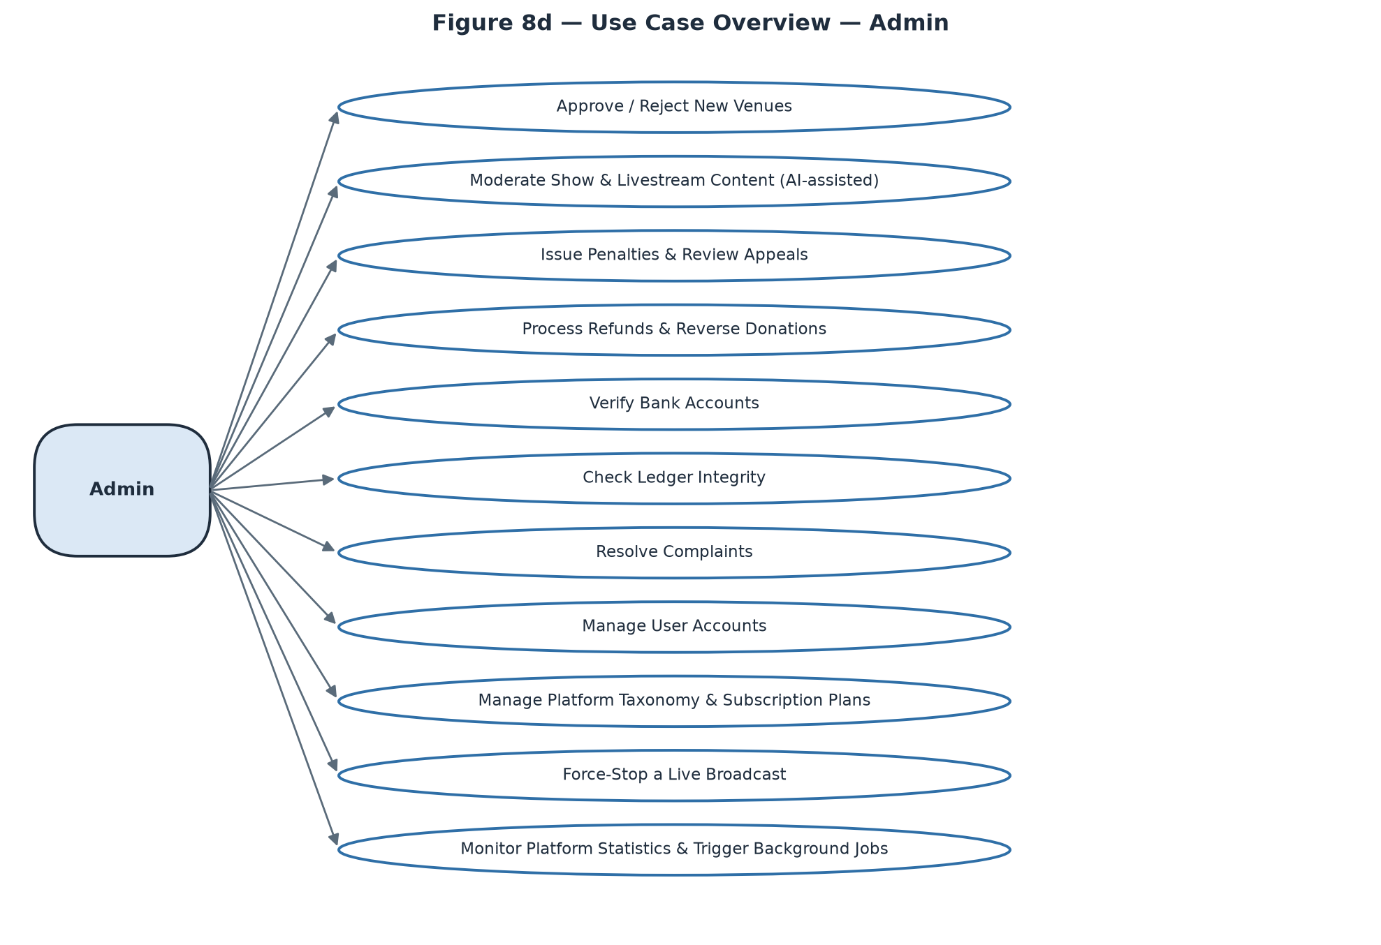
Figure 8e — Use Case Overview — Admin

2.2.2 Descriptions
ID | Use Case | Actors | Use Case Description
UC-01 | [Auth & Account] Register Account | Guest | Create an Audience or Owner account with email, password, full name and optional phone; account is not logged in until the email OTP is verified.
UC-02 | [Auth & Account] Verify Email | Guest | Enter the 6-digit OTP sent to the registered email to activate the new account.
UC-03 | [Auth & Account] Log In | Guest | Authenticate with email/password or Google OAuth. Returns a deliberately generic “Incorrect email or password” error for both wrong-email and wrong-password cases (anti user-enumeration).
UC-04 | [Auth & Account] Recover Password | Guest | Request a reset link by email (always shows a generic confirmation, never reveals whether the email is registered) and set a new password via the emailed one-time token.
UC-05 | [Auth & Account] Manage My Profile | Audience, Owner, Staff, Admin | View/edit name, phone, avatar, date of birth; change password (local accounts only — Google-linked accounts show “Linked to Google” instead).
UC-06 | [Auth & Account] Submit ID Verification | Audience, Owner, Staff, Admin | Upload front/back ID photos for optional identity verification.
UC-07 | [Auth & Account] Manage AI Recommendation Preferences | Audience, Owner, Staff, Admin | Set genre/mood/atmosphere taste tags and toggle personalised recommendations on/off (default opt-out per BVDLCN 2025 AI-consent rule).
UC-08 | [Auth & Account] Export My Data | Audience, Owner, Staff, Admin | Download a machine-readable export of the account's personal data (DSAR access right).
UC-09 | [Auth & Account] Deactivate My Account | Audience, Owner, Staff, Admin | Reversible self-service deactivation — blocks login until the user reactivates.
UC-10 | [Auth & Account] Erase My Data (DSAR) | Audience, Owner, Staff, Admin | Irreversible request to anonymise the account in place (never a hard delete, to preserve 10-year accounting-law retention on linked financial records) — requires re-entering the current password (local accounts) and immediately revokes every active JWT.
UC-11 | [Discovery] Search / Browse Shows | Guest, Audience | Full-text search and filter (genre, mood, date, price, format) across published shows.
UC-12 | [Discovery] View Show Detail | Guest, Audience, Owner | View full show information; action buttons are conditional — Buy Tickets (on-sale + seats remain), Watch Live (genuine ticket holder + show Ongoing), Rate (attended, ended ≤ 7 days, not yet rated), or a link to Show Control Center for the owning Owner.
UC-13 | [Discovery] Browse / Search Venues | Guest, Owner | List published venues; an Owner passing mine=true additionally sees their own Pending/Rejected venues.
UC-14 | [Discovery] View Venue Detail | Guest, Owner | View venue photos, address, atmosphere tags, upcoming shows, and seating-zone overview.
UC-15 | [Discovery] Explore 360° Virtual Tour | Guest, Audience | Drag-to-look-around panorama tour of a venue with clickable hotspots between scenes.
UC-16 | [Discovery] View Personalised Recommendations (“For You”) | Audience | Curated show feed; silently falls back to a generic “Trending” feed if personalisation is off or the account is too new for a signal.
UC-17 | [Discovery] View Performer Public Page | Guest, Audience | View a performer's bio, genre tags, upcoming/past shows, and link to their donation history.
UC-18 | [Discovery] View Subscription Plan Pricing | Guest, Audience, Owner | Publicly viewable plan comparison (price, ticket cap, AI-poster inclusion, tour-scene cap).
UC-19 | [Following] Follow / Unfollow a Venue | Audience | Toggle following a venue.
UC-20 | [Following] Wishlist / Remove a Show | Audience | Save or remove a show of interest.
UC-21 | [Following] View Following & Wishlist | Audience | Two-tab list (Venues / Shows) of everything followed/wishlisted.
UC-22 | [Ticket Purchase] Hold a Ticket | Audience | Reserve a tier/quantity for 15 minutes (configurable) before payment; a running countdown is a first-class UI element, not decorative.
UC-23 | [Ticket Purchase] Release a Ticket Hold | Audience | Cancel an active hold early.
UC-24 | [Ticket Purchase] Pay for a Held Ticket | Audience | Redirect to VNPay to complete payment for a held ticket; returns to a 3-state Payment Result screen (Processing / Success / Failed).
UC-25 | [Ticket Purchase] View My Tickets | Audience | Full ticket history across all statuses, upcoming separated from past.
UC-26 | [Ticket Purchase] View Ticket Detail / QR | Audience | View the entry QR code and seat/tier info; QR is hidden once Used/Cancelled/Refunded, replaced with a status label.
UC-27 | [Ticket Purchase] Transfer a Ticket | Audience | Transfer a Confirmed, not-yet-checked-in, never-streamed ticket to another Audience account.
UC-28 | [Ticket Purchase] Cancel a Ticket | Audience | Cancel a pending ticket freely, or a confirmed ticket within the show's own cancellation deadline/policy.
UC-29 | [Ticket Purchase] Track My Refund Requests | Audience | View refund status (pending/approved/rejected) after cancelling a ticket.
UC-30 | [Live & Donate] Watch a Livestream | Audience, Owner, Staff, Admin | Join the live viewing room subject to LivestreamAccessPolicy — genuine ticket holder within the concurrent-device limit (Audience), assigned venue operator (Owner/Staff), or unconditional access (Admin).
UC-31 | [Live & Donate] Send Live Chat Message | Audience, Owner, Staff, Admin | Post a chat message visible to everyone in the viewing room.
UC-32 | [Live & Donate] Donate to a Performer | Audience | Send a tip to one performer in the current line-up who has donations enabled for this set, with optional anonymity / amount-hiding / message-publishing toggles.
UC-33 | [Live & Donate] View My Donations | Audience | Track sent donations through a 3-step pipeline (Sent → Venue confirmed → Performer paid).
UC-34 | [Live & Donate] View Public Donation Ticker | Guest, Audience | Live, Twitch/Streamlabs-style alert feed for a specific show — no ticket or account needed.
UC-35 | [Live & Donate] View Public Donation Transparency Feed | Guest, Audience | Browse the settled (non-pending) platform-wide or per-performer donation ledger.
UC-36 | [Rating] Rate a Show | Audience | Submit a star rating + comment once per attended, ended show, within the review window.
UC-37 | [Complaints] File a Complaint | Guest, Audience | Report a problem against a ticket/show/venue/donation with category, description and optional evidence; guests must supply a phone number and are shown a reference number to save for later lookup.
UC-38 | [Complaints] Look Up a Guest Complaint | Guest | Check status using the reference number + the phone number supplied at filing.
UC-39 | [Complaints] View My Complaints | Audience, Owner, Staff, Admin | List filed complaints with status and, once resolved, the Admin's resolution notes.
UC-40 | [Notifications] View Notifications | Audience, Owner, Staff, Admin | Central inbox with unread badge and deep-link routing to the relevant screen; Admin additionally receives internal security/operations alerts no other role sees.
UC-41 | [Venue Setup] Register a Bank Account | Owner | Register a payout account for the venue itself or for a Performer the Owner manages; stays “Pending admin verification” until Admin verifies it — a real blocker on settlement and donation payout, not decorative.
UC-42 | [Venue Setup] Create a Venue | Owner | Submit venue profile, photos, business license, optional .glb 3D model; starts life at Pending, blocked from creating shows until Admin approval.
UC-43 | [Venue Setup] Edit a Venue | Owner | Edit an existing venue's profile fields.
UC-44 | [Venue Setup] Design Seating Zones | Owner | Drag-and-drop 2D/3D editor defining named zones and their real physical capacity — a hard, life-safety cap on ticket sales for that zone, reused across every show at the venue.
UC-45 | [Venue Setup] Build the 360° Virtual Tour | Owner | Upload a single pre-stitched panorama, or submit several room photos to the Python stitching microservice (Auto-Stitch, an async background job); place scenes on a floor-plan mini-map and add navigate/info hotspots between them. Scene count is capped by the subscription plan's MaxTourScenes.
UC-46 | [Venue Setup] Manage Venue Gallery & Custom Criteria | Owner | Maintain a showcase photo gallery (no subscription cap) and define venue-specific recommendation criteria tags that Audience members can express interest in.
UC-47 | [Venue Setup] Assign / Remove Staff | Owner | Look up a user by email, confirm eligibility (not already Owner/Admin/Staff-elsewhere), then assign as Staff for the venue; removal takes effect at the next login.
UC-48 | [Subscription] Subscribe to a Plan | Owner | Start checkout for a plan; blocked while an active plan already exists (cancel first).
UC-49 | [Subscription] Renew My Subscription | Owner | Extend the current plan via a fresh one-time VNPay payment (never auto-charged).
UC-50 | [Subscription] Cancel My Subscription | Owner | Cancel the active subscription.
UC-51 | [Show Management] Create a Show | Owner | Set name, description, format (in-person/livestream/hybrid), schedule, genre tags, ticket quota split, and build the performer line-up (typing an unmatched performer name silently creates a new catalog profile on submit).
UC-52 | [Show Management] Edit a Draft Show | Owner | Edit a show while still in Draft.
UC-53 | [Show Management] Submit a Show for Review | Owner | Requires an approved venue and at least one ticket tier; moves the show to Pending.
UC-54 | [Show Management] Reschedule a Show | Owner | Change the date/time of a Published, not-yet-ongoing show.
UC-55 | [Show Management] Change Show Format | Owner | In-person → online is one-way and automatically refunds 100% of confirmed in-person tickets — requires strong confirmation.
UC-56 | [Show Management] Change Playback Mode | Owner | Toggle 2D/3D for an online/hybrid show.
UC-57 | [Show Management] Cancel a Show | Owner | Refunds 100% of confirmed tickets; blocked while a livestream is actively broadcasting (must be terminated first).
UC-58 | [Show Management] Start / End an In-Person Show | Owner, Staff | Manual lifecycle buttons — hidden entirely (not just disabled) once a livestream is attached, which uses its own Start/End pair instead.
UC-59 | [Show Management] Manage Ticket Tiers | Owner | Add/edit/delete tiers (name, access type, zone, capacity, price) while the show is a Draft; total capacity is capped by the subscription plan's per-event ticket limit.
UC-60 | [Show Management] Generate / Upload a Show Poster | Owner | AI-generate a poster (subject to plan inclusion + monthly/per-show quota, async job with failure reason) or upload one directly; separate cover-image upload.
UC-61 | [Show Management] Declare Legal & Royalty References | Owner | Save the performance-permit reference and VCPMC music-royalty reference required before a livestream can start.
UC-62 | [Show Management] Manage the F&B Menu | Owner | Create/edit menu items (category, price, availability) for the venue.
UC-63 | [Livestream Ops] Create a Livestream | Owner, Staff | Provision RTMP URL + Stream Key for a show (kept hidden behind a reveal action — never shown to Audience).
UC-64 | [Livestream Ops] Start Broadcasting | Owner, Staff | Blocked until both the livestream-specific admin content review clears and the legal royalty reference is filled in — shown as two distinct missing-condition indicators.
UC-65 | [Livestream Ops] End Broadcasting | Owner, Staff | Manually end a live broadcast.
UC-66 | [Livestream Ops] Monitor Live Chat & Viewer Count | Owner, Staff, Admin | Viewer count is a manual-refresh figure, not a live-updating counter.
UC-67 | [Donation Handling] Acknowledge Donation Receipt | Owner | Confirm a VNPay-confirmed tip has arrived within a 24-hour window; auto-confirms on the Owner's behalf if the window lapses, with the two paths kept visually distinct.
UC-68 | [Donation Handling] Mark a Donation as Paid Out | Owner | Record that the performer's share has been manually wired, attaching a reference and proof photo; blocked (with a link to fix it) if the performer has no default bank account.
UC-69 | [Finance] View Earnings Overview | Owner | Cross-venue summary of settlements, ticket payments and donations; money held up by an unverified bank account is shown as “on hold”, never silently absent.
UC-70 | [Finance] View Venue Analytics | Owner | Per-venue performance metrics, with a venue picker for multi-venue Owners.
UC-71 | [Penalties & Appeals] Appeal a Penalty | Owner | File a written appeal against an Active penalty; view the venue's real combined restriction state (an overturned penalty does not auto-clear other overlapping ones).
UC-72 | [Performer Catalog] Create a Performer Profile | Owner | Add a performer to the platform-wide shared catalog (name, avatar, bio, type, genres).
UC-73 | [Performer Catalog] Edit / Delete a Performer Profile | Owner, Admin | Restricted to the profile's creator or Admin; delete is disabled (with reason) if the performer has ever been booked into any show.
UC-74 | [Performer Catalog] Manage Performer Social Links | Owner | Upsert social-platform links (Spotify/YouTube/SoundCloud/Facebook/Instagram) per performer.
UC-75 | [Counter Operations] Sell a Walk-in Ticket | Staff, Owner | One-step cash sale of an in-person-tier ticket with no buyer account; confirms immediately, no VNPay redirect, earns no platform commission by default.
UC-76 | [Counter Operations] Check In a Ticket at the Door | Staff, Owner | Scan a QR code, preview holder/tier before committing, then confirm; each rejection reason (already used, wrong show, online-only ticket, mid-transfer) is shown distinctly, with no offline fallback.
UC-77 | [F&B Operations] Take an F&B Order for a Table | Staff, Owner | Place an order on a customer's behalf, identical in effect to a self-service order.
UC-78 | [F&B Operations] Advance an F&B Order's Status | Staff, Owner | Move an order through the fixed sequence Pending → Preparing → Served → Paid, or Cancel at any point before Paid; marking Paid is a status flag only, not a payment reconciliation.
UC-79 | [F&B Ordering (Guest)] Browse F&B Menu & Order | Audience | Browse the venue's active menu (grouped by category) and place an order while physically at the venue; unavailable items are shown greyed-out, not hidden.
UC-80 | [F&B Ordering (Guest)] Track My F&B Order | Audience | View the current order's status stepper; not push-updated — requires a manual pull-to-refresh.
UC-81 | [Admin Approvals] Approve / Reject a New Venue | Admin | Review a Pending venue's submitted details and approve or reject (with a reason).
UC-82 | [Admin Approvals] Moderate Show / Livestream Content | Admin | Review an AI risk-scored submission (advisory only, full Admin discretion); a written note is required on rejection. Approving a show makes it public immediately; approving a livestream unlocks its Start Broadcasting control.
UC-83 | [Admin Penalties] Issue a Venue Penalty | Admin | Record Warning/Suspension/Ban with reason, evidence reference, and (for Suspension) a length.
UC-84 | [Admin Penalties] Review a Penalty Appeal | Admin | Uphold or overturn an Owner's appeal with a review note; no list view exists for open appeals today — reached only via a known penalty id (typically from a notification).
UC-85 | [Admin Finance] Approve / Reject a Refund Request | Admin | Full or partial approval (defaults to the full requested amount); reverses internal ledger entries only — does not call a live VNPay refund API in this environment.
UC-86 | [Admin Finance] Create a Manual Refund Request | Admin | Escape hatch for edge cases with no automatically generated request; still flows through the same approval queue.
UC-87 | [Admin Finance] Reverse a Donation | Admin | Reverse a specific donation's ledger entries by id, with a reason; refused once the performer has already been paid out. No queue exists — reached by id search, typically from a Complaint resolution.
UC-88 | [Admin Finance] Verify a Bank Account | Admin | Manually confirm a registered bank account by id after reconciling off-system; immediately unblocks any settlement waiting on it. No pending-verification list exists today.
UC-89 | [Admin Finance] Run the Ledger Integrity Check | Admin | Read-only diagnostic scanning for unbalanced accounting entries; an empty result is the good outcome and is shown distinctly from a loading/error state.
UC-90 | [Admin Complaints] Resolve a Complaint | Admin | Set status, resolution note and action type; refund/compensate against a ticket auto-creates a refund request, against a donation requires a separate manual reversal, take-down-content cancels the show and refunds all confirmed tickets. Guest complainants are notified by SMS, never in-app.
UC-91 | [Admin Users] Search & Inspect a User | Admin | Search/filter accounts by name, email, role, status; view submitted ID-verification photos through a protected (non-guessable) endpoint.
UC-92 | [Admin Users] Deactivate / Reactivate a User | Admin | Toggle account access; exactly one of the two actions is offered at a time based on current status.
UC-93 | [Platform Settings] Manage Taxonomy | Admin | Create category/genre/mood/atmosphere tags used platform-wide; creation only — no edit/delete exists today, a confirmed backend gap.
UC-94 | [Platform Settings] Manage Subscription Plans | Admin | Create/edit plans including an active/inactive toggle; edits never retroactively change terms for owners already subscribed under the old plan.
UC-95 | [Livestream Enforcement] Force-Stop a Livestream | Admin | Immediately terminate a broadcasting violation with a required reason; every viewer is disconnected instantly, shown distinctly from a normal Owner/Staff-initiated End.
UC-96 | [Monitoring] View Platform Statistics | Admin | System-wide analytics dashboard, distinct from a single venue's own Venue Analytics.
UC-97 | [Monitoring] Trigger a Background Job Manually | Admin | Run one job on demand from a fixed known list, for troubleshooting; a single immediate run only — does not alter that job's regular schedule, and returns no synchronous result.

3. Functional Requirements

3.1 System Functional Overview
The system is delivered as five separate client surfaces rather than one universal app — §3.1.1 summarises the split, §3.1.2–3.1.6 give the screens-flow diagram and screen catalog for each surface in turn, §3.1.7 consolidates role-based screen authorization across all five, §3.1.8 lists the non-screen (background job) functions, and §3.1.9 gives the entity catalog.

3.1.1 Client Surfaces & Roles
Backend (REST + SignalR) does not force any particular client — the 5-way split below is a documented product decision (platform-architecture.md), matched to how each actor actually works, not a technical limitation.
Surface | Primary Actor | Client Type | # Screens | Why
Audience — Website | Audience | Responsive website | 30 | Most concert-going is an in-person, occasional activity, not continuous app use — discovery/purchase/viewing/QR-at-the-door all work fine in a browser.
Audience — Mobile (F&B) | Audience | Native app (iOS/Android) | 2 | The one truly "phone in hand, at the table, right now" situation — in-venue food & drink ordering — kept deliberately narrow in scope.
Owner — Web Dashboard | Owner | Website (dashboard) | 27 | Desk work: multi-field forms, a drag-and-drop seating editor, financial dashboards.
Staff — Mobile | Staff | Native app/tablet | 7 | On-site, moving through the venue: counter sales, door check-in, kitchen/bar F&B board.
Admin — Web Console | Admin | Website (console) | 16 | Back-office: dense review queues, ledger reconciliation, user administration.
22 of the 75 catalogued screens (29.3%) are accessed by more than one actor; 3 of those have an explicit role-based difference in content or actions, called out in the Notes column (Live Viewing Room, Show Control Center, Performer Profiles), while the remaining 19 present identical content regardless of who is looking (e.g. Home / Show Search, Show Detail, Venue Detail, 360° Virtual Tour, Payment Result).

3.1.2 Audience — Website
Responsive website (desktop-primary, but the Ticket-Detail QR screen and Log In must also read well at phone width, since those two are the most likely to be opened on a phone at the door or on the go). Standard header navigation: Discover, My Tickets, Following, search bar, account menu. Covers domain groups A–F, H, I (30 screens) — everything an Audience member does except in-venue F&B ordering, which is the separate mobile app below.
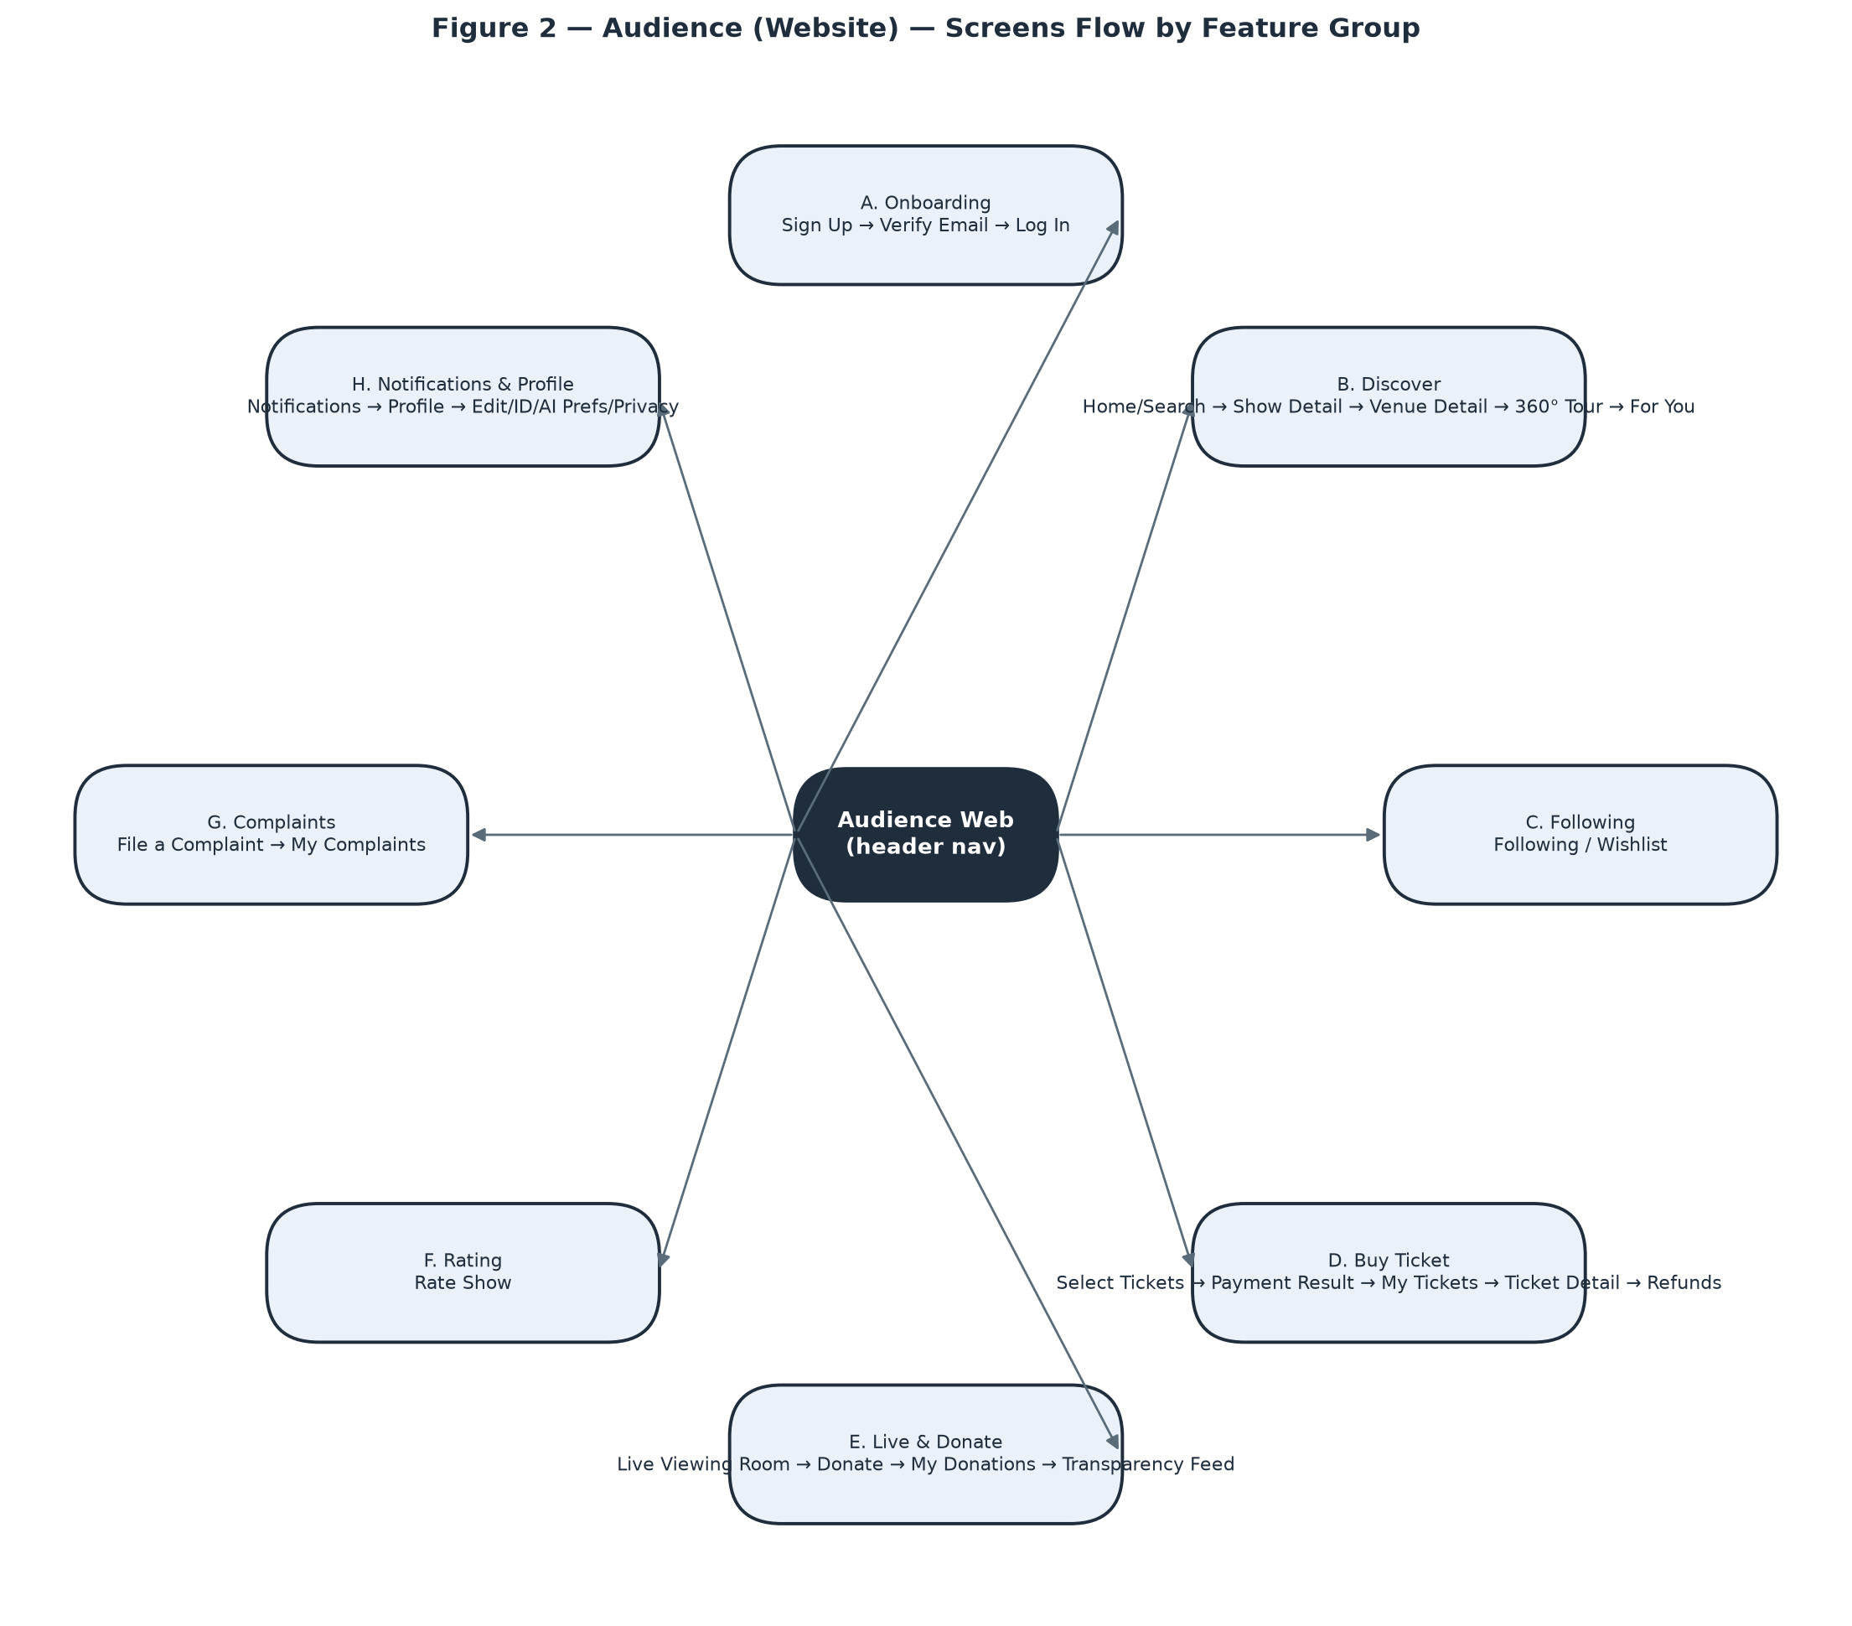
Screens Flow — Audience (Website).
# | Feature | Screen | Description
1 | Onboarding | Sign Up | Create an Audience/Owner account (email, password, name, optional phone); not logged in until email OTP verification.
2 | Onboarding | Verify Email | Enter the 6-digit OTP sent to the registered email to activate the account.
3 | Onboarding | Log In | Email/password or Google login; a single generic error covers both wrong-email and wrong-password.
4 | Onboarding | Forgot / Reset Password | Step 1 requests a reset email (always a generic confirmation); step 2, opened from the emailed link, sets a new password.
5 | Discover | Home / Show Search | Search and filter published shows by genre, mood, date, price, format; trending section and show-card grid.
6 | Discover | Show Detail | Full show info with conditional actions: Buy Tickets, Watch Live, Rate This Show, Follow/Wishlist — each gated on real eligibility, not just role.
7 | Discover | Venue Detail | Venue photos, address/map, atmosphere tags, upcoming shows, seating-zone overview, Follow toggle, link to the 360° tour if one exists.
8 | Discover | 360° Virtual Tour | Full-bleed drag-to-look-around panorama viewer with clickable hotspots between scenes.
9 | Discover | For You (Recommendations) | Personalised show feed; quietly becomes a generic Trending feed when personalisation is off or the account is new.
10 | Following | Following / Wishlist | Two tabs — Venues followed and Shows wishlisted — each with its own empty state.
11 | Buy Ticket | Select Tickets | Pick a tier + quantity and start a 15-minute hold (prominent countdown); sold-out tiers shown disabled with a reason.
12 | Buy Ticket | Payment Result | Shared 3-state template (Processing / Success / Failed) used for ticket, donation and subscription payments.
13 | Buy Ticket | My Tickets | Full ticket history, upcoming separated from past, across every status.
14 | Buy Ticket | Ticket Detail | Large entry QR code plus seat/tier info; conditional Transfer/Cancel actions; QR hidden once Used/Cancelled/Refunded.
15 | Buy Ticket | My Refund Requests | Status list (pending/approved/rejected) for cancelled tickets.
16 | Live & Donate | Live Viewing Room | Video player + chat + performer line-up for tipping, desktop-primary side-by-side layout; distinct messaging for access-rejected vs. a plain network hiccup.
17 | Live & Donate | Public Donation Ticker (widget) | Twitch/Streamlabs-style live alert feed embedded in Show Detail and the Live Viewing Room, visible with no ticket or account.
18 | Live & Donate | Donate (modal) | Tip a specific performer with optional anonymity/amount-hiding/message-publishing toggles, kept on top of the still-playing video.
19 | Live & Donate | My Donations | 3-step pipeline progress (Sent → Venue confirmed → Performer paid) per donation.
20 | Live & Donate | Public Donation Transparency Feed | Paginated public ledger — platform-wide with full fee breakdown, or per-performer amount-only — showing only settled donations.
21 | Live & Donate | Performer Public Page | Avatar, bio, genre tags, upcoming/past shows, link to the performer's transparency feed.
22 | Rating | Rate Show (modal) | Star rating + comment, reachable exactly once per attended show within the review window.
23 | Complaints | File a Complaint | Category, target, description, optional evidence; guests must also give a phone number and are shown a reference number to save.
24 | Complaints | My Complaints | Status list with full detail and Admin resolution notes once resolved.
25 | Notifications & Profile | Notifications | Central inbox with unread badge, deep-linking by notification type.
26 | Notifications & Profile | Profile | Account hub linking to Edit Profile, ID Verification, AI Preferences, Privacy & Data, My Donations, My Complaints.
27 | Notifications & Profile | Edit Profile | Name, phone, avatar, date of birth; change-password section hidden for Google-linked accounts.
28 | Notifications & Profile | ID Verification | Upload front/back ID photos; shows submission status.
29 | Notifications & Profile | AI Preferences | Genre/mood/atmosphere taste tags and a personalisation on/off toggle with a visible explanation of what turning it off changes.
30 | Notifications & Profile | Privacy & Data | Export My Data, Deactivate Account (reversible), Delete My Data (irreversible, two-step confirmation, signs out everywhere).

3.1.3 Audience — Mobile (F&B Ordering)
A deliberately narrow native mobile app (iOS/Android), used only while physically at a venue watching a show. No browsing, tickets, livestream or donations here — those live on the website above. Covers domain group G (2 screens).
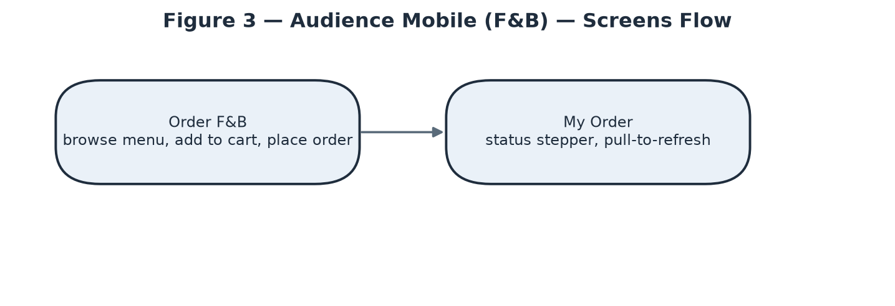
Screens Flow — Audience — Mobile (F&B Ordering).
# | Feature | Screen | Description
1 | F&B Ordering | Order F&B | Browse the venue's active menu grouped by category, add to cart, place order; sold-out items shown greyed-out, not removed; venue/table context established once at session start.
2 | F&B Ordering | My Order | Status stepper (Pending → Preparing → Served → Paid, or Cancelled); not push-updated — a manual pull-to-refresh, since staff update status from a separate tool with no live channel to this app.

3.1.4 Owner — Web Dashboard
Desktop-primary business dashboard (sidebar navigation with a venue switcher for multi-venue Owners) — form-heavy setup flows, a drag-and-drop seating editor, and financial dashboards. Covers domain groups J–Q, AA plus the Owner-facing share of N and R (27 screens). 7 of those — Notifications, Profile, Edit Profile, ID Verification, AI Preferences, Privacy & Data, My Complaints — are the same shared account-management screens already listed once under Audience Web, not repeated here.
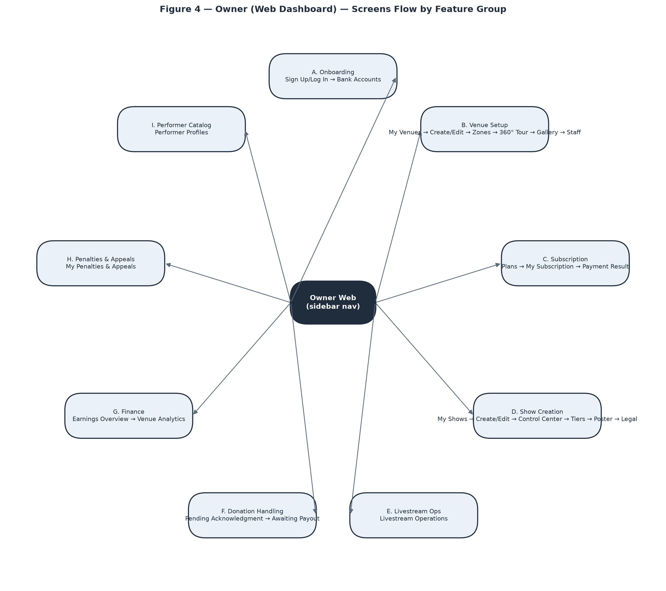
Screens Flow — Owner — Web Dashboard.
# | Feature | Screen | Description
1 | Onboarding | Sign Up / Log In / Password Recovery | Same account flows as Audience, skinned to the dashboard, registering with the Owner role.
2 | Onboarding | Bank Accounts | Register payout accounts for the venue and for performers the Owner manages; unverified accounts show a real “Pending admin verification” blocker on settlement/donation payout.
3 | Venue Setup | My Venues | Cards/rows per venue with status badge; Pending shows “waiting for admin approval” with all management disabled; Rejected shows the reason with no resubmit path.
4 | Venue Setup | Create / Edit Venue | Profile fields, photo/license upload, optional .glb 3D model (distinct from the 360° tour feature).
5 | Venue Setup | Seating Zone Editor | Drag-and-drop 2D/3D placement of named zones with a real physical capacity that hard-caps ticket sales for that zone.
6 | Venue Setup | 360° Virtual Tour (management) | Add a pre-made panorama or Auto-Stitch several room photos (async job, 15–30+s); place scenes on a mini-map with navigate/info hotspots; capped by subscription tier.
7 | Venue Setup | Venue Extras (Gallery & Custom Criteria) | Showcase photo gallery (no cap) plus venue-defined recommendation-criteria tags.
8 | Venue Setup | Staff Management | Look up a user by email, confirm eligibility, assign/remove as Staff for the venue.
9 | Subscription | Subscription Plans | Publicly viewable plan comparison; Choose Plan starts checkout for a logged-in Owner.
10 | Subscription | My Subscription | Current plan snapshot, Subscribe/Renew/Cancel; Renew still requires a real one-time payment.
11 | Subscription | Payment Result | Shared 3-state payment template; on success here, lands back on My Subscription.
12 | Show Management | My Shows | Every show at any stage (Draft/Pending/Published/Ongoing/Ended/Cancelled).
13 | Show Management | Create / Edit Show | Core details plus a line-up builder; typing an unmatched performer name silently creates a new profile on submit.
14 | Show Management | Show Control Center | Lifecycle hub — Submit for Review, Reschedule, Change Format, Change Playback Mode, Cancel, Start/End — with links out to Tiers, Poster, Legal, Livestream Ops.
15 | Show Management | Ticket Tiers | Add/edit/delete tiers while Draft, capped by the plan's per-event ticket limit; a running “X of Y tickets used” indicator.
16 | Show Management | Poster | AI-generate (plan-gated, async, quota-limited) or upload a poster; separate cover-image upload.
17 | Show Management | Legal & Royalty Declaration | Performance-permit and VCPMC royalty reference fields required before a livestream can start.
18 | Livestream Ops | Livestream Operations | RTMP URL + Stream Key (hidden by default), Start/End Broadcasting (blocked on two independent conditions shown distinctly), live chat/viewer monitor (manual-refresh).
19 | Donation Handling | Pending Acknowledgment | Countdown-to-24h list of tips awaiting Owner confirmation; auto-confirms on timeout, tracked distinctly from a manual confirm.
20 | Donation Handling | Awaiting Payout | Mark a donation Paid with a reference + transfer-proof photo; blocked if the performer has no default bank account.
21 | Finance | Earnings Overview | Cross-venue summary of settlements, ticket payments and donations; money on hold is shown as such, never silently absent.
22 | Finance | Venue Analytics | Per-venue performance metrics with a venue picker.
23 | Penalties & Appeals | My Penalties & Appeals | Penalty history and appeal filing; shows the venue's real combined restriction state, not one penalty in isolation.
24 | Performer Catalog | Performer Profiles | Searchable platform-wide catalog; Edit/Delete visible only to the creating Owner or Admin; Delete disabled if ever booked.
25 | F&B Menu | Manage F&B Menu | Create/edit menu items (category, price, availability) for the venue.
26 | Counter Ops (shared with Staff) | Walk-In Sale | Sell an in-person ticket for cash at the counter; same screen as Staff uses.
27 | Counter Ops (shared with Staff) | Manage F&B Orders at Counter | Same order board as Staff, same RequireVenueOperator access.

3.1.5 Staff — Mobile
Native mobile/tablet app used standing up, on the floor, during show hours — bottom tab bar (Sell / Check-In / F&B), large tap targets, minimal typing, no venue switcher (a Staff session is scoped to exactly one venue for the whole shift). Covers domain group S plus the Staff-facing share of M and N (7 screens).
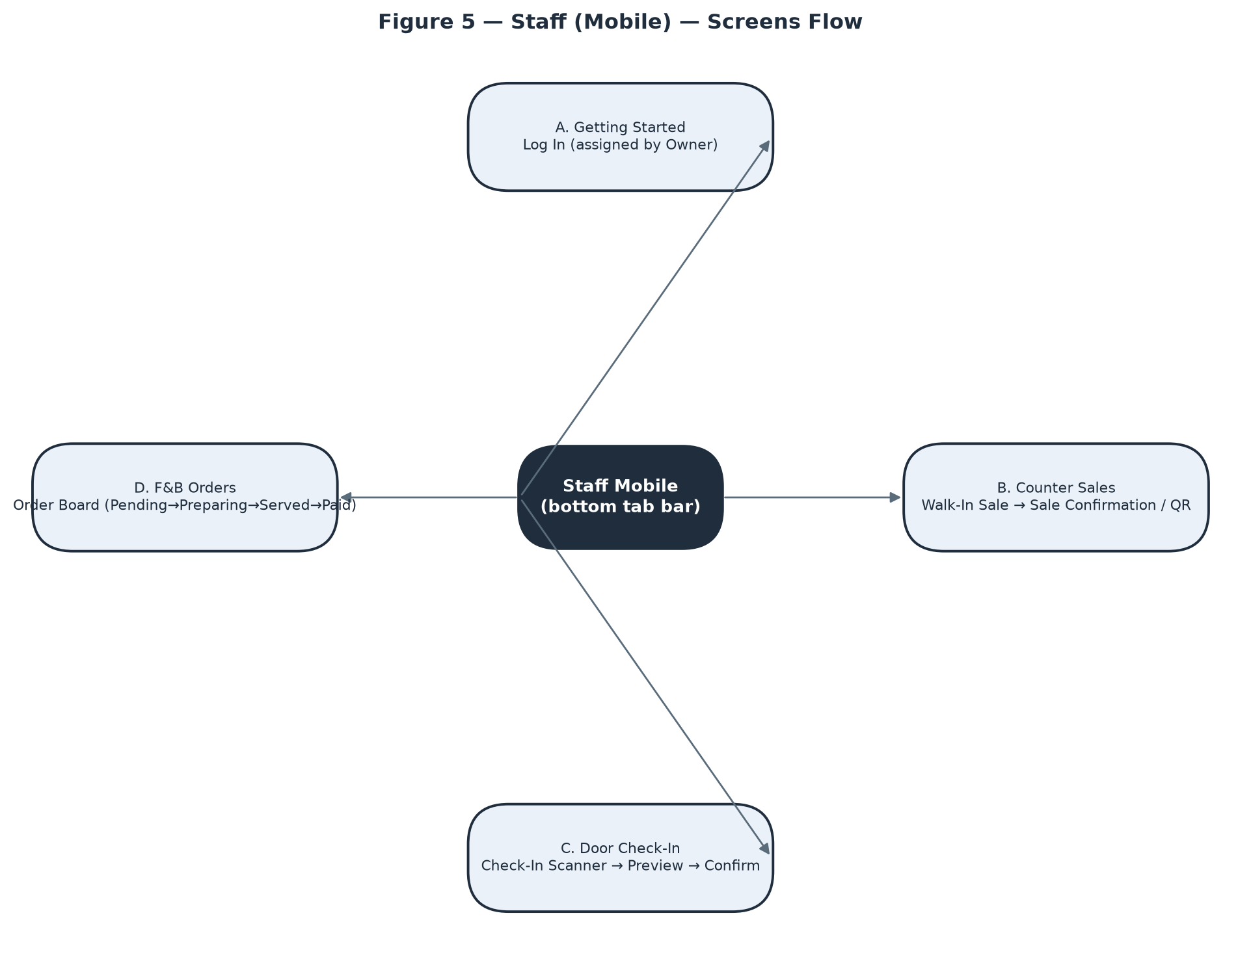
Screens Flow — Staff — Mobile.
# | Feature | Screen | Description
1 | Getting Started | Log In | Same login as Audience/Owner; access exists only after an Owner assigns the Staff role — revocation surfaces as a clear “no longer have access to this venue” state, not a crash.
2 | Counter Sales | Walk-In Sale | Sell an in-person ticket tier for cash, one step, no external payment redirect; earns no commission by default so none is shown on the receipt.
3 | Counter Sales | Sale Confirmation / QR | Large QR handed to a buyer with no account of their own — screenshot-friendly, no email step.
4 | Door Check-In | Check-In Scanner | Camera scan → preview (holder, tier) → explicit Confirm; each rejection reason (already used, wrong show, online-only ticket, mid-transfer) shown distinctly; no offline fallback, connection state always visible.
5 | F&B Orders | Order Board | Orders grouped by status; exactly one “next step” button per order following the fixed Pending→Preparing→Served→Paid sequence; Cancel available up to Paid; marking Paid is a status flag only.
6 | Shared with Owner | Livestream Operations | Identical screen/controls to the Owner dashboard's Livestream Ops — RTMP credentials, start/end, chat/viewer monitor.
7 | Shared with Owner | Show Control Center (Start/End only) | Staff sees only the Start/End buttons; every Owner-only action (Submit for Review, Reschedule, Change Format, Cancel) is hidden, not merely disabled.

3.1.6 Admin — Web Console
Desktop-only back-office console, no exceptions — dense data tables, multi-field review forms, cross-referencing several data sources at once. No self-service signup; every Admin account is provisioned by direct database edit as a deliberate security posture. Covers domain groups T–Z plus the Admin-facing share of F and R (16 screens).
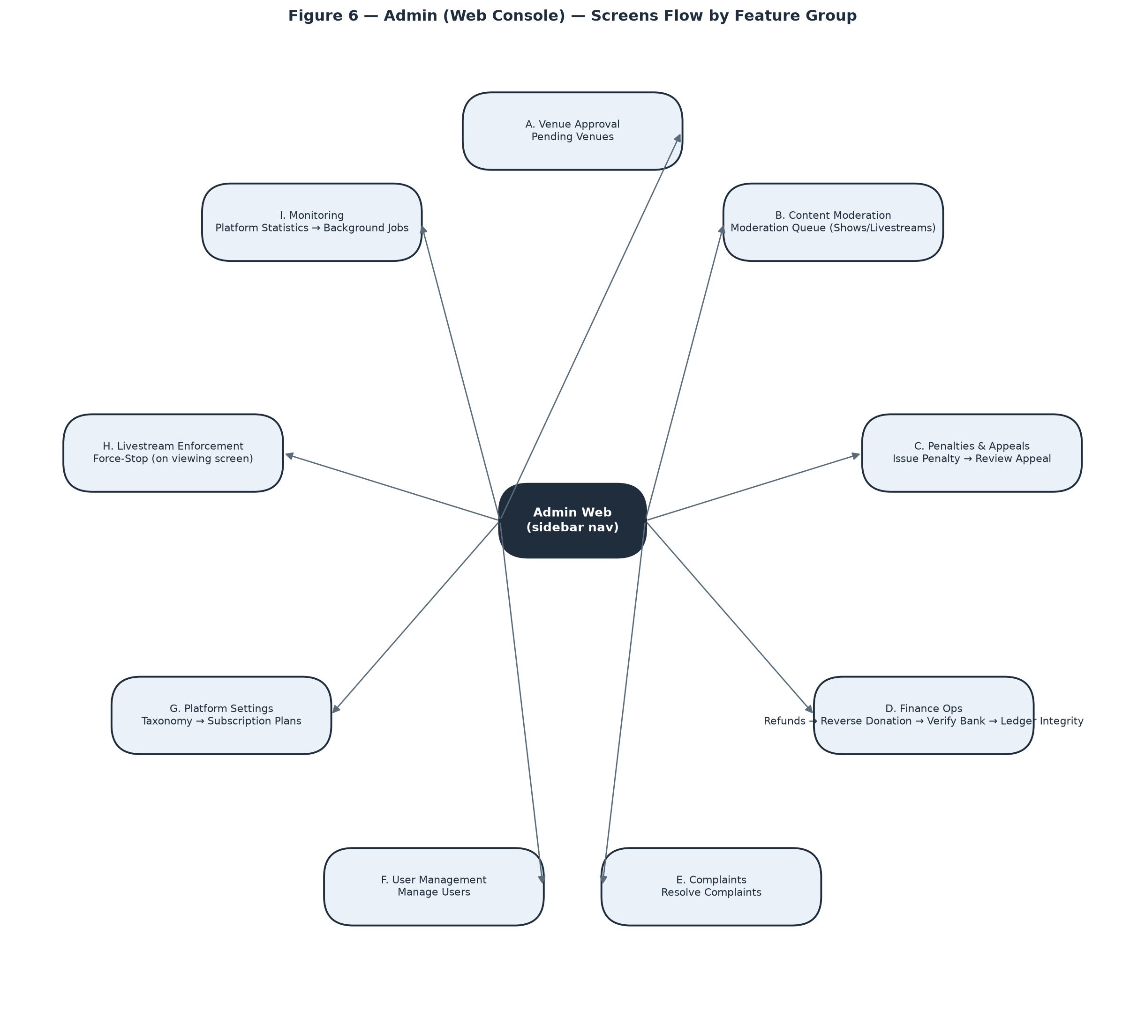
Screens Flow — Admin — Web Console.
# | Feature | Screen | Description
1 | Venue Approval | Pending Venues | Approve/reject queue for newly registered venues; every item immediately actionable, no conditional gating.
2 | Content Moderation | Moderation Queue | Tabbed Shows/Livestreams queue with an AI risk score shown as a suggestion only, full Admin discretion; a note is required on rejection.
3 | Penalties & Appeals | Issue Penalty | Target venue, level (Warning/Suspension/Ban), reason, evidence reference, suspension length when applicable.
4 | Penalties & Appeals | Review Appeal | Overturn or uphold with a review note; reached only via a known penalty id — no “all open appeals” list exists today, a confirmed backend gap.
5 | Finance Ops | Refund Requests | Queue spanning three origins (self-cancel, show-cancel, complaint resolution); approve full/partial or reject; internal ledger reversal only, no live gateway refund call in this environment.
6 | Finance Ops | Reverse a Donation | Stand-alone id-search action, no queue; refused once the performer has already been paid out.
7 | Finance Ops | Verify Bank Account | Stand-alone id-entry action with no pending-verification list anywhere in the backend today — the single screen in the whole console with no natural entry point.
8 | Finance Ops | Ledger Integrity Check | Read-only diagnostic; an empty result (the good outcome) is shown distinctly from loading/error states.
9 | Complaints | Resolve Complaints | Queue across ticket/show/venue/donation/penalty targets; the automation triggered varies by resolution-action type and is made explicit per combination; guest complainants notified by SMS only.
10 | User Management | Manage Users | Searchable/filterable account list plus per-user detail incl. protected ID-verification photos; Deactivate/Reactivate shown one at a time based on current status.
11 | Platform Settings | Taxonomy Management | Create category/genre/mood/atmosphere tags; creation only — no edit/delete exists today, a confirmed backend gap.
12 | Platform Settings | Subscription Plan Management | Create/edit plans incl. active/inactive toggle; edits never retroactively affect already-subscribed owners.
13 | Livestream Enforcement | Force-Stop a Livestream | An extra admin-only control on the shared Live Viewing screen (not a separate page); disconnects every viewer instantly.
14 | Monitoring | Platform Statistics | System-wide analytics, a completely separate screen from a single venue's own Venue Analytics.
15 | Monitoring | Background Jobs | Manually trigger one job on demand from a fixed list; a single immediate run, not a schedule editor; no synchronous result — check the job's own output surface afterward.
16 | Performer Catalog (shared with Owner) | Performer Profiles — Edit/Delete rights | Admin sees Edit/Delete on every performer profile platform-wide, where an Owner sees it only on profiles they created.

3.1.7 Screen Authorization
Consolidated matrix across all 5 surfaces (75 distinct screens — some names, e.g. Payment Result or Livestream Operations, are literally the same screen reused by more than one surface). See the Notes column for the handful of screens where two roles share access but not the same rights.
Screen | Anon. | Audience | Owner | Staff | Admin | Notes
Sign Up | X
Verify Email | X
Log In | X
Forgot / Reset Password | X
Home / Show Search | X | X | X
Show Detail | X | X | X
Venue Detail | X | X | X
360° Virtual Tour | X | X
For You (Recommendations) |  | X
Following / Wishlist |  | X
Select Tickets |  | X
Payment Result |  | X | X
My Tickets |  | X
Ticket Detail |  | X
My Refund Requests |  | X
Live Viewing Room |  | X | X | X | X | Audience: genuine ticket holder within device limit. Owner/Staff: assigned venue operator only. Admin: unconditional + exclusive Force-Stop control.
Public Donation Ticker (widget) | X | X
Donate (modal) |  | X
My Donations |  | X
Public Donation Transparency Feed | X | X
Performer Public Page | X | X
Rate Show (modal) |  | X
File a Complaint | X | X
My Complaints |  | X | X | X | X
Notifications |  | X | X | X | X
Profile |  | X | X | X | X
Edit Profile |  | X | X | X | X
ID Verification |  | X | X | X | X
AI Preferences |  | X | X | X | X
Privacy & Data |  | X | X | X | X
Order F&B |  | X
My Order |  | X
Bank Accounts |  |  | X
My Venues |  |  | X
Create / Edit Venue |  |  | X
Seating Zone Editor |  |  | X
360° Virtual Tour (management) |  |  | X
Venue Extras (Gallery & Custom Criteria) |  |  | X
Staff Management |  |  | X
Subscription Plans | X |  | X
My Subscription |  |  | X
My Shows |  |  | X
Create / Edit Show |  |  | X
Show Control Center |  |  | X | X |  | Owner: full (submit/reschedule/change-format/cancel/start/end). Staff: Start/End only — every other action hidden, not just disabled.
Ticket Tiers |  |  | X
Poster |  |  | X
Legal & Royalty Declaration |  |  | X
Livestream Operations |  |  | X | X
Pending Acknowledgment |  |  | X
Awaiting Payout |  |  | X
Earnings Overview |  |  | X
Venue Analytics |  |  | X
My Penalties & Appeals |  |  | X
Performer Profiles |  |  | X |  | X | Create/assign: any Owner. Edit/Delete: only the creating Owner, or Admin.
Manage F&B Menu |  |  | X
Walk-In Sale |  |  | X | X
Manage F&B Orders at Counter |  |  | X
Sale Confirmation / QR |  |  |  | X
Check-In Scanner |  |  |  | X
Order Board |  |  |  | X
Pending Venues |  |  |  |  | X
Moderation Queue |  |  |  |  | X
Issue Penalty |  |  |  |  | X
Review Appeal |  |  |  |  | X
Refund Requests |  |  |  |  | X
Reverse a Donation |  |  |  |  | X
Verify Bank Account |  |  |  |  | X
Ledger Integrity Check |  |  |  |  | X
Resolve Complaints |  |  |  |  | X
Manage Users |  |  |  |  | X
Taxonomy Management |  |  |  |  | X
Subscription Plan Management |  |  |  |  | X
Force-Stop a Livestream |  |  |  |  | X
Platform Statistics |  |  |  |  | X
Background Jobs |  |  |  |  | X

3.1.8 Non-Screen Functions
All 29 non-screen functions run as Hangfire background jobs, entirely outside the HTTP request pipeline and outside any user identity — see §4.2.2 (Reliability) for the SLA values several of these jobs enforce.
# | Feature | System Function | Description
1 | Ticket | Release Expired Holds | Recurring job — releases a ticket hold once its 15-minute (configurable) window has passed without payment, freeing the quota back to sale.
2 | Ticket | Expire Ticket Transfers | Recurring job — cancels a pending peer-to-peer ticket transfer that was never accepted within its window.
3 | Payment | Cancel Abandoned Payments | Recurring job — cancels a VNPay payment attempt that was started but never completed.
4 | Payment | Reconcile VNPay Payments | Recurring job — cross-checks local payment records against VNPay's own transaction records to catch silent drift.
5 | Finance | Release Due Settlements | Recurring job — releases each Settlement tranche (Partial70 / Final30) once its scheduled date arrives; routes a Final30 tranche to PendingReview instead of auto-release when the show's actual/expected duration ratio falls below the configured threshold (default 70%).
6 | Finance | Check Ledger Integrity | Recurring job — scans all LedgerEntry rows for any journal where debits and credits do not balance; feeds the Admin Ledger Integrity Check screen.
7 | Donation | Auto-Confirm Donations | Recurring job — auto-confirms a VNPay-paid donation into Owner-acknowledged status once the 24-hour acknowledgement window lapses without manual action.
8 | Donation | Check Overdue Donations | Recurring job — flags/notifies when a donation has sat unpaid-to-performer for 7 days, escalating to a venue penalty warning past 14 days.
9 | Donation | Expire Stuck Donations | Recurring job — cancels a donation payment attempt that never reached a terminal VNPay state.
10 | Subscription | Warn Expiring Subscriptions | Recurring job — sends an advance-warning notification before an Owner's active subscription expires.
11 | Subscription | Expire Subscriptions | Recurring job — transitions a subscription past its ExpiresAt to Expired.
12 | Venue | Apply Due Venue Penalties | Recurring job — applies a penalty's real effect (Suspended/Locked) once its EffectiveAt delay elapses.
13 | Venue | Auto-Approve Overdue Appeals | Recurring job — auto-overturns a penalty appeal that Admin has not reviewed within the 48-hour SLA.
14 | Moderation | Score Moderation with AI | Triggered job (enqueued on submission) — calls Gemini AI to produce a risk score and recommendation for a show/livestream/gallery-image/tour-scene moderation record.
15 | Moderation | Alert Moderation SLA Breaches | Recurring job — warns internally when a content-moderation review is approaching or has missed its 24-hour SLA (Decree 147/2024).
16 | Complaint | Alert Complaint SLA Breaches | Recurring job — same SLA-breach pattern applied to complaint resolution.
17 | Show | Send Event Reminders | Recurring job — sends a reminder notification ahead of an upcoming show to ticket holders / wishlisters.
18 | Recommendation | Log User Behaviour | Triggered job — records a single behaviour event (view/attend/rate/donate/wishlist) for the recommendation pipeline, skipped entirely when the user has not given AI consent.
19 | Recommendation | Recompute User Event Scores | Recurring job — aggregates raw behaviour logs into the User↔Show interest-score matrix.
20 | Recommendation | Refresh Recommendations | Recurring job — regenerates the platform-wide AiRecommendation feed from current scores.
21 | Recommendation | Refresh User Recommendation | Triggered job — regenerates one user's recommendation feed on demand (e.g. after an explicit preference change).
22 | Venue Tour | Stitch Venue Tour Scene | Triggered job — calls the external Python/OpenCV panorama-stitching microservice for an Auto-Stitch request and writes back the resulting scene or failure reason.
23 | Notification | Send Email Verification Code | Triggered job — sends the OTP email for account verification.
24 | Notification | Send Password Reset Email | Triggered job — sends the password-reset link email.
25 | Notification | Send Phone Verification Code | Triggered job — sends an SMS OTP via SpeedSMS for phone verification.
26 | Notification | Prune Stale Device Tokens | Recurring job — removes Firebase device tokens that have not been seen for an extended period.
27 | Notification | Alert Push Failures | Recurring job — raises an internal alert once FCM push failures cross a threshold, distinguishing a systemic push-delivery problem from one dead device.
28 | Security | Detect Login Spikes | Recurring job — scans recent login-failure logs for a credential-stuffing pattern across many accounts from one IP and alerts Admin.
29 | Security | Detect Admin Role Drift | Recurring job — compares the live set of Admin-role users against the known baseline snapshot and alerts if a new, unrecognised Admin has appeared (the only way to become Admin is a direct database edit, so this is treated as a compromise indicator).

3.1.9 Entity Relationship Diagram
68 entities in total. Figure 7 below shows only the central, cross-domain entities — the full catalog (68 entities across 56 rows below; a few closely-related join/preference tables are grouped per row for readability) follows in the table.
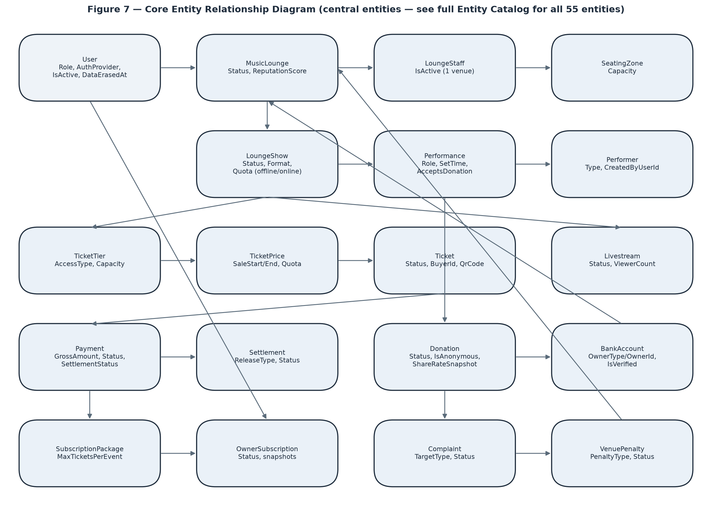
Figure 7 — Core Entity Relationship Diagram.
Entities Description
# | Entity | Description
1 | [Auth & User] User | Identity for every role (Audience/Staff/Owner/Admin); local or Google auth, DSAR erasure fields, brute-force lockout fields.
2 | [Venue] MusicLounge | A venue ("lounge"); state machine status, cached reputation score, optional 3D model, business license.
3 | [Venue] LoungeStaff | Assignment of one User as Staff to one venue; unique-active-per-user constraint.
4 | [Venue] SeatingZone | A named seating area with a real physical (fire-code) capacity, reused across a venue's shows.
5 | [Venue] VenueTourScene | One 360° panorama image — one stop in the virtual tour; flags AI-assisted completion for legal disclosure.
6 | [Venue] VenueTourHotspot | A clickable point inside a scene — navigates to another scene or shows an info popup.
7 | [Venue] VenueTourStitchAttempt | Log of one photo-stitching attempt (not just the final result), including the independent AI gap-fill outcome.
8 | [Venue] LoungeGalleryImage | One showcase photo for the venue's public gallery.
9 | [Venue] VenuePenalty | One penalty event against a venue; state machine incl. appeal fields.
10 | [Taxonomy] MusicGenre / Mood / VenueAtmosphere | Three independent, Admin-managed platform-wide tag catalogs, shared by shows, performers and user preferences.
11 | [Taxonomy] EventCategory | Admin-managed event category tag.
12 | [Taxonomy] CustomCriteria | A venue-defined (not global) recommendation-criteria tag with a typed value schema.
13 | [Taxonomy] EventCustomValue | One show's concrete value for a CustomCriteria.
14 | [Taxonomy] UserCustomPreference | One user's interest level in a CustomCriteria — explicit (self-set) or learned (AI-inferred, exponential moving average).
15 | [Show] LoungeShow | One concrete performance; the central state machine of the whole system (Draft→Pending→Published→Ongoing→Ended/Cancelled).
16 | [Show] LoungeShowRating | An audience rating for a show; can be soft-removed by Admin for a violation.
17 | [Show] EventModeration | A moderation case for one target (Show/Livestream/GalleryImage/TourScene) with AI score and Admin decision.
18 | [Show] Performance | One performer's slot within one show's line-up; carries donation-eligibility per slot, not per performer.
19 | [Show] AiPosterGeneration | Log of one AI poster-generation attempt; only a Succeeded attempt counts against the monthly quota.
20 | [Performer] Performer | Platform-wide performer catalog entry; no login of its own.
21 | [Performer] PerformerSocialLink | One social-platform link for a performer.
22 | [Ticket] TicketTier | A priced tier of access (Physical or Livestream) for one show.
23 | [Ticket] TicketPrice | One pricing window for a tier — supports the venue-specific "price by time slot" pattern.
24 | [Ticket] Ticket | One real ticket, GUID-keyed against ID guessing; nullable buyer for walk-in sales.
25 | [Ticket] TicketHold | A temporary 15-minute reservation before payment.
26 | [Ticket] PhysicalTicketDetail | 1-to-1 extension of Ticket for in-person tickets — seat info, who sold it, check-in timestamp.
27 | [Ticket] LivestreamTicketDetail | 1-to-1 extension of Ticket for online tickets — access token, first/last access timestamps.
28 | [Finance] Account (ledger_accounts) | A double-entry bookkeeping account (Gateway/Platform/Tax/User/Performer), not a bank account.
29 | [Finance] LedgerEntry | One append-only bookkeeping line; every journal must balance (SUM debit = SUM credit).
30 | [Finance] Payment | One VNPay transaction with the full fee/tax/net breakdown and idempotency key.
31 | [Finance] Donation | One tip to one performance; 5-state lifecycle, snapshots the performer's share rate and privacy toggles at confirmation time.
32 | [Finance] Settlement | One payout tranche to an Owner from ticket revenue; two-tranche release policy tied to venue reputation.
33 | [Finance] RefundRequest | A refund request that can be partially approved.
34 | [Finance] BankAccount | A payout account, polymorphic across venue or performer ownership; must be Admin-verified before use.
35 | [Finance] SubscriptionPackage | An Owner subscription plan; immutable once anyone has subscribed to it.
36 | [Finance] OwnerSubscription | One Owner's subscription instance; snapshots the plan's benefits at signup so later plan edits don't retroactively change it.
37 | [Livestream] Livestream | One broadcast tied to a show; distinguishes a natural End from an enforced Terminate.
38 | [Livestream] LivestreamChatMessage | One chat message in a livestream.
39 | [F&B] FnbMenu / FnbMenuItem | A venue's menu and its items.
40 | [F&B] FnbOrder / OrderItem | One order and its line items; unit price is snapshotted at order time.
41 | [Recommendation] AiRecommendation | One scored show recommendation for one user, with an explainable reason string.
42 | [Recommendation] UserBehaviourLog | One raw behaviour event, retained 6 months.
43 | [Recommendation] UserEventScore | The aggregated User↔Show interest-score matrix, broken down by signal type.
44 | [Recommendation] UserFavouriteGenre / Mood / Atmosphere | Explicit user taste tags.
45 | [Notification] Notification | One notification to one user, with deep-link reference fields.
46 | [Notification] DeviceToken | One Firebase Installation ID for push delivery.
47 | [Follow] Follow / ShowWishlist | A user following a venue / wishlisting a show.
48 | [Security & Ops] LoginFailureLog / LoginSpikeAlertState | Short-retention failed-login tracking feeding the credential-stuffing detector.
49 | [Security & Ops] KnownAdminSnapshot | Baseline of recognised Admin accounts, since no API path exists to create one.
50 | [Security & Ops] PushFailureLog / PushFailureAlertState | System-level push-delivery failure tracking, distinct from a single device going stale.
51 | [Complaint] Complaint | A complaint against any target type, nullable complainant for guest reporters.
52 | [Config] SystemConfig / SystemConfigHistory | Every tunable business parameter, keyed by name, so no business rule is hardcoded.
53 | [Upload] UploadedFile | Tracks who uploaded a file, for authorised deletion.
54 | [Show] LoungeShowGenre / LoungeShowMood / LoungeShowAtmosphere | Three many-to-many join rows linking one LoungeShow to a MusicGenre / Mood / VenueAtmosphere tag respectively — the tables behind a show's genre/mood/atmosphere badges.
55 | [Performer] PerformerGenre | Many-to-many join row linking one Performer to one MusicGenre tag — the table behind a performer's genre badges.
56 | [Venue] LoungeImage | One venue image slot (hero/profile image, set via PUT /lounges/{id}/image) — distinct from LoungeGalleryImage (multiple showcase photos) and VenueTourScene (360° panoramas).
Detailed Function Design
The 11 features below were chosen to cover the system's full value chain end-to-end (account → venue → show → ticket → livestream/donation → payment → moderation → complaint → F&B → subscription → AI). Documenting all 75 screens at this depth was judged not to add proportional value for a capstone-scale report; the remaining screens are already fully specified by purpose, content, actions and states in §3.1.2–3.1.6 and in the companion UI design brief (Stitch-Master-Brief.md), which each function below cross-references for its screen layout instead of repeating a mock-up here.

3.2 Authentication & Account Lifecycle

3.2.1 Register & Verify Account
Function trigger: User submits the Sign Up form; system enqueues an OTP email job.
Function description: Actors: Guest → Audience/Owner. Creates a User row with the chosen role (only Audience/Owner may self-register — Staff is assigned by an Owner, Admin exists only via direct database provisioning). The account cannot log in until EmailVerifiedAt is set by a correct, unexpired OTP.
Business rules & validation:
• Password is hashed, never stored or logged in plain text.
• Duplicate email is rejected at registration, not silently merged.
• Wrong/expired OTP shows a specific error; correct OTP sets EmailVerifiedAt and allows the first login.
• Resend OTP is rate-limited to prevent email-bombing a target address.

3.2.2 Log In
Function trigger: User submits email/password or completes Google OAuth.
Function description: Validates credentials, checks account-state gates in order — EmailVerifiedAt not null, LockedUntil not in the future, IsActive true, DataErasedAt null — before issuing a JWT. A Staff login additionally attaches the lounge_id claim from the current active LoungeStaff assignment, if any.
Business rules & validation:
• Wrong email and wrong password return the exact same generic message (anti user-enumeration) — never reveal which field was wrong.
• Failed attempts increment FailedLoginAttempts; crossing the configured threshold sets LockedUntil for a cool-down window (brute-force protection), tracked in system_config, not hardcoded.
• A Staff account whose LoungeStaff assignment was deactivated still logs in successfully but receives no lounge_id claim — every venue-scoped action then fails authorization, which is the intended "access revoked" behaviour.

3.2.3 Recover Password
Function trigger: User submits an email on the Forgot Password screen, then opens the emailed link.
Function description: Step 1 always returns the same generic "check your email" response whether or not the address is registered (anti-enumeration). Step 2 validates a single-use, time-limited token from the query string and sets a new password hash.
Business rules & validation:
• Reset token is single-use and expires after a short configured window.
• Setting a new password rotates SecurityStamp, which invalidates every JWT issued before the reset — a genuine "log out everywhere" side effect users should be told about.

3.2.4 Erase My Data (DSAR)
Function trigger: Authenticated user submits Delete My Data with password re-confirmation (local accounts) or a confirmation-only step (Google accounts).
Function description: Anonymises the User row in place — this is never a hard delete, because linked financial records (tickets, payments, donations) must be retained for the Vietnamese Accounting Law's 10-year window. Sets DataErasedAt, IsActive=false, PasswordHash=null, EmailVerifiedAt=null, and rotates SecurityStamp — three independent mechanisms that each, on their own, would already block the account.
Business rules & validation:
• Irreversible — no code path restores an erased account.
• Every active JWT is revoked immediately via the SecurityStamp rotation, not on next expiry.
• Foreign keys from historical rows (tickets.buyer_id, donations.donor_user_id, event_ratings.user_id, complaints.complainant_user_id) are configured ON DELETE SET NULL so those rows survive as anonymous history.

3.3 Venue Registration & Approval

3.3.1 Create a Venue
Function trigger: Owner submits the Create Venue form.
Function description: Creates a MusicLounge row at Status=Pending. An Owner may create and freely edit the venue profile at this stage, but cannot submit any show for review until the venue itself is approved.
Business rules & validation:
• Business license upload is required before submission for review.
• A venue at Pending or Rejected cannot have a show moved past Draft (PublishLoungeShowCommandHandler gate).

3.3.2 Approve / Reject a Venue
Function trigger: Admin reviews an item in the Pending Venues queue.
Function description: Admin sets Status=Approved or Rejected with a reason. Approval is the single gate that unblocks every other Owner venue action (show creation, staff assignment downstream effects, etc.).
Business rules & validation:
• Rejected has no resubmit path by design — the Owner must create a new venue record, not amend the rejected one, keeping the rejection reason attached to an immutable record.
• A venue can later move to Warned/Suspended/Locked via the penalty workflow independently of this initial approval.

3.4 Show Creation & Lifecycle

3.4.1 Create / Submit a Show for Review
Function trigger: Owner fills the Create Show form and clicks Submit for Review from the Show Control Center.
Function description: Validates the venue is Approved and at least one TicketTier exists before moving Status from Draft to Pending. Building the line-up: typing a performer name with no catalog match silently creates a new Performer profile at submit time, attributed to the current Owner via CreatedByUserId.
Business rules & validation:
• An Owner without an active subscription is blocked from submission with an explanatory banner, not a late-stage error.
• Ticket-tier total capacity is capped by the Owner's subscription plan MaxTicketsPerEvent — enforced at the same submission gate.

3.4.2 Change Show Format / Cancel a Show
Function trigger: Owner triggers Change Format or Cancel Show from the Show Control Center.
Function description: In-person → online is one-way and automatically refunds 100% of every confirmed in-person ticket. Cancel refunds 100% of every confirmed ticket regardless of format, and is blocked outright while a livestream attached to the show is actively broadcasting — that must be Terminated/Ended first.
Business rules & validation:
• Both actions create RefundRequest rows in bulk, which then flow through the normal Admin refund-approval queue rather than being paid out instantly.
• Both are flagged in the source view catalog as needing a stronger confirmation step than a plain "Are you sure?" given the blast radius — an open UX decision, not yet finalised.

3.5 Ticket Purchase & Check-In

3.5.1 Hold & Pay for a Ticket
Function trigger: Audience selects a tier/quantity and clicks Hold on Select Tickets.
Function description: Creates a TicketHold with ExpiresAt = now + configured window (default 15 minutes) against a specific TicketPrice, decrementing available quota for the hold's duration. Continuing to payment redirects to VNPay; a successful IPN callback confirms the linked Ticket(s) (Status=Confirmed) and generates the entry QR.
Business rules & validation:
• An expired, unpaid hold is released back to quota by the Release Expired Holds background job — no user action required.
• Quota is decremented at hold time, not at payment time, to prevent overselling during the payment window.
• A tier can define multiple concurrent TicketPrice windows with different sale start/end and channel (Online/Offline/Both) — the venue-specific "price by time slot" rule.

3.5.2 Check In a Ticket at the Door
Function trigger: Staff scans a ticket's QR code in the Check-In Scanner.
Function description: Resolves the QR to a Ticket, evaluates eligibility (Confirmed status, correct show, not already used, not mid-transfer), and shows a preview before Staff explicitly confirms — scan and commit are two separate steps.
Business rules & validation:
• A ticket is valid for the whole evening, not a fixed time window — there is no "too early/too late" rejection reason (BR: full-night validity, this domain's core departure from cinema-style ticketing).
• Each rejection reason is surfaced distinctly: already used, wrong show, online-only ticket presented at a physical door, or frozen mid-transfer.
• There is no offline fallback — a dropped connection must be shown honestly, never silently treated as a successful check-in.

3.6 Livestream & Real-Time Donation

3.6.1 Watch a Livestream
Function trigger: Audience opens the Live Viewing Room for a show that is Ongoing.
Function description: LivestreamAccessPolicy evaluates the caller: a genuine ticket holder (Confirmed ticket for this show, LivestreamTicketDetail present) within the concurrent-device session limit (default 2 devices per ticket) is admitted; the assigned venue operator (Owner/Staff via RequireVenueOperator) is always admitted; Admin is always admitted and additionally sees a Force-Stop control.
Business rules & validation:
• A rejected connection must show the specific reason (no ticket, device-limit exceeded) — never a blank or frozen player.
• A plain network hiccup should retry quietly and must not be confused in the UI with an access rejection.
• Viewer count shown on the Owner/Staff Livestream Operations screen is a manual-refresh figure, not a live-updating counter.

3.6.2 Donate to a Performer
Function trigger: Audience opens Donate on a performer in the current line-up during the Live Viewing Room.
Function description: Only performers whose current Performance has AcceptsDonation=true are offered. Creates a Donation at PendingPayment, redirects to VNPay; on confirmation the platform commission (default 5%) and tax (default 5%) are deducted from the gross and credited to the ledger, and the PerformerShareRateSnapshot — the share of the ORIGINAL gross the Owner must later forward to the performer (default 88%) — is frozen from the current system_config value, independent of later config changes. The Owner retains the remaining ~2% of gross for handling the payout.
Business rules & validation:
• Status then advances PendingOwnerAck → OwnerReceived (manual or 24h auto-confirm) → PerformerPaid (manual, evidence photo attached) — a real multi-day pipeline the My Donations screen must represent honestly, not as a single "done/not done" flag.
• Anonymity, amount-hiding and message-publishing are three independent toggles captured at donation time.
• The public transparency feed (GET /donations/public) only ever shows OwnerReceived/PerformerPaid rows — a donation still at PendingOwnerAck can still be Cancelled/Refunded and is deliberately excluded until it is a settled fact, the same "pending vs. posted" pattern used by banking statements.

3.7 Payment, Settlement & the Ledger

3.7.1 Process a VNPay Payment
Function trigger: Any payment-triggering action (ticket purchase, donation, subscription) redirects to VNPay; VNPay calls back via return-URL and IPN.
Function description: Every confirmed Payment writes a balanced double-entry LedgerEntry set (SUM debit = SUM credit per JournalId), split into GrossAmount / GatewayFee / PlatformFee / TaxWithheld / NetAmount. IdempotencyKey guards the IPN callback against VNPay's documented at-least-once delivery, so a duplicate notification cannot double-credit an account.
Business rules & validation:
• Reconciliation against VNPay's own records runs as a recurring background job, not only on the inbound callback, to catch any silently missed notification.
• TaxWithheld reflects Decree 117/2025's withholding-tax requirement on the relevant payment types.

3.7.2 Release a Settlement Tranche
Function trigger: The Release Due Settlements background job runs on schedule.
Function description: Pays an Owner's share of ticket revenue in two tranches: Partial70 releases on a fixed short delay after the payment (~T+48h) at a rate keyed to the venue's ReputationScore tier; Final30 releases later (~T+14d) unless the show's actual duration fell under 70% of its scheduled length (configurable SettlementCompletionThresholdPct), in which case it moves to PendingReview for a human Admin decision instead of auto-releasing.
Business rules & validation:
• Partial70 is never subject to the completion-ratio check — only Final30 is.
• A cancelled or refunded show cancels its linked Settlement rows rather than releasing them.

3.8 Content Moderation & Venue Penalties

3.8.1 Moderate a Show / Livestream
Function trigger: Owner submits a show/livestream that requires review; Admin opens the Moderation Queue.
Function description: Score Moderation with AI (Gemini) produces an EventModeration risk score and recommendation as a suggestion only — Admin retains full discretion to approve or reject against the AI's recommendation. A written note is required on rejection, optional on approval.
Business rules & validation:
• Approving a show makes it public to Audience immediately; approving a livestream unlocks its Start Broadcasting control on the Owner/Staff side — the moderation decision is the actual gate, not a formality.
• SLA: 24 hours (Decree 147/2024), with an internal warning alert once ~20 hours have elapsed unreviewed.

3.8.2 Issue & Appeal a Venue Penalty
Function trigger: Admin issues a penalty from evidence; Owner appeals from My Penalties & Appeals.
Function description: A Warning applies immediately; Suspension/Ban apply once EffectiveAt is reached (handled by the Apply Due Venue Penalties job, giving a grace/notice period). An Owner appeal moves the penalty to Appealed; Admin Overturns (venue returns to Approved) or Upholds; an appeal Admin never reviews within 48 hours is auto-overturned by a background job.
Business rules & validation:
• An overturned penalty does not automatically clear other overlapping active penalties on the same venue, nor reverse a financial side-effect such as an extended subscription — those need separate manual follow-up today.
• The distinction between an Admin-reviewed overturn and an SLA-timeout auto-overturn is preserved in the record, since an Owner might reasonably ask why in one case and not the other.

3.9 Complaint Handling

3.9.1 File & Resolve a Complaint
Function trigger: Anyone — including a Guest — submits File a Complaint; Admin resolves it from the Resolve Complaints queue.
Function description: A logged-in complainant is linked via ComplainantUserId; a Guest instead supplies a ContactPhone and receives a reference number for later lookup (no account exists to log back into). Resolution requires a status, a resolution note, and — where relevant — a ResolvedAction that can trigger further automation.
Business rules & validation:
• Refund/Compensate against a ticket auto-creates a RefundRequest, which still needs its own separate approval in the Refund Requests queue.
• Refund/Compensate against a donation does not automatically do anything — Admin must separately use Reverse a Donation.
• TakeDownContent against a show cancels the show outright and refunds 100% of confirmed tickets — the heaviest of the available resolution actions.
• A guest complainant is notified of the outcome by SMS only; there is no in-app channel to reach them.

3.10 F&B Ordering

3.10.1 Place & Progress an F&B Order
Function trigger: Audience (mobile app) or Staff (order-on-behalf) places an order; Staff advances it on the Order Board.
Function description: An order can optionally attach to a specific show (ShowId nullable — F&B sales continue outside show hours) and is attributed to either an AudienceUserId (self -service) or a StaffId (ordered on the customer's behalf) — never both. Status advances through a fixed sequence.
Business rules & validation:
• Sequence is strictly Pending → Preparing → Served → Paid, with Cancel available as a side-exit at any point before Paid — the UI offers exactly one "next step" action, never a free-choice status dropdown.
• UnitPrice is captured on OrderItem at the moment of ordering and is never recalculated even if the menu price changes later.
• Marking Paid is a status flag only — it does not verify that money actually changed hands, so no payment-confirmation ceremony belongs around that action.
• The customer's own order-tracking screen has no live push channel to staff status updates — it is manual pull-to-refresh only.

3.11 Subscription Plans

3.11.1 Subscribe, Renew & Cancel a Plan
Function trigger: Owner acts from My Subscription / Subscription Plans.
Function description: Subscribing while an active OwnerSubscription already exists is blocked — Cancel first. At signup, the plan's benefit fields (MaxTicketsPerEvent, HasAiPoster/MaxAiPostersPerMonth, MaxTourScenes) are copied onto the OwnerSubscription as an immutable snapshot.
Business rules & validation:
• If Admin later edits the underlying SubscriptionPackage, every Owner already subscribed keeps their original snapshot — plan edits are never retroactive.
• Renew always requires a fresh one-time VNPay payment; nothing auto-charges.
• A Suspension penalty on the venue extends ExpiresAt to compensate the Owner for lost operating time during the suspension.

3.12 AI-Assisted Recommendation & 360° Tour

3.12.1 Generate Personalised Recommendations
Function trigger: The Refresh Recommendations background job runs on schedule, or Refresh User Recommendation runs on an explicit preference change.
Function description: FinalScore is computed from three inputs — ContentScore (taste-tag match), CollabScore (similar-user behaviour), and CustomScore (venue-specific CustomCriteria match) — with an explainable Reason string attached to every recommendation, not a black-box number.
Business rules & validation:
• Nothing is logged to UserBehaviourLog, and no personalised feed is produced, for any user with AiConsent=false (opt-out by default per BVDLCN 2025) — the For You screen falls back to a generic Trending feed for that user instead.
• Every recommendation carries an ExpiresAt and is refreshed rather than accumulated indefinitely.

3.12.2 Build a 360° Venue Tour
Function trigger: Owner uploads a pre-stitched panorama, or submits several room photos via Auto-Stitch.
Function description: Auto-Stitch enqueues Stitch Venue Tour Scene, which calls the standalone Python/OpenCV microservice over HTTP (kept out-of-process specifically to isolate its native-binary/OS dependency risk from the .NET host). A VenueTourStitchAttempt row logs every try, not just the final image.
Business rules & validation:
• The job typically takes 15–30+ seconds — the UI must show a processing state, not a spinner implying near-instant completion, with a clear failure reason and retry on failure.
• An independent, optional AI gap-fill step (TourCompletionStatus) can fail without failing the underlying stitch attempt itself — the two outcomes are tracked separately.
• Scene count is hard-capped by the Owner's subscription plan (MaxTourScenes); the gallery feature nearby has no such cap.

4. Non-Functional Requirements

4.1 External Interfaces
The platform integrates eight external systems, one internal microservice, and the Azure services it is deployed onto — see Figure 1 (§1) for the context diagram. Each integration's failure mode and its fallback behaviour, where one exists, is noted against the relevant function in §3.2.
System | Role | Notes
VNPay | Payment Gateway | The sole payment intermediary for ticket purchases, donations and subscriptions. The platform never touches card data — the customer is redirected to VNPay and returns with a signed result, with an independent server-to-server IPN callback as the authoritative confirmation.
Mux / Cloudflare Stream | Live Video Platform | RTMP ingest for Owner/Staff broadcasting and HLS playback for viewers. The two providers sit behind one provider-factory abstraction so either can be selected per environment without changing application code.
Firebase Cloud Messaging | Push Notification | Delivers push notifications to registered device tokens on the two mobile applications; delivery failures are logged and a persistently failing token is pruned automatically.
Google OAuth | Identity | Social sign-in alternative to local email/password accounts, available on all five client surfaces.
Google Maps | Geolocation | Venue address display on the Audience Website and map-based location picking during venue setup on the Owner Dashboard.
SpeedSMS | SMS Gateway (Vietnam) | OTP and notification SMS delivery inside Vietnam — replaced an earlier Twilio integration that could not reliably deliver to Vietnamese numbers.
Gemini | AI Services | Three independent uses: risk-scoring input to the two-layer AI-plus-Admin moderation decision, show-poster image generation, and feature scoring for the recommendation pipeline. Every call degrades gracefully — a neutral score rather than a blocked request.
OpenAI | AI Services (alternate) | Alternate image-generation provider for show posters, behind the same interface as Gemini so the two are interchangeable per environment.
Panorama Stitcher | Internal Microservice (Python / OpenCV + Hugin) | A standalone HTTP microservice rather than an external vendor, kept out-of-process specifically so its native image-processing binaries cannot destabilise the .NET host; a stitching failure degrades one feature instead of the whole API.
Azure App Service | Cloud Hosting — API | Hosts the ASP.NET Core API and its SignalR hubs, with deployment slots used for zero-downtime releases.
Azure SQL Database | Cloud Hosting — Data | Managed SQL Server instance holding the transactional database and the Hangfire job store, with automated backups and point-in-time restore.
Azure Container Apps | Cloud Hosting — Microservice | Runs the containerised panorama-stitching service, scaled independently of the API since stitching is bursty and CPU-bound.
Azure Static Web Apps | Cloud Hosting — Web Clients | Serves the three React web surfaces (Audience Website, Owner Dashboard, Admin Console) as static bundles from the edge.
Azure Blob Storage + CDN | Media Storage & Delivery | Stores uploaded images, business-licence documents, show posters and 360° panoramas; the CDN fronts public media so image delivery does not consume API capacity.
Azure Key Vault | Secrets Management | Holds connection strings, gateway credentials and API keys; no secret is stored in source control or in an application settings file that ships with the build.
Azure Application Insights + Monitor | Observability | Request/dependency telemetry, structured logs, background-job outcomes, and the alert rules that page the team on a failed job or an error-rate spike.

4.2 Quality Attributes

4.2.1 Usability
• Every conditional action (Buy Tickets, Watch Live, Rate, Transfer/Cancel Ticket, Generate Poster, Force-Stop) must be shown or hidden based on real eligibility, never shown-then-rejected — a user should not be able to tap a button that was always going to fail.
• Destructive or financially consequential actions (Cancel Show, Change Format, Delete My Data, Reject a refund) require a deliberate confirmation step proportional to their blast radius, not a single generic "Are you sure?" for everything.
• Every empty state (no search results, no notifications, no donations yet) must be visually distinct from a loading skeleton and from an error state — three different conditions, three different presentations.
• The anti-enumeration error messages (login, forgot-password) and the countdown-driven ticket hold timer are the two places where the exact wording/prominence is a deliberate security or product decision, not an incidental copy choice, and must not be "cleaned up" away in a later redesign without re-confirming the reasoning in this document.
• Supported browsers for the three web surfaces are the current and previous major versions of Chrome, Edge, Firefox and Safari; the two mobile applications support Android 10 and later and iOS 15 and later.
• The Audience Website is responsive across three breakpoints — phone (≤480px), tablet (481–1024px) and desktop (>1024px). The Ticket Detail QR screen and Log In in particular must remain fully usable at phone width, since those are the two most likely to be opened on a phone at the venue door. The Owner Dashboard and Admin Console are desktop-first and are not required to be usable below 1024px.
• All three web surfaces meet WCAG 2.2 Level AA: every interactive control is reachable and operable by keyboard alone with a visible focus indicator, form fields carry programmatic labels and errors are announced to assistive technology, and text contrast is at least 4.5:1 (3:1 for large text and meaningful icons).
• No information is conveyed by colour alone — ticket, show, donation and moderation statuses each carry a text label or icon in addition to their colour, so the state remains legible to a colour-blind user and in a printed or screenshotted view.

4.2.2 Reliability
• Content-moderation takedown SLA: 24 hours from submission (Decree 147/2024), with an internal warning once ~20 hours have elapsed unreviewed (ModerationSlaBreachAlertJob).
• Penalty-appeal review SLA: 48 hours; an appeal Admin does not review in time is auto-overturned by AutoApproveOverdueAppealsJob rather than left stuck.
• Donation acknowledgement: Owner has 24 hours to manually acknowledge receipt before the system auto-confirms on their behalf.
• Donation-to-performer-payout escalation: a notification at 7 days unpaid, a venue penalty (Warning) at 14 days unpaid.
• All of the SLA values above are configuration-driven via system_config, never hardcoded — changing one is an operational action, not a code change.
• The livestream check-in and door check-in paths have no offline fallback by explicit, accepted design choice — a dropped connection must fail visibly rather than silently appearing to succeed.

4.2.3 Performance
• Ticket-hold and seating-zone-capacity enforcement are the system's most concurrency-sensitive paths — a real venue's fire-code occupancy limit must never be oversold under concurrent load, which this project treats as a safety property (ISO/IEC 25010:2023 Safety characteristic), not merely a performance nicety.
• The realistic peak-load shape to design and test for is a ticket on-sale spike (many concurrent Hold requests against one tier the instant sales open) and a concurrent livestream audience combined with real-time chat and the donation ticker for a popular show.
• Viewer counts, F&B order-board status for the customer's own tracking screen, and background-job outcomes are all explicitly manual-refresh, not real-time-guaranteed — this is a deliberate scope boundary that keeps the truly real-time surfaces (chat, the donation ticker, livestream video) held to a tighter latency bar without over-promising elsewhere.
• API response-time targets under normal load: 95th-percentile under 500 ms for read requests and under 1 second for write requests, measured at the API rather than in the browser.
• Frontend performance budget for the web surfaces on a mid-range device over a 4G connection: Largest Contentful Paint under 2.5 seconds, Interaction to Next Paint under 200 ms, and an initial JavaScript bundle under 250 KB compressed per surface, with route-level code splitting so a visitor browsing shows never downloads the seating-zone editor.
• Long-running work never blocks a request: panorama stitching, AI poster generation, moderation scoring and settlement release all run as background jobs, and the screen that triggered them shows an explicit processing state rather than a spinner implying near-instant completion.

4.2.4 Security
• Authorization is checked in three layers on every request that touches one venue's data: JWT role → policy (RequireAuthenticated/RequireVenueOperator/RequireOwner/RequireAdmin) → venue-scoping (CanOperate: Admin, or Staff whose JWT lounge_id claim matches, or Owner whose id matches the venue's OwnerId read fresh from the database).
• There is deliberately no API path to create or promote an Admin account — every Admin exists only via a direct database edit, and AdminRoleDriftDetectionJob alerts if one appears outside the known baseline, treated as a possible compromise indicator rather than a normal event.
• Login responses never reveal which of email/password was wrong; password-reset requests never reveal whether an email is registered — both are deliberate anti-enumeration decisions, evaluated against the current OWASP ASVS 5.0.0 authentication requirements.
• Brute-force login attempts are throttled by a failed-attempt counter plus a temporary lockout window, and cross-account credential-stuffing patterns from one IP are separately detected by a background job (LoginSpikeDetectionJob).
• PII fields (ID document photos, citizen ID number) are served only through protected, non-guessable endpoints — never a plain public URL — and citizen ID numbers are stored encrypted with a separate hash column for lookup/comparison.
• This system is a security-testing subject in its own right — see the companion OWASP ASVS 5.0.0 audit trail maintained alongside this codebase for the current pass/fail status of each requirement category.

4.2.5 Compliance
• Payment intermediation: VNPay only, per Decree 52/2024 — direct card handling is out of scope by design.
• Withholding tax on qualifying payment types is tracked per Decree 117/2025 (Payment.TaxWithheld, a dedicated tax ledger account).
• Content-takedown SLA and phone verification: Decree 147/2024 (24-hour moderation SLA, PhoneVerified field).
• Mandatory complaint channel: Decree 85/2021 — the Complaint entity and its guest-accessible filing/lookup path exist specifically to satisfy this obligation, not as a generic support feature.
• Personal data protection: Law 91/2025/QH15 (BVDLCN 2025) — AI-consent default opt-out (AiConsent=false), the DSAR export/erase pair, and PII anonymise-in-place-not-hard-delete erasure design that must still satisfy the Accounting Law's 10-year financial-record retention requirement at the same time.
• Performance licensing and music-copyright royalty: performance-permit reference and VCPMC royalty reference fields are hard requirements before a livestream may start.

4.2.6 Maintainability
• Backend follows Clean Architecture across four projects (Domain, Application, Infrastructure, Api) with CQRS via MediatR — see Report 4 (Software Design Document) for the full architecture and package diagrams.
• Every business-tunable number (SLA windows, hold duration, donation-split percentage, settlement thresholds) lives in system_config rather than being hardcoded, so operational tuning does not require a code deployment.
• The five client surfaces share one REST + SignalR backend; splitting the UI into five separate apps is a documented product decision (platform-architecture.md), not a technical constraint — a future surface (e.g. a unified super-app) remains technically possible without a backend rewrite.
• Every tier is deployed from source by the same CI/CD pipeline — no manual build is copied to a server by hand — and all environment-specific configuration and secrets are supplied at deploy time from Azure Key Vault rather than baked into a build, so the same artefact can be promoted from staging to production unchanged.

5. Requirement Appendix

5.1 Business Rules
ID | Rule Definition
BR-01 | A new venue starts at Pending and cannot submit any show for review until an Admin approves it; Rejected has no resubmit path — a new venue record is required.
BR-02 | A seating zone's Capacity is a real physical (fire-code) occupancy limit — it hard-caps ticket sales for that zone, not merely a sales target.
BR-03 | A ticket is valid for the entire evening of the show, not a fixed arrival time window — door check-in never rejects a ticket for being "too early" or "too late."
BR-04 | Walk-in ticket sales may continue after a show has already started.
BR-05 | A ticket tier may define multiple concurrent pricing windows (different sale-start/end, different sales channel), at the Owner's discretion.
BR-06 | A ticket hold reserves quota for 15 minutes by default (configurable via system_config); an unpaid hold past its expiry is released back to quota automatically.
BR-07 | A Staff account is scoped to exactly one active venue at a time; deactivating the assignment takes effect on the account's next login, not instantly.
BR-08 | Walk-in (counter) ticket sales earn no platform commission by default — the platform's revenue for those sales instead comes from the Owner's subscription fee. A config toggle exists to change this later.
BR-09 | A donation's gross splits into 4 system_config-driven shares at confirmation: platform commission (default 5%), tax (default 5%), performer payout (default 88% of gross, frozen onto the donation as PerformerShareRateSnapshot), and the remainder (~2% of gross) retained by the Owner for handling the payout — later config changes never alter already-confirmed donations.
BR-10 | Donation funds pass through Owner acknowledgement (auto-confirmed after 24 hours if not manual) before being marked paid out to the performer — donations are never paid directly performer-side.
BR-11 | The public donation transparency feed shows only settled donations (OwnerReceived/PerformerPaid) — a donation still pending owner acknowledgement can still be cancelled or refunded and is deliberately excluded until settled.
BR-12 | Settlement to an Owner releases in two tranches: Partial70 on a short fixed delay, Final30 later, at a rate keyed to the venue's reputation tier; Final30 is withheld for manual review if the show's actual duration falls under 70% of its scheduled length.
BR-13 | A bank account (venue or performer payout target) must be Admin-verified before any settlement or donation payout depending on it can proceed.
BR-14 | A subscription plan's benefit fields are immutable once anyone has subscribed to it; an Owner's subscription snapshots those benefits at signup and is unaffected by later plan edits.
BR-15 | A venue's active subscription is required before the Owner can submit any show for review.
BR-16 | Changing a show's format from in-person to online is one-way and automatically refunds 100% of confirmed in-person tickets.
BR-17 | Cancelling a show refunds 100% of confirmed tickets and is blocked while an attached livestream is actively broadcasting — the stream must be ended/terminated first.
BR-18 | A livestream may not start broadcasting until both an independent, livestream-specific Admin content review has cleared and the show's VCPMC music-royalty reference has been filled in — both conditions, checked and surfaced separately.
BR-19 | Livestream access for a ticket holder is capped at a configurable number of concurrent devices per ticket (default 2).
BR-20 | A ticket may be transferred only while Confirmed, never checked in, never yet used to access a livestream, and only before the show has ended or been cancelled.
BR-21 | Content moderation for shows and livestreams uses an AI risk score as an advisory input only — final approve/reject discretion always rests with Admin.
BR-22 | A venue penalty's Suspension/Ban effect applies only once its configured effective-date delay elapses, giving the Owner an advance-notice window before the restriction actually bites.
BR-23 | An overturned penalty appeal does not automatically clear other overlapping active penalties on the same venue, nor reverse a related financial side-effect (such as an extended subscription) — those require separate manual action.
BR-24 | There is no API or self-service path to create or promote an Admin account — every Admin today exists only via a direct database edit, monitored by a drift-detection background job.
BR-25 | A performer profile may be edited or deleted only by the Owner who created it, or by Admin; deletion is blocked outright once the performer has ever been booked into any show, past or present.
BR-26 | AI-driven personalisation (recommendations, behaviour logging) is opt-out by default — a user must explicitly enable AI consent before any personalised profile is built from their behaviour.
BR-27 | Erasing a user's personal data (DSAR) anonymises the User row in place — it is never a hard delete, since linked financial records must be retained for the Accounting Law's 10-year window; the action is irreversible and immediately revokes every active session.
BR-28 | F&B order status advances only through the fixed sequence Pending → Preparing → Served → Paid (with Cancel available up to Paid) — never a free-choice status change.
BR-29 | An F&B order-item's unit price is fixed at the moment of ordering and is never recalculated even if the menu's price changes afterward.
BR-30 | A guest (no account) complainant is identified by a system-issued reference number plus the phone number supplied at filing, and is notified of the outcome by SMS only — there is no in-app channel back to a guest.

5.2 Common Requirements
The following items were surfaced while building the UI design brief that accompanies this SRS (Stitch-Master-Brief.md / View-Design-Spec.md) by reading the current backend implementation screen-by-screen. They are split into two kinds that need two different audiences to resolve, and are carried into this document so they are not lost between the UI-design track and the backend-requirements track.
Backend gaps (ask the dev/BE team):
• Bank-account verification and donation-refund (Admin) have action endpoints (POST /admin/bank-accounts/{id}/verify, POST /admin/donations/{id}/refund) but no endpoint listing the pending queue — unlike every other approval flow in the system, which pairs an action endpoint with a GET .../pending list. Needs a decision: add the missing list endpoint, or confirm this is intentionally a rare, id-known action with no list UI needed.
• Penalty-appeal review (Admin) has the same shape of gap — no GET listing every currently-open appeal; an appeal is reachable only by an id already known (typically from a notification).
UX decisions needed (ask the design/PM team):
• Donate and Rate Show: currently designed as modals over the Live Viewing Room / Show Detail respectively (keeping the video/context visible) — confirm this over a full page navigation, which risks losing the SignalR/video connection on return.
• File a Complaint: opened from several different contexts (ticket/show/venue) — a context-prefilled modal is proposed, but a guest's submission result (their only copy of the reference number) must not disappear if the modal is dismissed before they've saved it.
• Payment Result: one shared template is proposed for ticket, donation and subscription outcomes — confirm this over three purpose-built screens (e.g. a donation result that re-shows the performer, a ticket result that shows the QR immediately).
• Owner "My Shows"/"My Venues" management views vs. the public browse/search screens: GET .../lounge-shows?mine=true and GET .../lounges?mine=true reuse the exact same public endpoint as browsing — this brief assumes two separate dashboard-style pages; confirm against a single browse page with a "mine only" toggle instead.
• The public donation transparency feed's two variants (platform-wide with a full fee breakdown vs. one performer's amount-only history) are assumed to be one parameterised component — confirm against two fully separate layouts.
• Venue Extras (Gallery & Custom Criteria) are combined onto one settings view in the current brief for catalog brevity — confirm whether design wants these split into two separate tabs.
• Reset-password step 2 must be an independently addressable route/URL reachable from an emailed link (not a continued in-tab form session) — confirm the exact route pattern is agreed with the team building each client surface, and that deep-linking into it works on mobile where a client exists.
• Show Control Center actions with a large financial blast radius (Change Format, Cancel Show) are currently a single-step action with a warning banner — confirm whether a stronger confirmation (e.g. re-typing the show name or the affected ticket count) is required, as is common practice for other irreversible, large-scale financial actions.

5.3 Application Messages List
# | Message code | Message Type | Context | Content
1 | MSG-01 | Inline, form error | Wrong email or wrong password on Log In | Incorrect email or password. Please check and try again.
2 | MSG-02 | Inline banner | Password-reset request submitted, regardless of whether the email is registered | If that email is registered, a reset link has been sent.
3 | MSG-03 | Toast | Ticket hold created successfully | Ticket held — complete payment within 15:00 to keep it.
4 | MSG-04 | Inline banner | Ticket hold about to expire (< 2 minutes remaining) | Hurry — your hold expires in {mm:ss}. Complete payment now or it will be released.
5 | MSG-05 | Full-screen state | Livestream access rejected — no genuine ticket | You need a ticket for this show to watch the livestream.
6 | MSG-06 | Full-screen state | Livestream access rejected — device limit reached | This ticket is already being watched on the maximum number of devices.
7 | MSG-07 | Confirmation screen | Guest complaint submitted successfully | Your complaint has been recorded. Reference number: {complaintId} — save this and your phone number to check the status later.
8 | MSG-08 | Toast | Donation confirmed and delivered to the pipeline | Thank you — your donation is on its way to {performerName}.
9 | MSG-09 | Inline banner | Owner venue pending approval | Your venue is pending admin approval — you can't create shows yet.
10 | MSG-10 | Inline banner | Show submission blocked — no active subscription | An active subscription is required before you can submit a show for review.
11 | MSG-11 | Confirmation dialog | Change show format from in-person to online | This will automatically refund 100% of all confirmed in-person tickets and cannot be undone. Continue?
12 | MSG-12 | Inline banner | DSAR erasure — final confirmation step | This will permanently anonymise your account and sign you out on every device. This cannot be undone.

5.4 Glossary & Definitions
Term | Definition
Lounge / Venue | A physical live-music venue registered on the platform (table MusicLounge).
Show | One concrete performance event at a venue (table LoungeShow).
Performance | One performer's slot within one show's line-up — the unit donations attach to.
Walk-in ticket | A ticket sold for cash at the venue counter by Staff, with no buyer account.
Hold | A temporary 15-minute reservation of a ticket before payment is completed.
Settlement | A payout tranche of ticket revenue released to an Owner.
Donation | An audience tip to a performer during a livestream (distinct from a ticket payment).
DSAR | Data Subject Access Request — the export/erasure rights granted under Vietnam's personal-data-protection law (Law 91/2025/QH15).
VNPay | The licensed third-party payment gateway used for all card/e-wallet transactions.
IPN | Instant Payment Notification — VNPay's asynchronous server-to-server payment confirmation callback.
RTMP | Real-Time Messaging Protocol — the ingest protocol Owners/Staff use to broadcast a livestream to Mux.
KYC / ID Verification | Optional identity-document verification a user can submit.
ASVS | OWASP Application Security Verification Standard — the checklist used for this project's security audits.
SLA | Service-Level Agreement — a maximum allowed response/resolution time for a process (e.g. 24h content-moderation takedown).
Hangfire | The background-job scheduling library used for every recurring/triggered non-screen function in §3.1.8.

IV. Software Design Description

1. System Design

1.1 System Architecture
MusicLounge's backend follows Clean Architecture, split into four .NET projects with a strict inward dependency rule — Api → Infrastructure → Application → Domain — enforced at the project-reference level, not just by convention: Domain has zero references to any other project or external framework, so every business rule inside it is pure, unit-testable C#.
Api is the thinnest layer by design: 25 controllers (~209 endpoints total) that do nothing but authenticate/authorize the caller (JWT + policy + venue-scoping, see Report 3 §3.1.7), map the HTTP request onto a MediatR command/query, and return its result. No business logic lives in a controller.
Application holds all business logic as MediatR command/query handlers, one feature folder per business area (28 folders — Auth, Lounges, LoungeShows, Tickets, Payments, Donations, Livestreams, Complaints, and so on — see §1.2). Cross-cutting concerns (logging, FluentValidation, transaction boundaries) are implemented once as MediatR pipeline behaviors rather than repeated in every handler.
Infrastructure implements every interface Application defines but does not itself implement: the EF Core DbContext and repositories, and adapters for every external system in Figure 1 of Report 3 — VNPay, a livestream-provider abstraction that can target either Mux or Cloudflare Stream behind a factory (LivestreamServiceFactory), Gemini AI (content moderation scoring, poster generation, recommendation feature scoring — with an OpenAI image-generation adapter present as an alternate provider), Firebase Cloud Messaging, SpeedSMS, and the standalone Python/OpenCV panorama-stitching microservice. All 29 background jobs (Hangfire) also live here, since a job is infrastructure — a way of invoking Application handlers on a schedule instead of via HTTP.
This split exists for two concrete reasons, not architectural fashion: (1) Domain and Application can be fully unit-tested with no database, no HTTP server and no external service running; (2) an external integration can be swapped (as already happened once — SMS provider Twilio → SpeedSMS — without touching a single Application handler) because Application only ever depends on the interface, never the concrete adapter.
All 5 client surfaces (Audience Web, Audience Mobile F&B, Owner Web, Staff Mobile, Admin Web) live outside this backend repository and consume only the Api layer, over REST and SignalR — no client ever talks to Infrastructure, Application or Domain directly. This document covers the backend's own internal layering; see Report 3 §3.1 for the frontend screens themselves and docs/platform-architecture.md for why the platform is split into 5 surfaces instead of one universal app.
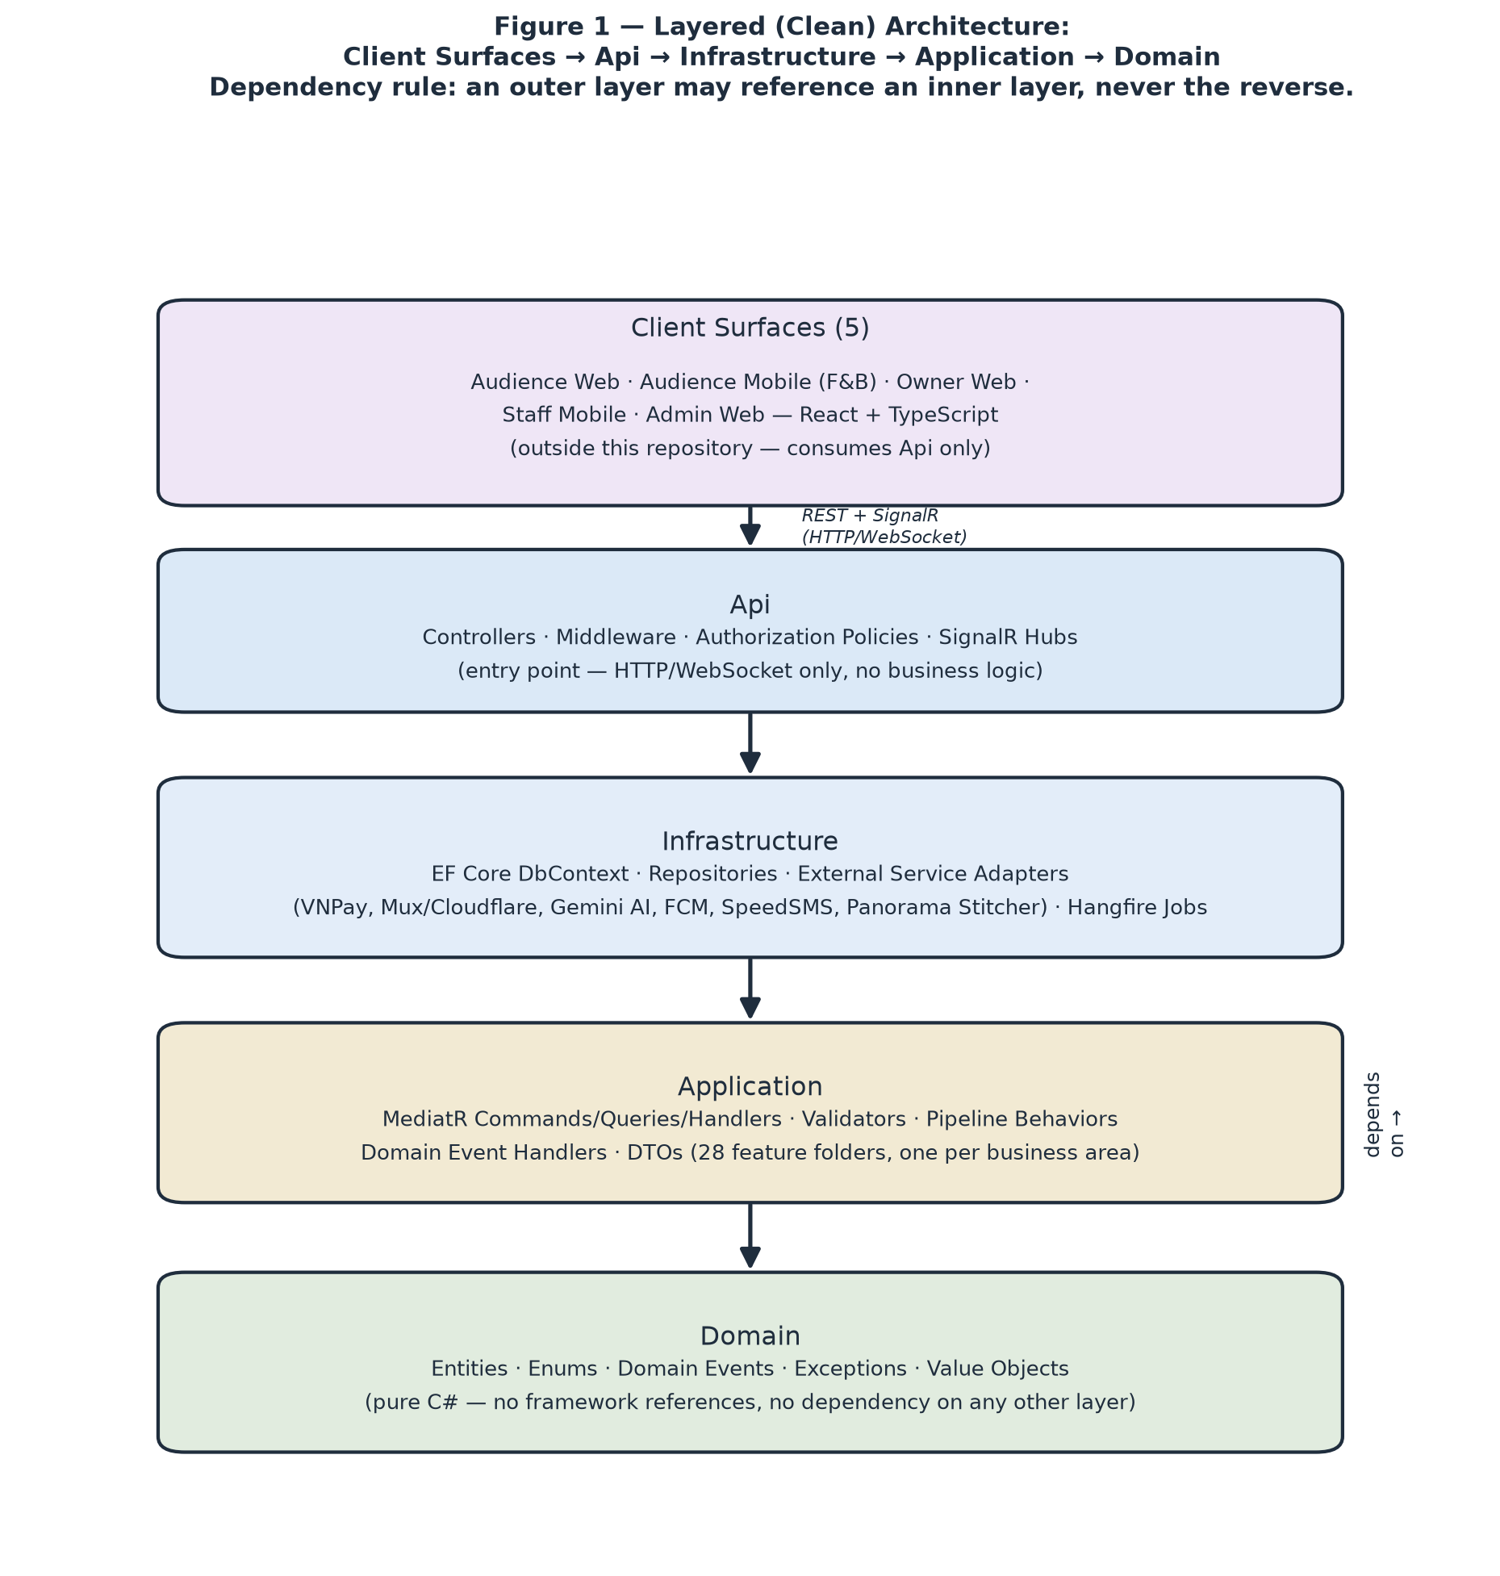
Figure 1 — Layered (Clean) Architecture, with the 5 client surfaces that consume it.

1.2 Package Diagram
Figures 2a–2d show the package structure of each of the four backend projects (Domain, Application, Infrastructure, Api introduced in §1.1); the table below gives a one-line description for every package, using dotted Project.Package notation. The frontend's own internal structure is covered separately in §1.3.
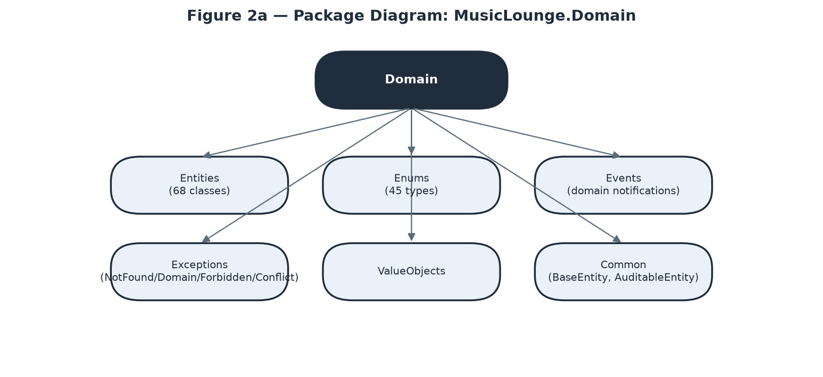
Figure 2a — Package Diagram: MusicLounge.Domain
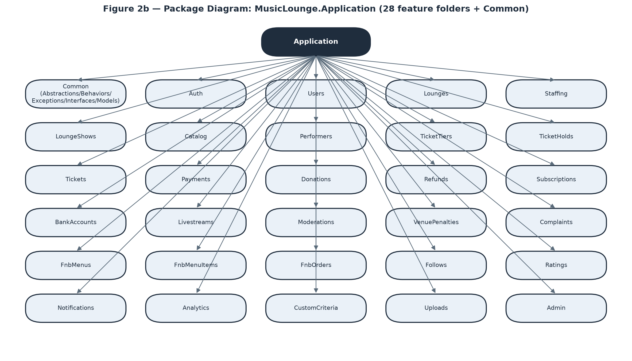
Figure 2b — Package Diagram: MusicLounge.Application
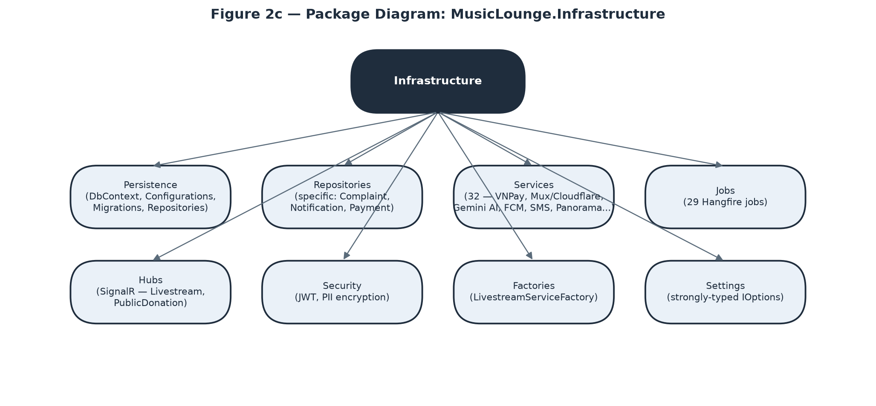
Figure 2c — Package Diagram: MusicLounge.Infrastructure
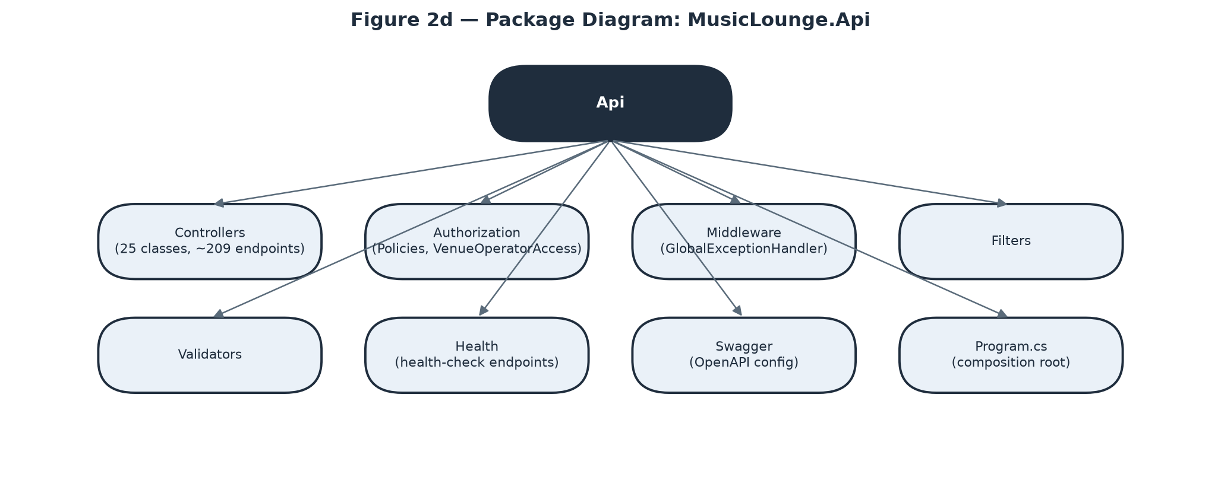
Figure 2d — Package Diagram: MusicLounge.Api
No | Package | Description
1 | Domain.Entities | 68 entity classes — the full business data model (see §2 Database Design for the complete table catalog).
2 | Domain.Enums | 45 enum types — every state-machine status and closed classification value (TicketStatus, DonationStatus, UserRole, etc.).
3 | Domain.Events | Domain event records (e.g. TicketPaymentConfirmed) raised by entities and dispatched via MediatR notifications after SaveChanges.
4 | Domain.Exceptions | Domain-level exception types (e.g. business-rule violations) distinct from the Application-layer exception hierarchy.
5 | Domain.ValueObjects | Small immutable types with no identity of their own, embedded inside entities.
6 | Domain.Common | BaseEntity<TKey> / AuditableEntity<TKey> base classes every entity derives from (Id, CreatedAt, UpdatedAt, CreatedBy, domain-event collection).
7 | Application.Common | Abstractions (ICommand/IQuery), Behaviors (Logging/Validation/Transaction pipeline), Exceptions (NotFound/Domain/Forbidden/Conflict/Validation), Interfaces (IRepository, IUnitOfWork, ICurrentUserService, external-service interfaces), Models (ApiResponse, PaginatedResult).
8 | Application.Auth | Register, verify email/phone, log in, forgot/reset password, DSAR export/erase, deactivate/reactivate.
9 | Application.Users | Profile management, ID verification submission, AI-preference settings.
10 | Application.Lounges | Venue CRUD, seating-zone editor, 360° tour scenes/hotspots, gallery, custom criteria, Admin approve/reject.
11 | Application.Staffing | Assign/remove Staff to a venue, look-up-by-email eligibility check.
12 | Application.LoungeShows | Show CRUD, lifecycle transitions (submit/publish/reschedule/change-format/cancel/start/end), legal & royalty declaration.
13 | Application.Catalog | Platform-wide taxonomy — music genres, moods, venue atmospheres, event categories.
14 | Application.Performers | Performer catalog CRUD, social links, line-up assignment.
15 | Application.TicketTiers | Ticket tier CRUD, pricing windows (TicketPrice).
16 | Application.TicketHolds | 15-minute hold creation/release, expiry.
17 | Application.Tickets | Purchase confirmation, QR generation, check-in, transfer, walk-in sale, cancellation.
18 | Application.Payments | VNPay redirect/return/IPN handling, ledger journal creation, reconciliation.
19 | Application.Donations | Donate, owner acknowledgement, payout marking, public feed/ticker queries.
20 | Application.Refunds | Refund request creation (auto + manual), Admin approve/reject.
21 | Application.Subscriptions | Plan CRUD (Admin), subscribe/renew/cancel (Owner), snapshot-on-subscribe logic.
22 | Application.BankAccounts | Register/edit payout accounts, Admin verification.
23 | Application.Livestreams | Create/start/end broadcast, access-policy evaluation, chat, viewer count, force-stop.
24 | Application.Moderations | AI-assisted content review queue, Admin decision recording.
25 | Application.VenuePenalties | Issue penalty, appeal, review appeal, auto-overturn on SLA breach.
26 | Application.Complaints | File (incl. guest), look up, resolve, resolution-triggered automation.
27 | Application.FnbMenus | Venue menu CRUD.
28 | Application.FnbMenuItems | Menu item CRUD, availability toggling.
29 | Application.FnbOrders | Place order (self or staff-on-behalf), status progression, order items.
30 | Application.Follows | Follow/unfollow a venue, wishlist/un-wishlist a show.
31 | Application.Ratings | Submit/view show ratings, Admin soft-removal.
32 | Application.Notifications | Notification inbox queries, FCM device-token registration.
33 | Application.Analytics | Owner venue analytics, Admin platform-wide statistics.
34 | Application.CustomCriteria | Venue-defined recommendation criteria, user preference values.
35 | Application.Uploads | File upload handling and ownership tracking.
36 | Application.Admin | Cross-cutting Admin actions that don't fit one specific domain folder (ledger integrity check, background-job trigger, user management).
37 | Infrastructure.Persistence | ApplicationDbContext (68 DbSet<T>), EF Core entity configurations (IEntityTypeConfiguration<T> per entity), migrations, and the concrete Repository<T,TKey> + UnitOfWork implementations.
38 | Infrastructure.Repositories | Specific repositories with complex Include() query needs beyond the generic repository — Complaint, Notification, Payment.
39 | Infrastructure.Services | 32 concrete adapters: VnPayService, MuxStreamService + CloudflareStreamService (behind a factory), GeminiModerationService/GeminiImageModerationService/GeminiTextGenerationService, OpenAiImageGenerationService, FcmService + FcmMessagingClient, SmsService, SmtpEmailService, HttpPanoramaStitchingService/HttpPanoramaCompletionService, QrCodeGeneratorService, PiiEncryptionService, CurrentUserService, SystemConfigService, and concurrency-control helpers (ShowBookingLock, AsyncKeyedLock, ChatRateLimiter, LivestreamSessionTracker).
40 | Infrastructure.Jobs | 29 Hangfire background jobs — see Report 3 §3.1.8 for the full catalog and each job's purpose.
41 | Infrastructure.Hubs | SignalR hubs — LivestreamHub (chat + access gating) and the public donation-ticker hub.
42 | Infrastructure.Security | JWT issuing/validation support and PII encryption helpers.
43 | Infrastructure.Factories | LivestreamServiceFactory — selects the Mux or Cloudflare Stream adapter at runtime without Application code knowing which provider is active.
44 | Infrastructure.Settings | Strongly-typed IOptions<T> configuration classes bound from appsettings.json for every external integration.
45 | Api.Controllers | 25 REST controllers, ~209 endpoints total — the complete inventory is Report 3 §2.2 (Use Cases) and §3.1.2–3.1.6 (screens each endpoint serves).
46 | Api.Authorization | Policy definitions (RequireAuthenticated/RequireVenueOperator/RequireOwner/RequireAdmin) and VenueOperatorAccess — the venue-scoping check layered on top of policies (see Report 3 §3.1.7 for the full 3-layer model).
47 | Api.Middleware | GlobalExceptionHandler — maps Application/Domain exceptions to consistent HTTP status codes and ApiResponse error bodies.
48 | Api.Filters | Action filters applied across controllers (e.g. model-state validation shortcuts).
49 | Api.Validators | Request-level validators supplementing FluentValidation command validators.
50 | Api.Health | Health-check endpoints used by the deployment platform and uptime monitoring.
51 | Api.Swagger | OpenAPI/Swagger generation configuration, incl. JWT bearer auth wiring for the interactive docs UI.
52 | Api.Program.cs | Composition root — registers AddApplication()/AddInfrastructure(), configures the middleware pipeline, and starts the Hangfire server + recurring job schedule.

1.3 Frontend Architecture
The five client surfaces are separate deployable applications, but they are not five unrelated codebases: they share one design system, one generated API client and one set of cross-cutting conventions, so a change to an API contract or a shared component propagates to every surface that uses it. The three web surfaces (Audience Website, Owner Web Dashboard, Admin Web Console) are React 18 + TypeScript applications built with Vite and styled with Tailwind CSS; the two mobile surfaces (Staff Mobile, Audience Mobile F&B) are React Native applications sharing the same TypeScript models and API client. Figure 3 shows the layering every surface follows.
Screens/Routes is the only layer that knows about navigation. Each screen in the Report 3 §3.1 catalogue maps to exactly one route, lazy-loaded so a visitor browsing shows never downloads the seating-zone editor. A route guard resolves the caller's role from the JWT and redirects before the screen renders, which means an unauthorised user never sees a flash of protected content — though this is a usability measure, never the security boundary, since the API re-checks every request independently.
Feature Modules mirror the backend's 28 feature folders one-for-one (auth, venues, shows, tickets, livestream, donations, f&b, admin, and so on). Keeping the two sides named identically means a developer tracing a bug moves between tiers without re-learning a second vocabulary, and it makes it obvious when a screen has quietly grown a dependency on a feature it should not touch.
State Management is deliberately split in two. Server state — anything the API owns — lives in TanStack Query, which handles caching, retry and invalidation, so a screen never hand-rolls loading flags or goes stale after a mutation. Only genuinely client-owned state (the current session, UI preferences, a multi-step form in progress) lives in a Zustand store. The API Client Layer is generated from the backend's OpenAPI contract rather than hand-written, so a breaking contract change surfaces as a TypeScript compile error at build time instead of a runtime failure in front of a user; a SignalR client alongside it carries livestream chat and the public donation ticker.
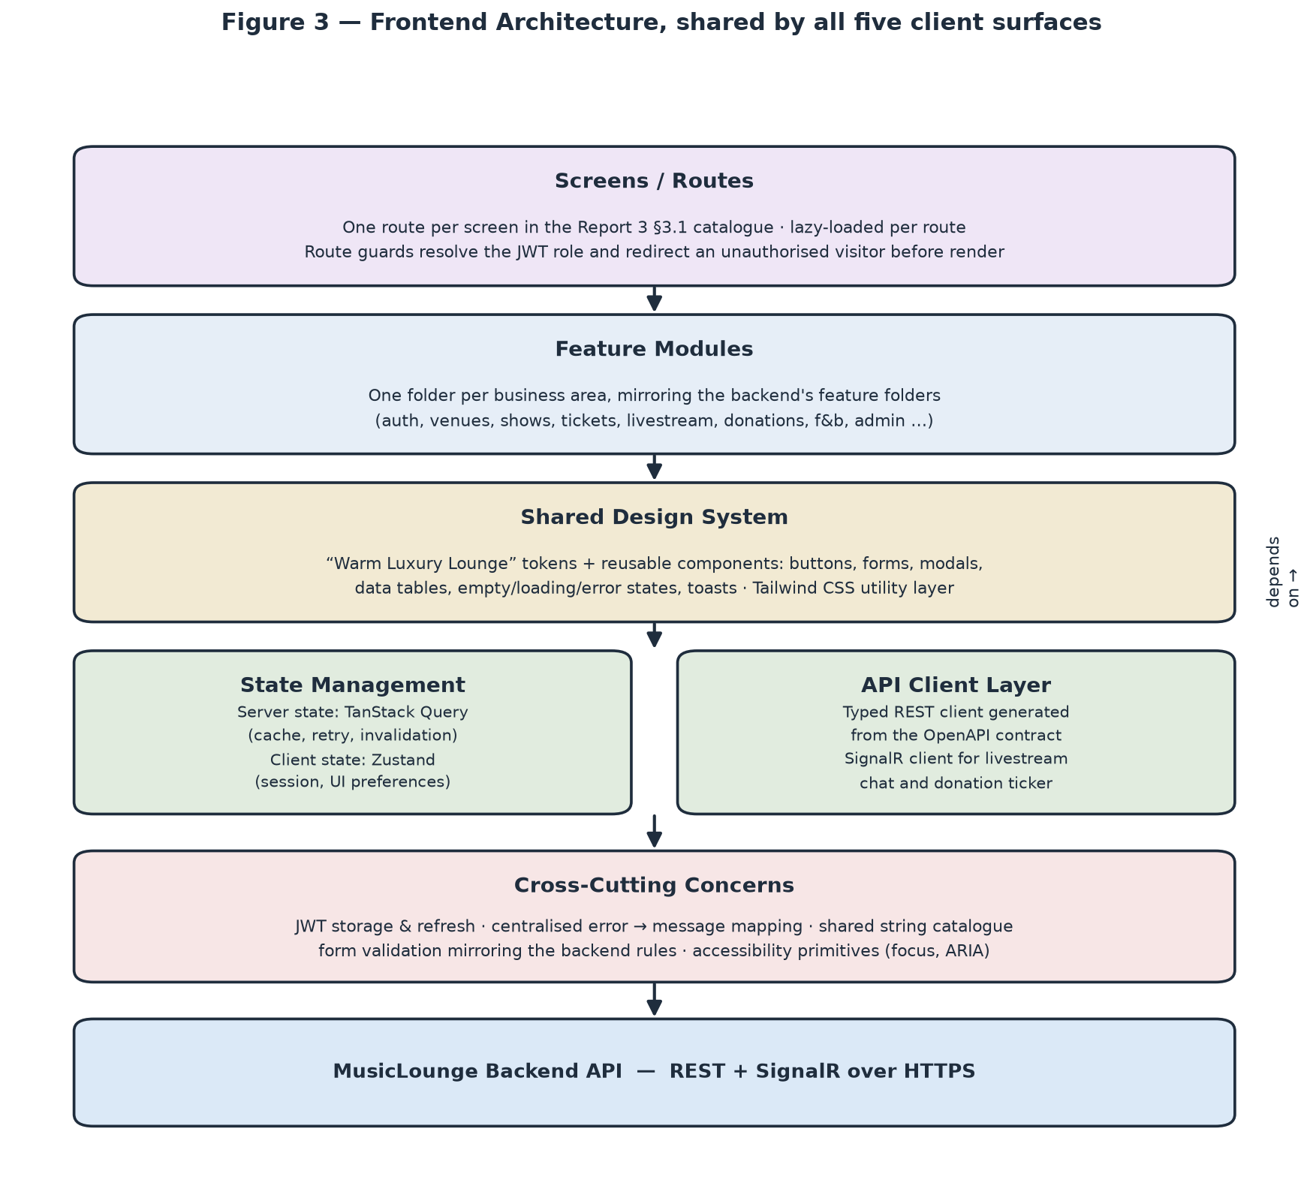
Figure 3 — Frontend Architecture, shared by all five client surfaces.

1.4 Deployment Architecture
The platform is deployed to Microsoft Azure, chosen because the backend is ASP.NET Core on SQL Server and Azure's managed equivalents of both remove the most operational work for a small team. Figure 4 shows how the pieces sit together.
The three React web bundles are served as static assets from Azure Static Web Apps at the edge, so a page load costs the API nothing. The API itself and its SignalR hubs run on Azure App Service (Linux) with the Hangfire worker in the same process; the service is configured with a staging slot so a release is warmed up and smoke-tested before being swapped into production, which makes a rollback a slot swap back rather than a redeploy. The panorama-stitching microservice runs separately on Azure Container Apps precisely because its workload is different — bursty, CPU-bound and dependent on native imaging binaries — so it scales on its own and a stitching failure cannot destabilise the API host.
Azure SQL Database holds both the transactional data and the Hangfire job store, with automated backups and point-in-time restore. Uploaded media — venue photos, business licences, show posters and 360° panoramas — goes to Blob Storage and is served publicly through Azure CDN, keeping image traffic off the API entirely. Every secret (database connection strings, VNPay credentials, AI and messaging API keys) is held in Azure Key Vault and injected at deploy time, so no secret exists in source control or in a build artefact. Application Insights and Azure Monitor collect request traces, dependency timings and background-job outcomes, and carry the alert rules that notify the team on a failed job or an error-rate spike.
Deployment is entirely automated through GitHub Actions: a pull request runs build and the full test suite, and a merge to the main branch builds once, deploys that same artefact to the staging slot, runs the end-to-end suite against it, and swaps to production. No artefact is ever rebuilt between staging and production, so what was tested is exactly what ships.
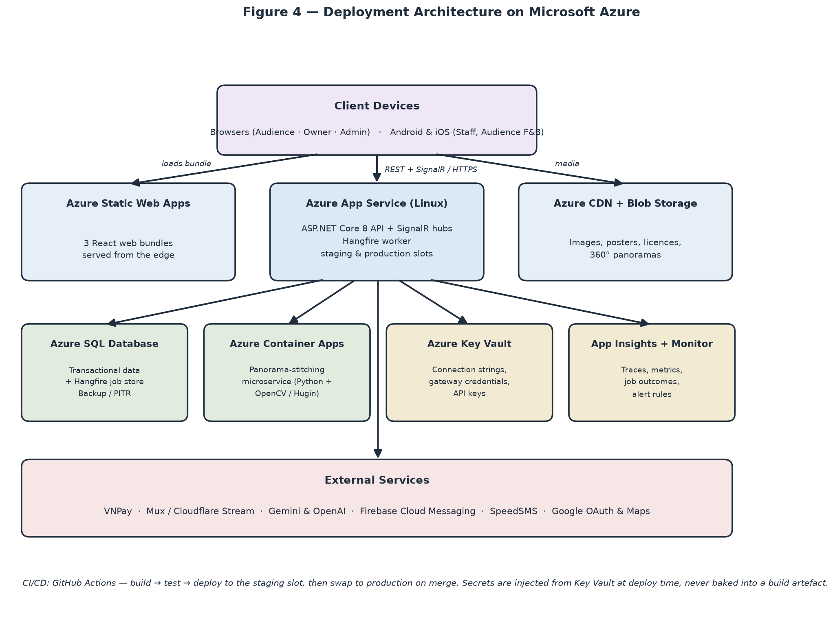
Figure 4 — Deployment Architecture on Microsoft Azure.

2. Database Design
68 entity classes / tables in SQL Server (Developer Edition), managed entirely through EF Core Code-First migrations — there is no hand-written DDL. Figure 5 below repeats the core entity relationship diagram from Report 3 §3.1.9 (the central, cross-domain entities); the table below is the complete catalog with primary/foreign key notes for every table, grouped the same way as the entity catalog in Report 3 for consistency between the two documents.
Conventions applied consistently across the schema: Ticket's primary key is a server-generated GUID (NEWSEQUENTIALID() — sequential for B-tree index performance, but non-guessable, since a ticket ID must never be enumerable) while every other table uses an int identity primary key; two tables (PhysicalTicketDetail, LivestreamTicketDetail) are true 1-to-1 extensions of Ticket sharing its primary key rather than carrying their own; five polymorphic-reference tables (BankAccount, Payment, EventModeration, Complaint, the ledger Account table) use an OwnerType/TargetType + Id pair with no physical FK constraint, enforced only at the application layer, because a single physical FK column cannot reference two different parent tables; JSON-shaped columns are stored as nvarchar(max) (SQL Server has no native jsonb); the ledger table (LedgerEntry) is append-only by design — it has no UpdatedAt and no code path ever updates a row after insert, since a correction is always a new, opposite-signed entry, never an edit to history; and every PII foreign key (Ticket.BuyerId, Donation.DonorUserId, LoungeShowRating.UserId, Complaint.ComplainantUserId) is configured ON DELETE SET NULL so DSAR erasure anonymises history instead of breaking referential integrity.

Figure 5 — Core Entity Relationship Diagram (repeated from Report 3 §3.1.9 for a self-contained design reference).
Table Descriptions
No | Table | Description
1 | [Auth & User] User | Identity for every role. PK: Id (int identity). No FK (root entity).
2 | [Venue] MusicLounge | A venue. PK: Id (int identity). FK: OwnerId → User.
3 | [Venue] LoungeStaff | Staff assignment. PK: Id (int identity). FK: UserId → User, LoungeId → MusicLounge, AssignedBy → User. Unique filtered index (UserId) WHERE IsActive=1.
4 | [Venue] SeatingZone | Venue seating area. PK: Id (int identity). FK: LoungeId → MusicLounge.
5 | [Venue] VenueTourScene | 360° panorama scene. PK: Id (int identity). FK: LoungeId → MusicLounge.
6 | [Venue] VenueTourHotspot | Clickable point in a scene. PK: Id (int identity). FK: SceneId → VenueTourScene, TargetSceneId → VenueTourScene (nullable, Navigate type only).
7 | [Venue] VenueTourStitchAttempt | Stitch job log. PK: Id (int identity). FK: LoungeId → MusicLounge, ResultSceneId → VenueTourScene (nullable).
8 | [Venue] LoungeGalleryImage | Gallery photo. PK: Id (int identity). FK: LoungeId → MusicLounge.
9 | [Venue] VenuePenalty | Penalty record. PK: Id (int identity). FK: LoungeId → MusicLounge, IssuedByAdminId → User.
10 | [Taxonomy] MusicGenre / Mood / VenueAtmosphere | 3 independent tables, structurally identical. PK: Id (int identity). (each) No FK — Admin-managed root taxonomy.
11 | [Taxonomy] EventCategory | Event category tag. PK: Id (int identity). No FK.
12 | [Taxonomy] CustomCriteria | Venue-defined criteria. PK: Id (int identity). FK: LoungeId → MusicLounge.
13 | [Taxonomy] EventCustomValue | Show's value for a criteria. PK: Id (int identity). FK: LoungeShowId → LoungeShow, CustomCriteriaId → CustomCriteria.
14 | [Taxonomy] UserCustomPreference | User's interest in a criteria. PK: Id (int identity). FK: UserId → User, CustomCriteriaId → CustomCriteria.
15 | [Show] LoungeShow | One performance. PK: Id (int identity). FK: LoungeId → MusicLounge, LegalApprovalConfirmedByAdminId → User (nullable).
16 | [Show] LoungeShowGenre / LoungeShowMood / LoungeShowAtmosphere | 3 junction tables (n-n). Composite PK: (LoungeShowId, GenreId/MoodId/AtmosphereId). FK to LoungeShow + the respective taxonomy table.
17 | [Show] LoungeShowRating | Audience rating. PK: Id (int identity). FK: LoungeShowId → LoungeShow, UserId → User (SET NULL).
18 | [Show] EventModeration | Moderation case. PK: Id (int identity). Polymorphic: TargetType + TargetId (no physical FK) → LoungeShow/Livestream/GalleryImage/TourScene.
19 | [Show] Performance | Line-up slot (n-n Show↔Performer with extra attributes). PK: Id (int identity). FK: LoungeShowId → LoungeShow, PerformerId → Performer.
20 | [Show] AiPosterGeneration | Poster attempt log. PK: Id (int identity). FK: LoungeShowId → LoungeShow.
21 | [Performer] Performer | Performer catalog entry. PK: Id (int identity). FK: CreatedByUserId → User (nullable).
22 | [Performer] PerformerGenre | Junction (n-n). Composite PK: (PerformerId, GenreId).
23 | [Performer] PerformerSocialLink | Social link. PK: Id (int identity). FK: PerformerId → Performer. Unique (PerformerId, Platform).
24 | [Ticket] TicketTier | Access tier. PK: Id (int identity). FK: LoungeShowId → LoungeShow, ZoneId → SeatingZone (nullable, online tiers).
25 | [Ticket] TicketPrice | Pricing window. PK: Id (int identity). FK: TicketTierId → TicketTier.
26 | [Ticket] Ticket | PK: Id (uniqueidentifier, NEWSEQUENTIALID()) — sequential GUID, not int. FK: TicketPriceId → TicketPrice, BuyerId → User (nullable, SET NULL), PaymentId → Payment (nullable), PendingTransferToUserId → User (nullable).
27 | [Ticket] TicketHold | Temporary reservation. PK: Id (int identity). FK: TicketPriceId → TicketPrice, UserId → User.
28 | [Ticket] PhysicalTicketDetail | 1-to-1 with Ticket. PK: TicketId (shared PK, not a separate Id). FK: TicketId → Ticket, SoldByStaffId → User (nullable), CheckedInByStaffId → User (nullable).
29 | [Ticket] LivestreamTicketDetail | 1-to-1 with Ticket. PK: TicketId (shared PK). FK: TicketId → Ticket.
30 | [Payment/Finance] Account (ledger_accounts) | Bookkeeping account. PK: Id (int identity). FK: OwnerId → User/Performer (nullable, polymorphic via OwnerType).
31 | [Payment/Finance] LedgerEntry | Bookkeeping line. PK: Id (int identity). FK: AccountId → Account, PaymentId → Payment (nullable). Append-only — no UpdatedAt column.
32 | [Payment/Finance] Payment | VNPay transaction. PK: Id (int identity). Polymorphic: ReferenceType + ReferenceId (no physical FK) → Ticket/Donation/FnbOrder/Subscription/RefundRequest. Unique: IdempotencyKey.
33 | [Payment/Finance] Donation | One tip. PK: Id (int identity). FK: PerformanceId → Performance, DonorUserId → User (nullable, SET NULL), PayoutBankAccountId → BankAccount (nullable snapshot).
34 | [Payment/Finance] Settlement | Payout tranche. PK: Id (int identity). FK: PaymentId → Payment, LoungeId → MusicLounge.
35 | [Payment/Finance] RefundRequest | Refund request. PK: Id (int identity). FK: PaymentId → Payment, ReviewedByAdminId → User (nullable).
36 | [Payment/Finance] BankAccount | Payout account. PK: Id (int identity). Polymorphic: OwnerType + OwnerId (no physical FK) → MusicLounge/Performer. Unique filtered index (OwnerType, OwnerId) WHERE IsDefault=1.
37 | [Payment/Finance] SubscriptionPackage | Plan definition. PK: Id (int identity). No FK — immutable once ≥1 subscriber exists.
38 | [Payment/Finance] OwnerSubscription | Owner's subscription. PK: Id (int identity). FK: UserId → User, PackageId → SubscriptionPackage, PaymentId → Payment.
39 | [Livestream] Livestream | Broadcast. PK: Id (int identity). FK: LoungeShowId → LoungeShow, TerminatedById → User (nullable).
40 | [Livestream] LivestreamChatMessage | Chat line. PK: Id (int identity). FK: LivestreamId → Livestream, UserId → User.
41 | [F&B] FnbMenu | Venue menu. PK: Id (int identity). FK: LoungeId → MusicLounge.
42 | [F&B] FnbMenuItem | Menu item. PK: Id (int identity). FK: FnbMenuId → FnbMenu.
43 | [F&B] FnbOrder | Order. PK: Id (int identity). FK: LoungeId → MusicLounge, LoungeShowId → LoungeShow (nullable), AudienceUserId → User (nullable), StaffId → User (nullable).
44 | [F&B] OrderItem | Order line. PK: Id (int identity). FK: FnbOrderId → FnbOrder, FnbMenuItemId → FnbMenuItem.
45 | [Recommendation] AiRecommendation | Scored suggestion. PK: Id (int identity). FK: UserId → User, LoungeShowId → LoungeShow.
46 | [Recommendation] UserBehaviourLog | Raw event. PK: Id (int identity). FK: UserId → User, LoungeShowId → LoungeShow (nullable).
47 | [Recommendation] UserEventScore | Aggregated score. PK: Id (int identity). FK: UserId → User, LoungeShowId → LoungeShow.
48 | [Recommendation] UserFavouriteGenre / Mood / Atmosphere | 3 junction tables (n-n). Composite PK: (UserId, GenreId/MoodId/AtmosphereId).
49 | [Notification] Notification | One notification. PK: Id (int identity). FK: UserId → User. Polymorphic ReferenceType + ReferenceId (no physical FK) for deep-linking.
50 | [Notification] DeviceToken | FCM installation ID. PK: Id (int identity). FK: UserId → User. Unique: Fid.
51 | [Follow] Follow | Venue follow. Composite PK: (UserId, LoungeId).
52 | [Follow] ShowWishlist | Show wishlist. Composite PK: (UserId, LoungeShowId).
53 | [Security & Ops] LoginFailureLog | Failed login. PK: Id (int identity). No FK — keyed by Email + IpAddress, short retention.
54 | [Security & Ops] LoginSpikeAlertState | Alert de-dup. PK: IpAddress. No FK.
55 | [Security & Ops] KnownAdminSnapshot | Admin baseline. PK: Id (int identity). FK: UserId → User.
56 | [Security & Ops] PushFailureLog | Push failure. PK: Id (int identity). No FK.
57 | [Security & Ops] PushFailureAlertState | Alert de-dup, single global row. PK: fixed singleton key. No FK.
58 | [Complaint] Complaint | Complaint. PK: Id (int identity). FK: ComplainantUserId → User (nullable, SET NULL). Polymorphic TargetType + TargetId/TargetGuid (no physical FK).
59 | [Config] SystemConfig | Tunable parameter. PK: ConfigKey (string, not int). No FK.
60 | [Config] SystemConfigHistory | Audit trail (unused — see Report 3 known-gaps). FK: ConfigKey → SystemConfig (not by numeric id).
61 | [Upload] UploadedFile | Upload tracking. PK: Id (int identity). FK: UploaderUserId → User.
62 | [Venue] LoungeImage | One venue image slot (hero/profile, set via PUT /lounges/{id}/image). PK: Id (int identity). FK: LoungeId -> MusicLounge.

3. Detailed Design

3.1 Common CQRS & Cross-Cutting Design
Every one of the ~209 endpoints across the 28 Application feature folders follows the exact same class shape, shown once in Figure 6 and referenced by every feature below instead of being redrawn per feature, per the recommended practice for features that share one structure. Only the sequence of calls differs meaningfully feature to feature — that variation is what each feature's own sequence diagram captures.
A Controller action does nothing beyond authorization and mapping: it builds an ICommand<TResponse> or IQuery<TResponse> record from the request and sends it through IMediator. MediatR runs the request through three pipeline behaviors in a fixed decorator order — LoggingBehavior (every request/response, with timing), ValidationBehavior (FluentValidation; throws before the handler ever runs on invalid input), and TransactionBehavior (wraps IUnitOfWork.Begin/Commit/RollbackTransactionAsync — applied only to commands, since a query never mutates state and AsNoTracking reads need no transaction) — before reaching the actual handler.
A handler depends only on interfaces (IUnitOfWork / a specific IXxxRepository for complex Include() queries), never on EF Core directly, which is what keeps Application unit-testable without a real database. Where an action has consequences beyond its own aggregate — e.g. a confirmed ticket payment needs a ledger entry, a scheduled settlement, a push notification and a SignalR broadcast, none of which should block or fail each other — the entity raises a domain event instead of the handler calling four services directly; independent INotificationHandler<TEvent> implementations pick it up after SaveChanges and run in parallel. FCM and SignalR delivery from those handlers are additionally enqueued through Hangfire (an Outbox-style pattern) so delivery survives a process crash between the domain event firing and the message actually being sent.

3.1.1 Class Diagram
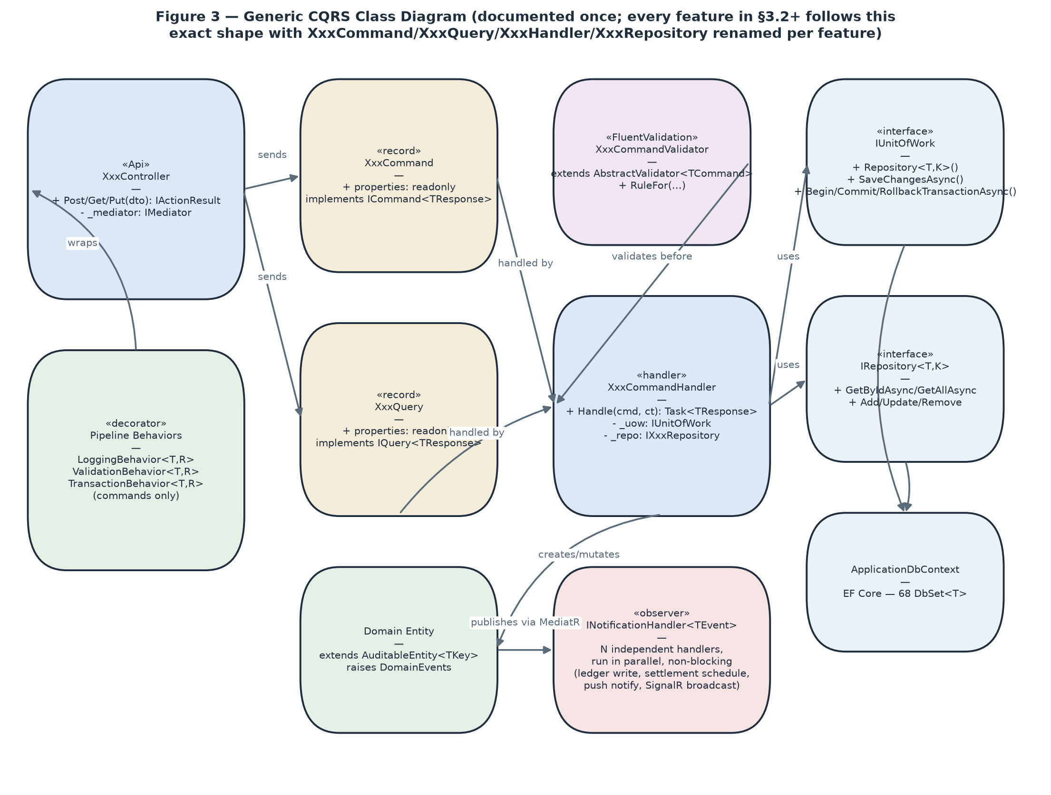
Figure 6 — Generic CQRS Class Diagram.

3.2 Authentication & Account Lifecycle

3.2.1 Class Diagram
Follows the generic CQRS shape in Figure 6 (RegisterCommand/LoginCommand → RegisterCommandHandler/LoginCommandHandler → IUnitOfWork). No feature-specific class structure beyond that — see Figures 4–5 below for the two sequences with genuinely different call shapes.

3.2.2 Figure 7 — Register & Verify Account
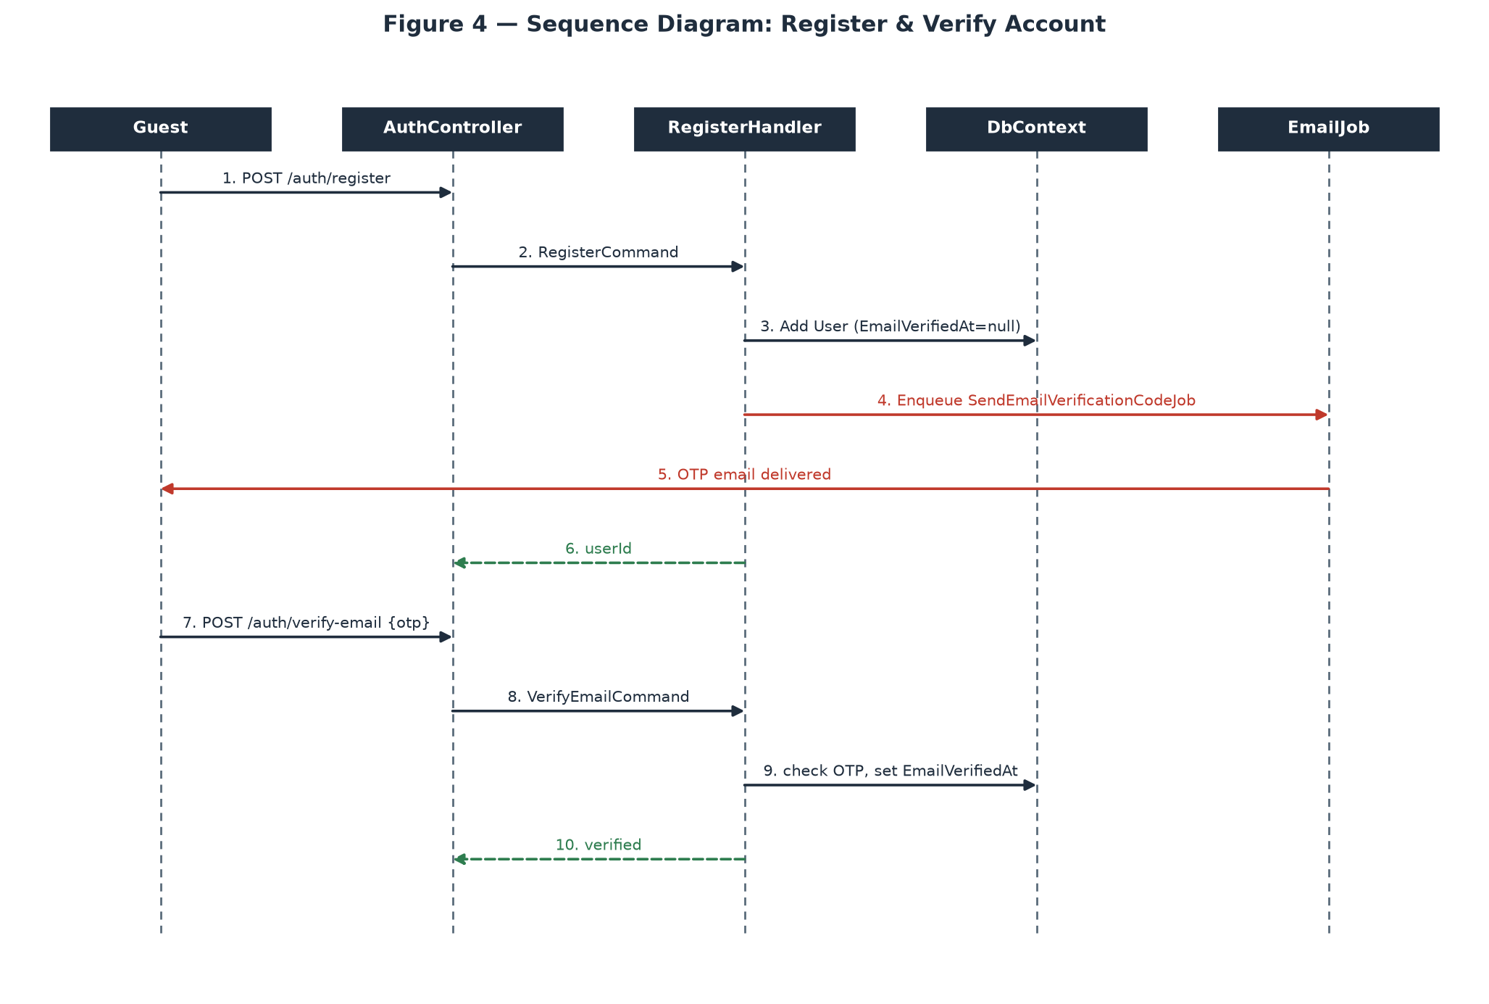
Registration and OTP verification are two separate commands, connected only by the fact that login is blocked until the second one succeeds — the OTP email itself is sent asynchronously via a triggered Hangfire job, not inline in the request.

3.2.3 Figure 8 — Log In
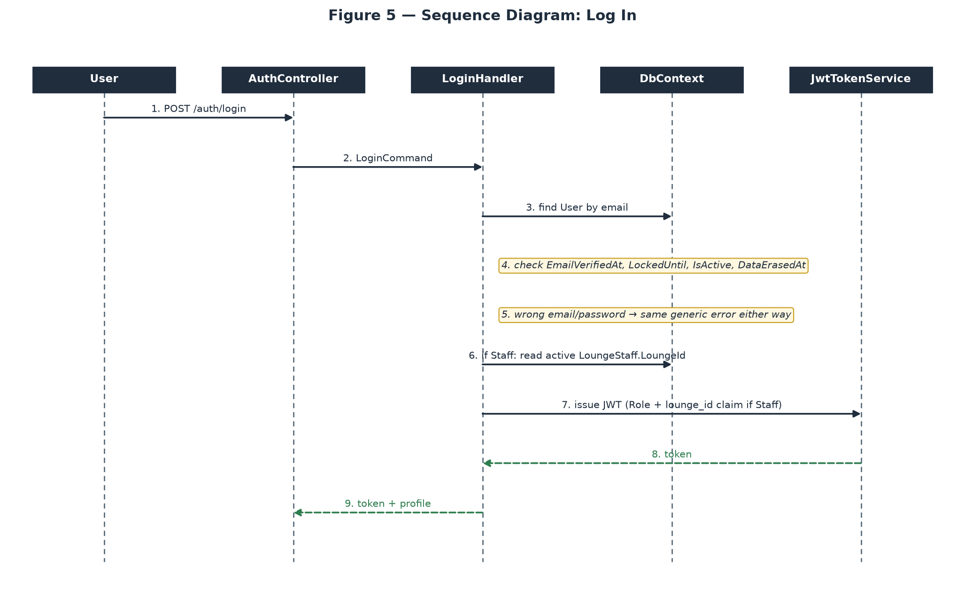
All account-state gates (email verified, not locked, active, not erased) are checked in a fixed order before any JWT is issued; the generic wrong-email/wrong-password error and the Staff lounge_id claim attachment both happen inside this one handler.

3.3 Venue Registration & Approval

3.3.1 Class Diagram
Generic CQRS shape (Figure 6): CreateLoungeCommand/ApproveLoungeCommand → their respective handlers → IUnitOfWork.

3.3.2 Figure 9 — Create Venue → Admin Approval
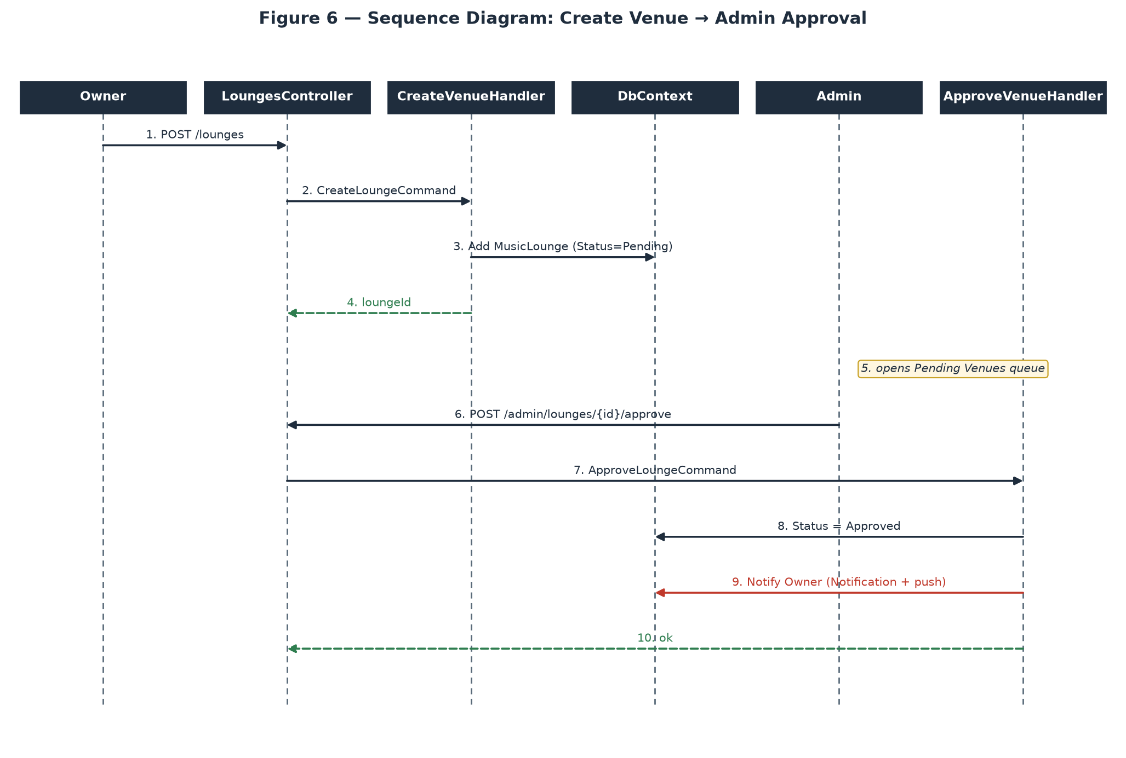
Two independent actors act on the same MusicLounge row at different points in time — Owner creates it (Status=Pending), Admin later approves or rejects it from a completely separate request; there is no synchronous coupling between the two calls beyond the row's own status field.

3.4 Show Creation & Lifecycle

3.4.1 Class Diagram
Generic CQRS shape (Figure 6), with one addition: SubmitForReviewCommandHandler enqueues a triggered background job (ScoreModerationWithAiJob) rather than calling Gemini AI inline, keeping the HTTP request fast regardless of the AI service's latency.

3.4.2 Figure 10 — Submit for Review → AI Moderation → Admin Publish
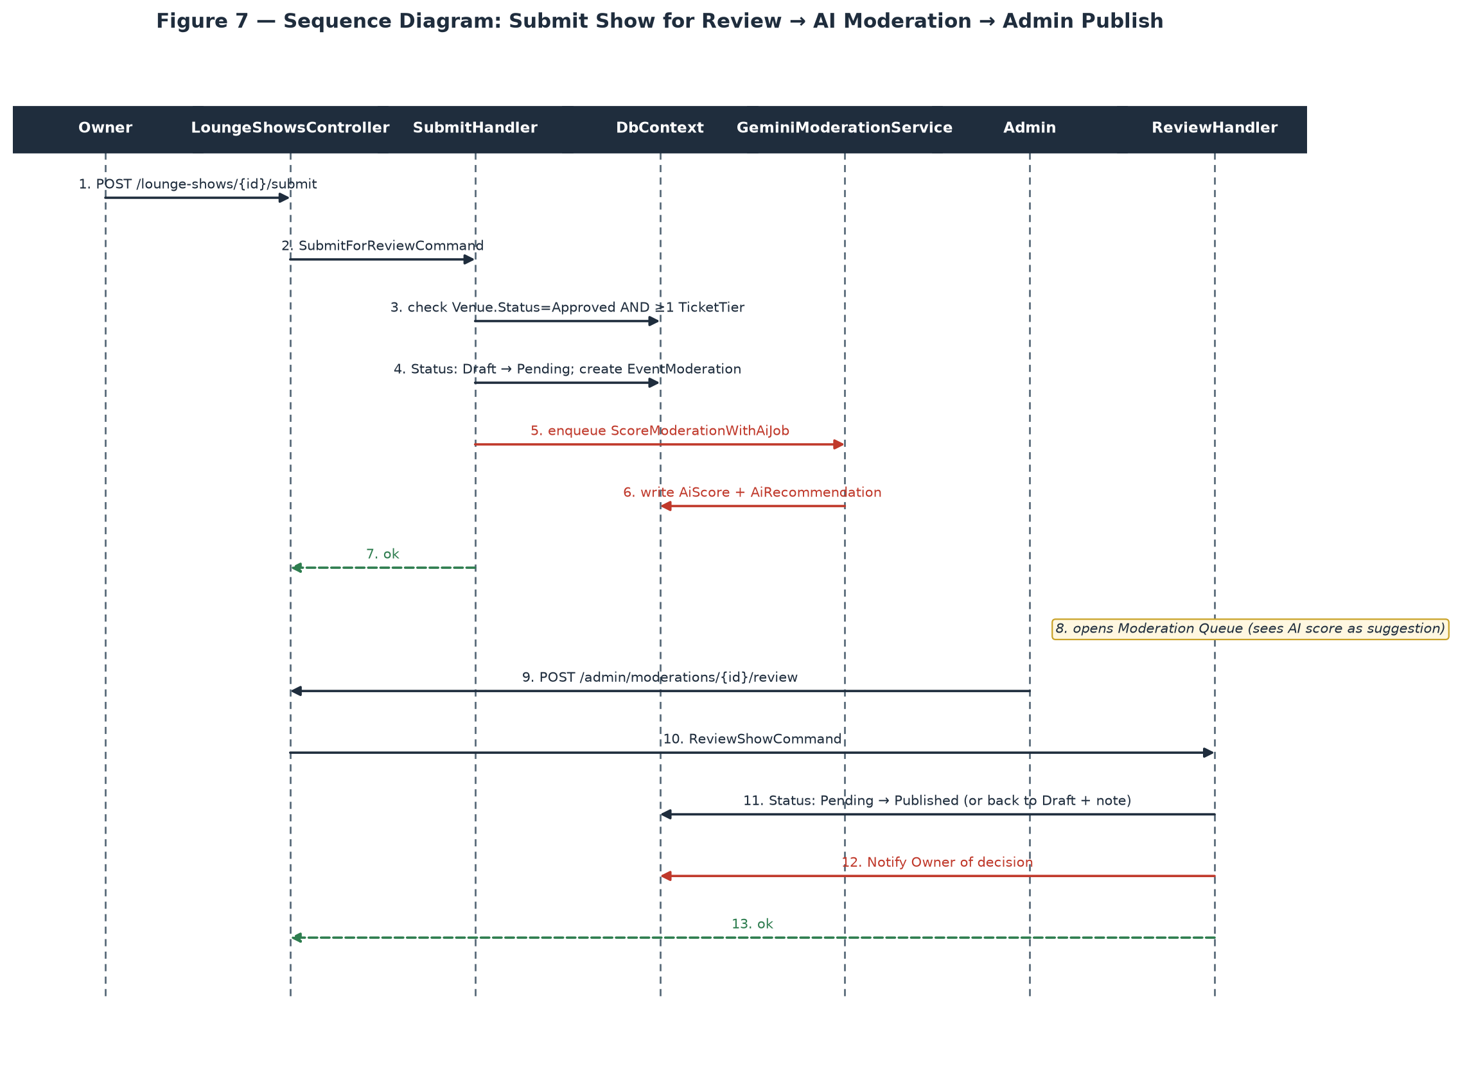
The AI score is written to EventModeration asynchronously and is purely advisory — Admin's ReviewShowCommand is the only thing that actually changes LoungeShow.Status, and it can go either direction regardless of what the AI recommended.

3.5 Ticket Purchase & Payment Confirmation

3.5.1 Class Diagram
Generic CQRS shape (Figure 6) plus an external redirect: HoldTicketCommandHandler and ConfirmPaymentCommandHandler are two separate handlers connected only by the VNPay round-trip in between — the system has no synchronous call spanning both.

3.5.2 Figure 11 — Hold → Pay → VNPay IPN → Confirm
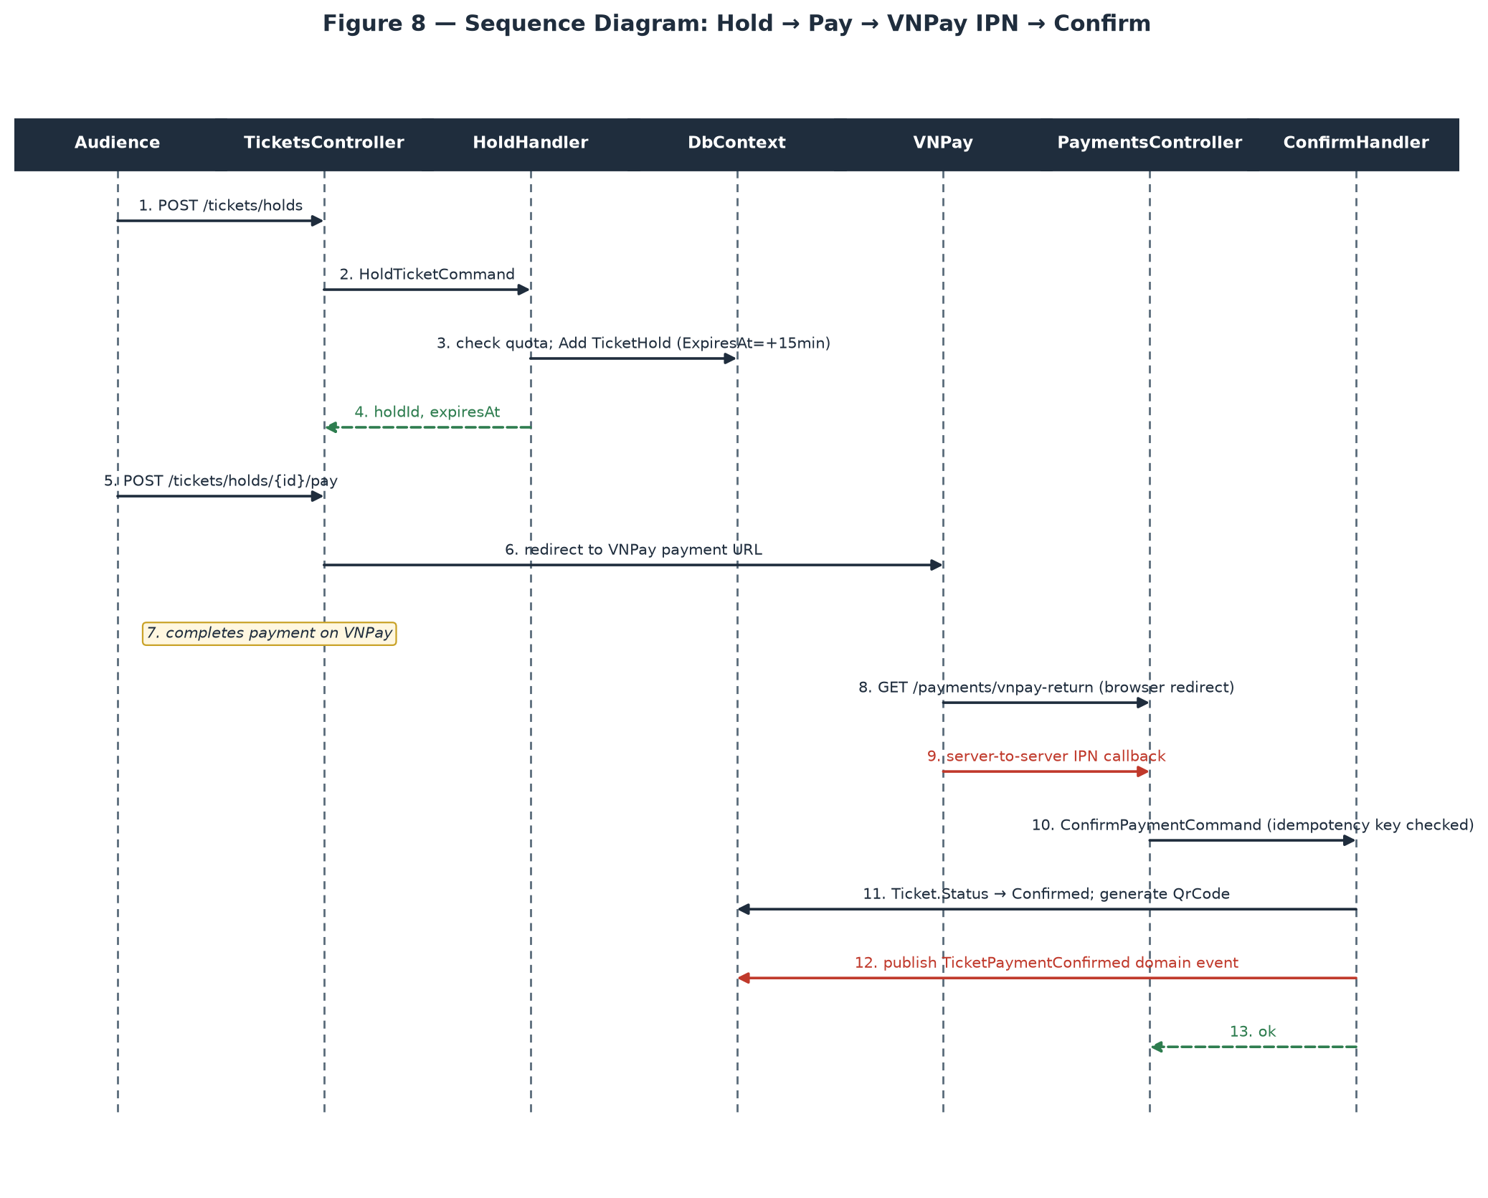
The IPN callback (step 9) is the transaction of record, not the browser return-URL redirect (step 8) — VNPay guarantees the IPN even if the buyer's browser never makes it back to the return URL, which is why ConfirmPaymentCommand is only ever triggered from the IPN handler, and why it is guarded by an idempotency key against VNPay's documented at-least-once IPN delivery.

3.6 Livestream Access & Real-Time Donation

3.6.1 Class Diagram
LivestreamAccessPolicy (Figure 12) is a plain service class, not a MediatR handler — invoked from the SignalR hub's connection handshake, before any hub method is callable, rather than from a controller action. DonateHandler otherwise follows the generic CQRS shape (Figure 6).

3.6.2 Figure 12 — Livestream Access Check
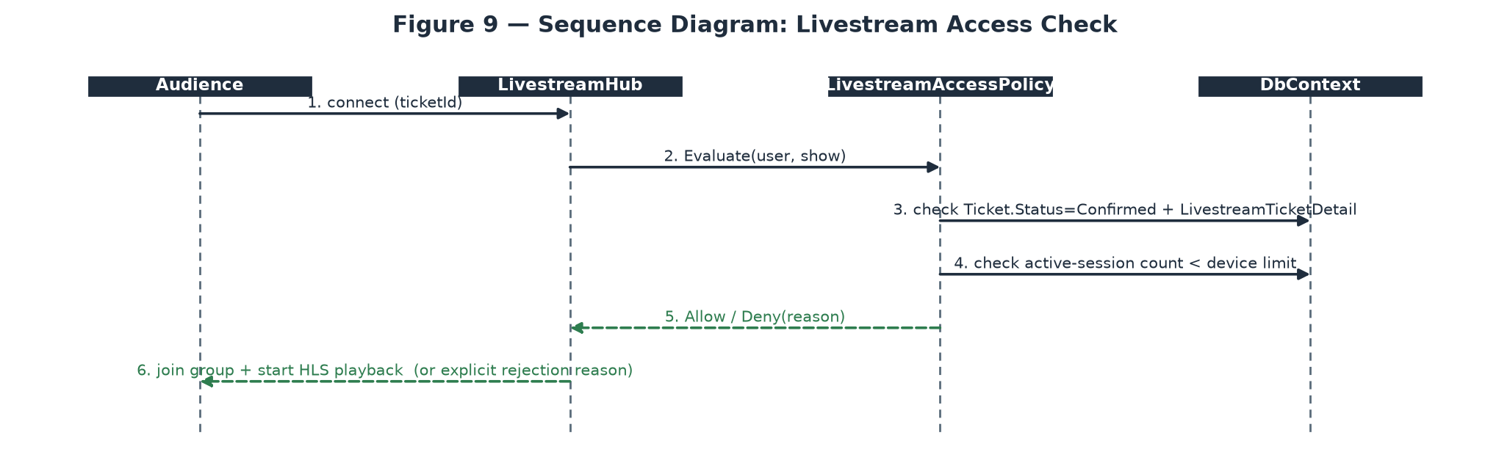
Runs on every hub connection attempt, not just the first — a client that later loses eligibility (e.g. the concurrent-device limit is hit by a second device) is re-evaluated, not grandfathered in from an earlier successful check.

3.6.3 Figure 13 — Donate to a Performer
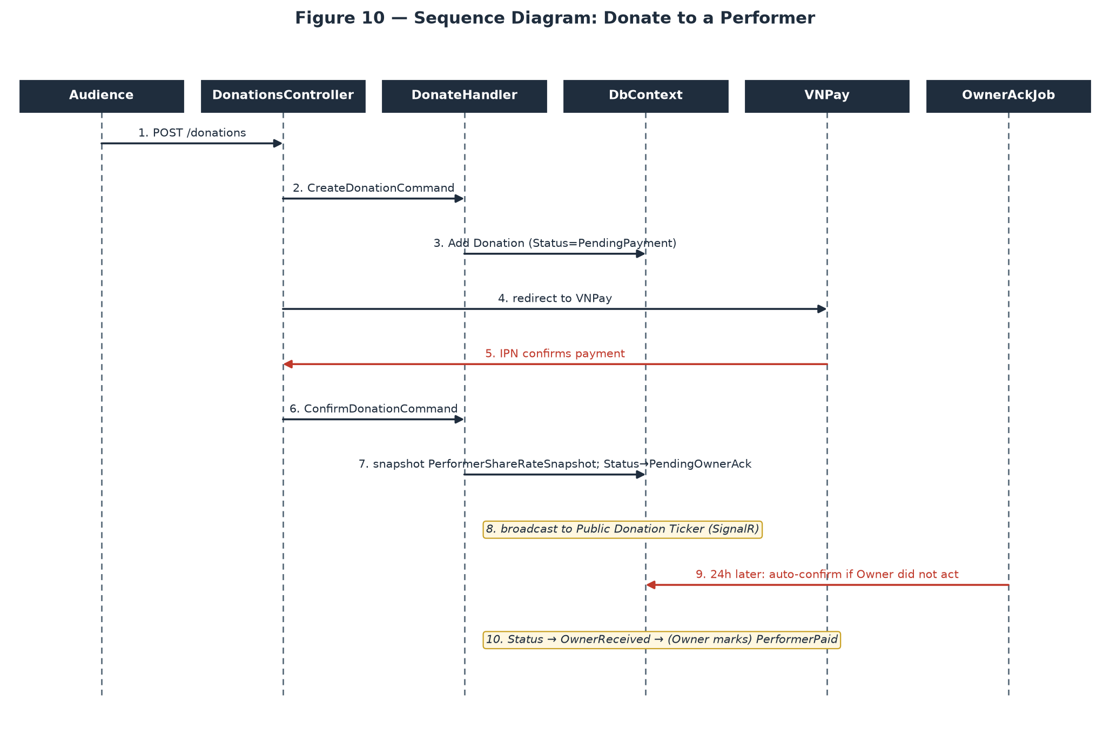
The donation's ledger-relevant fields (PerformerShareRateSnapshot) are frozen at IPN-confirmation time, not at the moment the Audience clicks Donate — the config value in effect at confirmation is what gets snapshotted, exactly mirroring the ticket-payment ledger pattern in Figure 14.

3.7 Payment, Double-Entry Ledger & Settlement

3.7.1 Class Diagram
LedgerJournalFactory (Figure 14) is a Factory, not a handler — it is a pure static function called from inside ConfirmPaymentCommandHandler that turns one Payment into a balanced array of LedgerEntry rows, keeping the debit/credit-balancing arithmetic in exactly one place in the codebase.

3.7.2 Figure 14 — VNPay IPN → Ledger → Settlement Release
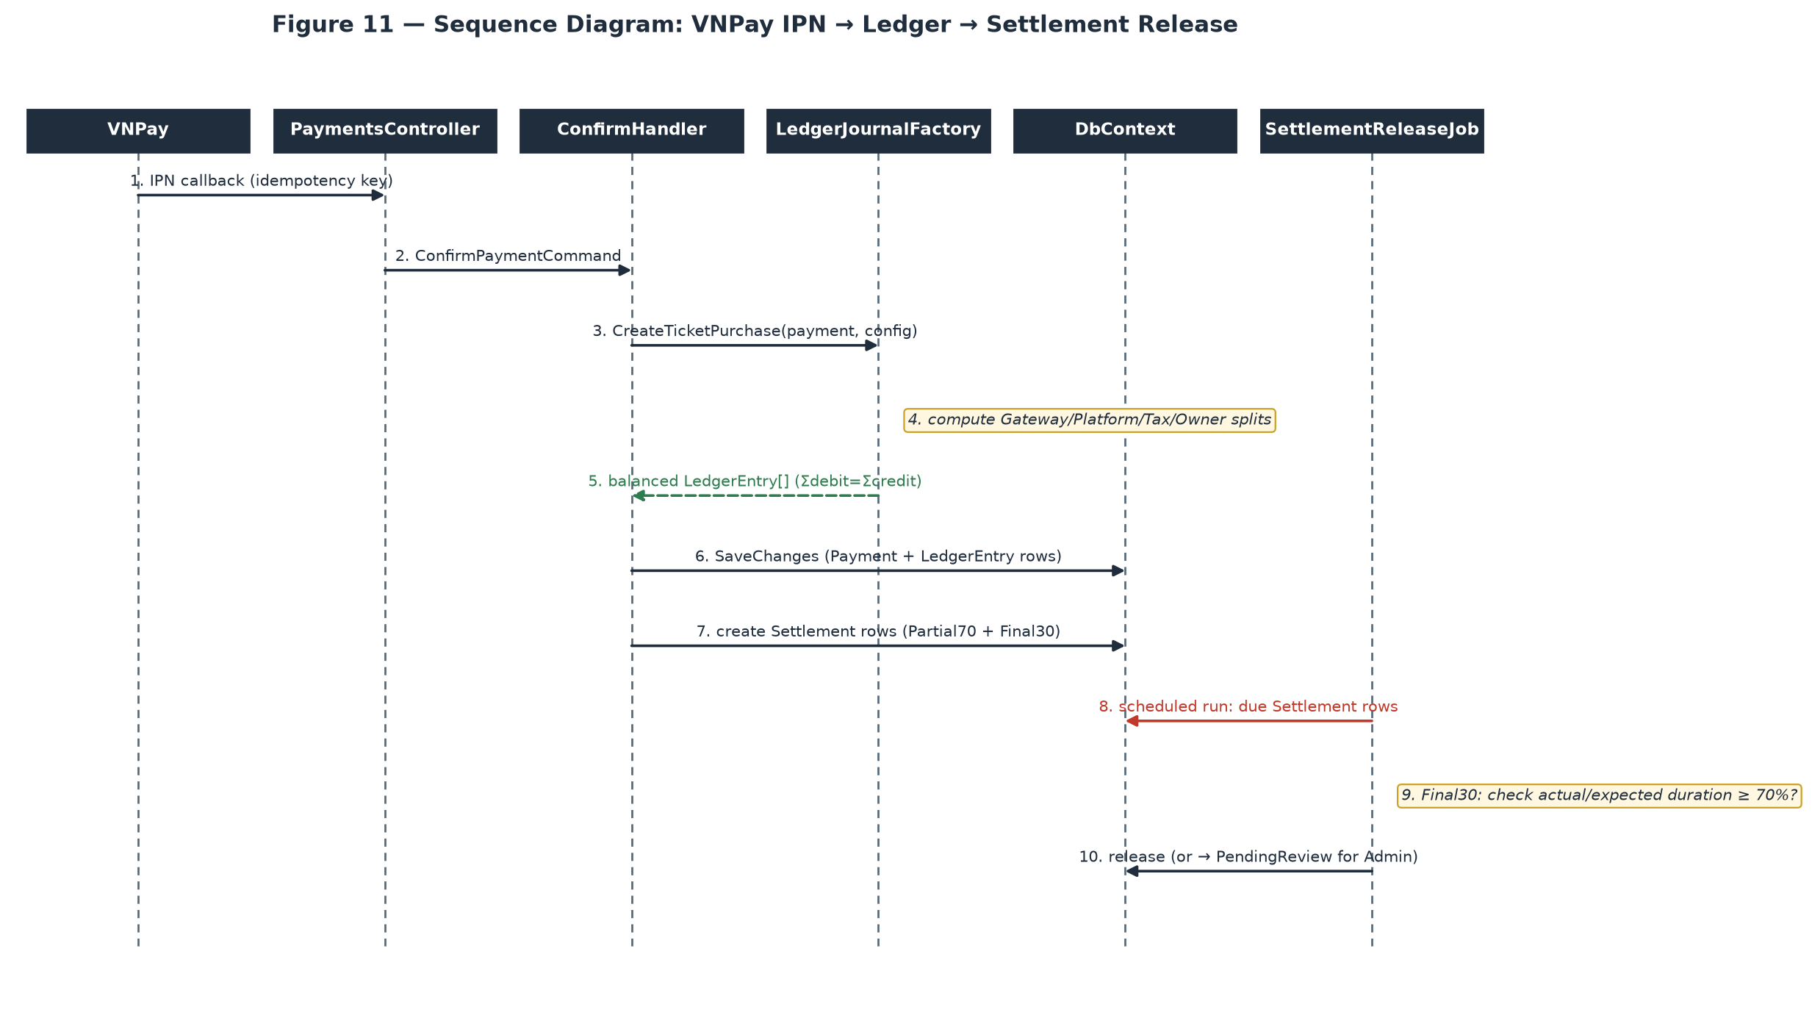
SettlementReleaseJob runs independently of the payment confirmation, on its own schedule — a Settlement row is created at confirmation time but not released until its own due date, and the Final30 tranche additionally gates on the show's actual duration ratio before releasing automatically.

3.8 Complaint Handling

3.8.1 Class Diagram
Generic CQRS shape (Figure 6). The one feature-specific branch is inside ResolveComplaintCommandHandler, which conditionally creates a RefundRequest depending on the resolution action chosen — not a separate class, just a conditional inside one handler.

3.8.2 Figure 15 — File & Resolve a Complaint
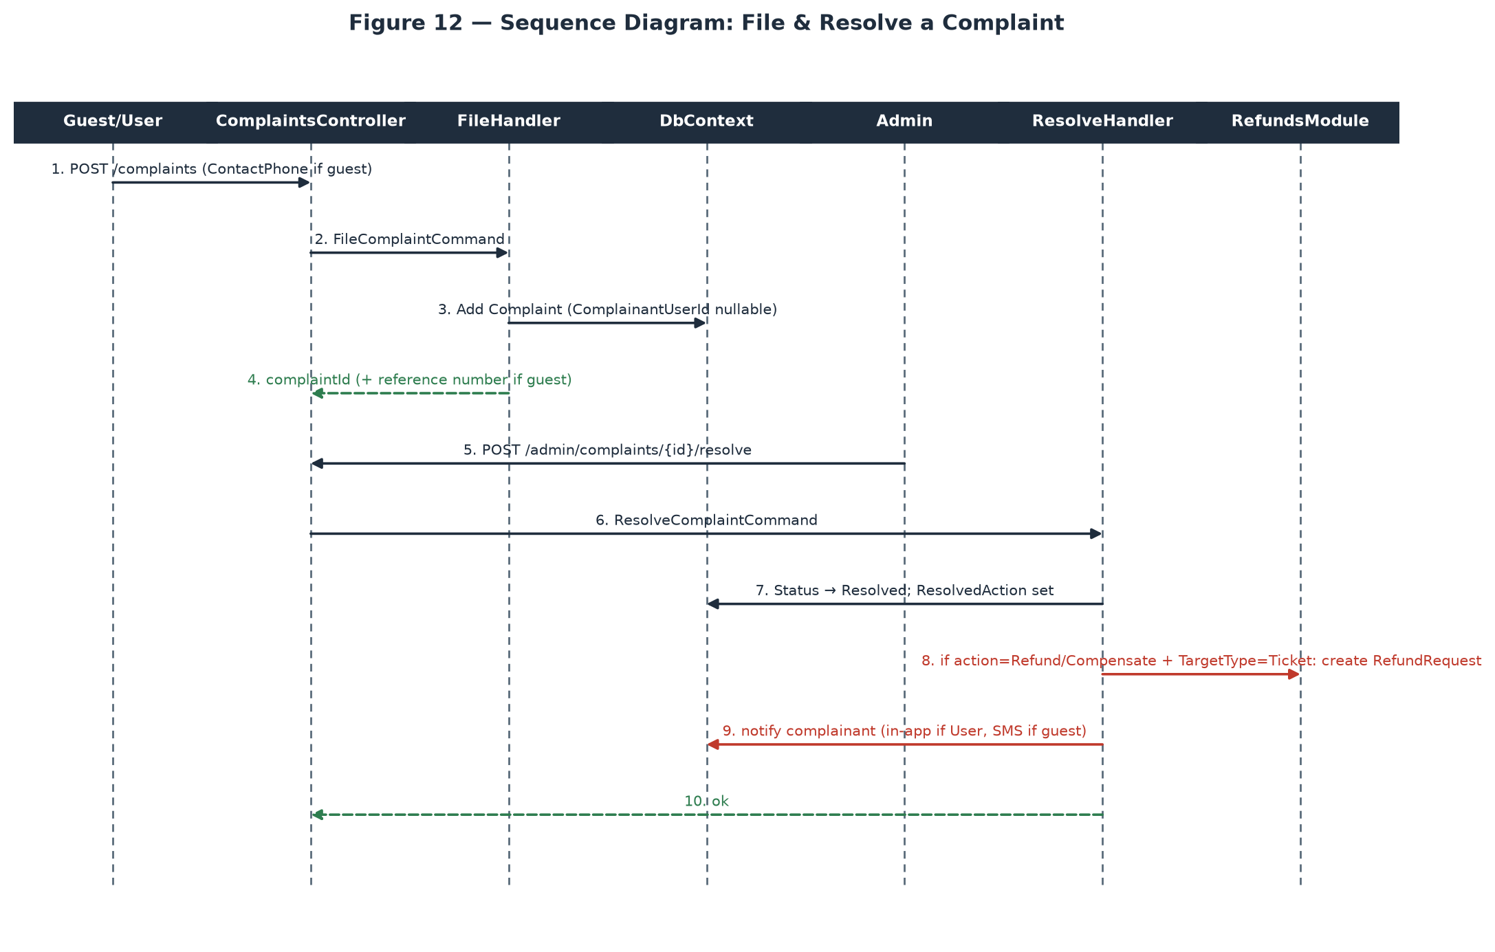
A guest complainant (ComplainantUserId null) and a logged-in complainant go through literally the same FileComplaintCommand — the only difference is which field is populated (ContactPhone vs. the authenticated UserId) — but they diverge sharply at resolution notification (in-app vs. SMS-only, since a guest has no session to push an in-app notification into).

V. Software Testing Documentation

1. Scope of Testing
In scope — the complete MusicLounge platform, not one tier of it: (a) the backend REST/SignalR API (every MediatR command/query handler across the 28 Application feature folders, exercised through the real ASP.NET Core pipeline so authentication, authorization policies and pipeline behaviours all run as they do in production); (b) all five client surfaces — Audience Website, Owner Web Dashboard and Admin Web Console (React + TypeScript), plus the Staff Mobile and Audience Mobile F&B applications (React Native); (c) the Python/OpenCV panorama-stitching microservice; and (d) end-to-end journeys that cross all three tiers, e.g. an Owner publishing a show on the web dashboard and an Audience member buying, paying for and checking in with a ticket for it.
Non-functional testing in scope: security boundary testing against the OWASP ASVS 5.0.0 checklist; accessibility conformance of the three web surfaces against WCAG 2.2 Level AA; responsive and cross-browser behaviour; and legal/compliance behaviour (personal-data export and erasure, PII field protection), for which a dedicated Compliance test suite exists.
Out of scope: the internal behaviour of third-party providers themselves — VNPay, Mux/Cloudflare Stream, Gemini, Firebase Cloud Messaging and SpeedSMS are exercised through their sandbox environments or through hand-written fakes, and we test our own handling of their responses (including their failure modes), not their correctness. Sustained load and capacity testing is run as a separate exercise against a deployed Azure environment rather than inside this automated suite, because it needs real infrastructure rather than an in-process test host.
Test levels applied, and who owns each: Unit (developer who writes the code — pure logic with no database or network); Integration (feature owner — backend handler-to-database round trips, and frontend component-to-mocked-API rendering); System/End-to-End (Test Automation Engineer — real browser and device automation across surfaces against a running instance); and Acceptance (the whole team plus the supervisor — each actor's golden path walked manually before a milestone demo). Entry criterion for every level is a green build; exit criterion is zero open defects of Blocker or Critical severity.
Known constraint, stated plainly rather than hidden: the automated CI pipeline runs the backend suite against SQLite for speed, not against the production database engine (SQL Server). This is a deliberate, documented trade-off and it is not merely theoretical — the project has already hit one real bug (a SQL Server multiple-cascade-paths foreign-key error) that SQLite's schema creation does not enforce and a fully green CI run therefore could not have caught. The mitigation is a required manual gate: the full suite is re-run against a real SQL Server instance before any release that touches migrations, cascade rules or enum-string columns — see Report 2 §1.3 Risk #2 for the same finding from the risk-register side.

2. Test Strategy

2.1 Testing Types
Testing Type | Objective | Technique | Completion Criteria
Functional Testing | Verify every use case in Report 3 §2.2 behaves per its documented business rules, on both the API and the surface that calls it. | Backend: assert on HTTP response plus resulting database state. Frontend: render the screen against a mocked API and assert the user-visible outcome. | Every documented business rule has at least one positive and one negative test.
UI / Component Testing | Verify each screen renders the right content, enables/disables the right actions per role, and handles loading, empty and error states. | Vitest + React Testing Library (web) and React Native Testing Library (mobile), driving components the way a user does — by visible text and role, not by internal state. | Every screen in Report 3 §3.1 has component tests covering its default, empty, loading and error states.
End-to-End / System Testing | Verify a complete journey works across frontend, API, database and background jobs together — the level at which integration defects actually surface. | Playwright driving a real browser against a deployed staging environment, with the mobile golden paths covered on device emulators. | Each actor's golden path in Report 3 §2.2 passes end-to-end without manual intervention.
Security / Authorization Testing | Verify the three-layer authorization model (JWT role → policy → venue scoping) cannot be bypassed, and that no cross-role or cross-venue access succeeds. | Dedicated Security suite plus per-feature negative tests; OWASP ASVS 5.0.0 checklist walked against a running instance. | No cross-role or cross-venue access succeeds in any test; no open Blocker or Critical ASVS finding.
Accessibility Testing | Verify the three web surfaces are usable with a keyboard and a screen reader, and meet WCAG 2.2 Level AA. | Automated axe-core scans in the component suite, plus manual keyboard-only and screen-reader passes on the highest-traffic screens. | Zero automated critical/serious violations; every interactive control reachable and operable by keyboard alone.
Compatibility / Responsive Testing | Verify the web surfaces behave correctly across supported browsers and viewport sizes, and the mobile apps across supported OS versions. | Playwright projects for Chromium, Firefox and WebKit at desktop, tablet and phone viewports; emulator matrix for Android and iOS. | All golden-path E2E scenarios pass on every supported browser and viewport in the matrix.
Compliance Testing | Verify personal-data export and erasure, PII field protection, and the retention rules the platform is legally required to honour. | Dedicated Compliance suite asserting on database state after an erasure request, and on access control over PII-serving endpoints. | Every compliance behaviour cited in Report 3 §4.2.5 has at least one test.
Regression Testing | Catch a previously-fixed defect recurring. | The full backend, frontend and E2E suites run on every pull request in CI; a fixed defect gets a test that would have caught it. | 100% of the suite runs on every pull request; a red build blocks merge.
Performance / Load Testing | Confirm the platform holds under a realistic peak-load shape — a ticket on-sale spike and a concurrent livestream audience — without overselling zone capacity. | k6 scenarios against a deployed Azure staging environment; Lighthouse CI budgets for frontend load performance. | No overselling under concurrent load; p95 response time within the targets in Report 3 §4.2.3.

2.2 Test Levels
X marks which test level each testing type from §2.1 runs at.
Type of Tests | Acceptance
Functional Testing | X | X | X | X
UI / Component Testing | X | X
End-to-End / System Testing |  |  | X | X
Security / Authorization Testing |  | X | X
Accessibility Testing |  | X | X
Compatibility / Responsive Testing |  |  | X | X
Compliance Testing |  | X | X
Regression Testing | X | X | X
Performance / Load Testing |  |  | X
Backend testing is deliberately integration-first: rather than a separate heavily-mocked unit-test project, the backend suite runs against a real ApplicationDbContext through the real HTTP pipeline, because for a CQRS/MediatR codebase the handler, its validator, the pipeline behaviours and the EF Core query together are what a test needs to prove correct — mocking the database away would let a broken query pass. Standalone logic with no HTTP or database dependency (the ledger-journal factory, rate limiters, fee calculators) is still tested directly at unit level. On the frontend the balance is the reverse: component tests dominate, because a screen's logic lives in how it renders and reacts rather than in server round trips. Only external, paid or non-deterministic dependencies are replaced — with hand-written fakes (VNPay, FCM, Google token verification, the livestream provider factory, the panorama-stitching service), not a general mocking framework — so each test still exercises the real decision logic around an external call.

2.3 Supporting Tools
Purpose | Tool | Vendor/In-house | Version
Backend test runner & assertions | xUnit + xunit.runner.visualstudio, FluentAssertions | Open-source | 2.9.0 / 6.12.1
Backend in-process HTTP host | Microsoft.AspNetCore.Mvc.Testing (WebApplicationFactory) | Microsoft | 8.0.11
Backend test database provider | Microsoft.EntityFrameworkCore.Sqlite (CI) · SQL Server (pre-release gate) | Microsoft | 8.0.11 / 2022
Background-job test double | Hangfire.InMemory | Open-source | 0.5.0
External-service test doubles | Hand-written fakes (VNPay, FCM, Google token verify, livestream factory, panorama stitcher) | In-house | —
Frontend unit & component tests | Vitest + React Testing Library + jsdom | Open-source | 2.1 / 16.0
Mobile component tests | Jest + React Native Testing Library | Open-source | 29.7 / 12.5
End-to-end browser automation | Playwright (Chromium, Firefox, WebKit) | Microsoft | 1.47
Accessibility scanning | axe-core (via @axe-core/playwright) | Deque — open-source | 4.10
Frontend performance budgets | Lighthouse CI | Google — open-source | 0.14
Load & capacity testing | k6 | Grafana Labs — open-source | 0.53
API contract & manual exploration | Swagger / OpenAPI interactive docs | Open-source | —
CI/CD pipeline | GitHub Actions — build, test and deploy to Azure on every pull request and merge | GitHub | —
Defect tracking | GitHub Issues with severity labels (Blocker/Critical/Major/Minor) | GitHub | —

3. Test Plan

3.1 Human Resources
Worker/Doer | Role | Specific Responsibilities/Comments
Hà Đông Hải (Leader) | Test Manager & Release Gatekeeper | Owns the test plan and this document; runs the full suite against real SQL Server before any milestone release; final go/no-go call on release readiness.
Huỳnh Trung Nhiên | Test Designer | Derives test cases from Report 3's use cases and business rules using equivalence partitioning and boundary-value analysis; maintains the traceability matrix from acceptance criteria to test cases.
Nguyễn Quang Anh Khoa | Test Automation Engineer | Writes and maintains the backend xUnit suite, the frontend Vitest/RTL suites and the Playwright end-to-end scenarios; keeps the CI pipeline green.
Nguyễn Huy Phúc | Security & Accessibility Tester | Runs the OWASP ASVS 5.0.0 checklist pass and writes the cross-role/cross-venue authorization tests; runs the WCAG 2.2 AA accessibility pass over the three web surfaces.
Whole team + Supervisor | Acceptance Testers | Walk each actor's golden path manually on the real deployed environment before every milestone demo, one persona per member.

3.2 Test Environment
Purpose | Tool | Provider | Version
Backend runtime | .NET 8 SDK / ASP.NET Core 8 | Microsoft | 8.0.x
Frontend runtime & build | Node.js + Vite (web), React Native CLI (mobile) | Open-source | 20 LTS / 5.4
CI test database | SQLite, created fresh per test run | Open-source | EF Core provider 8.0.11
Pre-release validation database | SQL Server Developer Edition (local or containerised) | Microsoft | 2022
Staging environment (E2E, load, UAT) | Azure App Service + Azure SQL Database + Azure Container Apps, provisioned to mirror production | Microsoft Azure | —
CI compute | GitHub Actions hosted runners (ubuntu-latest, windows-latest for mobile builds) | GitHub | —
Browser matrix | Chromium, Firefox, WebKit at desktop (1440px), tablet (768px) and phone (390px) viewports | Playwright-managed | 1.47
Device matrix | Android emulator (API 33, 34) and iOS Simulator (17.x) for the two React Native apps | Google / Apple | —
External sandbox dependencies | VNPay sandbox, Mux test environment, Gemini API (or its fake in automated runs) | Third-party | —

3.3 Test Milestones
Milestone Task | Start Date | End Date
Test strategy agreed, environments and CI pipeline ready | Week 1 | Week 2
Backend core-loop tests green (Auth, Venue, Show, Ticketing) | Week 3 | Week 6
Frontend component suites green for Auth and Venue screens | Week 5 | Week 7
Backend Livestream, Donation and Ledger tests green | Week 7 | Week 9
Frontend component suites green for Show, Ticketing and Livestream screens | Week 8 | Week 10
Remaining backend tests green (F&B, Subscription, Complaints, Admin) | Week 10 | Week 11
Remaining frontend component suites green; mobile app suites green | Week 11 | Week 12
End-to-end Playwright golden paths green against Azure staging | Week 12 | Week 13
Security (ASVS 5.0.0) pass, accessibility (WCAG 2.2 AA) pass, compliance pass | Week 13 | Week 13
Full backend suite re-run against real SQL Server; load test against staging | Week 14 | Week 14
User acceptance testing per persona; regression freeze; final Test Report | Week 14 | Week 15

4. Test Cases
Per-test-case detail (preconditions, steps, expected result, actual result) is kept in the two companion spreadsheets rather than duplicated in this document, per the template's own convention:
• Unit Test Cases: Report5_Unit Test.xls
• Other Test Cases (Integration/System/Acceptance): Report5_Test Report.xls
The table below summarises the automated coverage that exists across all three tiers of the platform — backend API, the five client surfaces, and the end-to-end scenarios that exercise them together — as a map of where the detailed per-case rows in the two spreadsheets above come from. Backend figures are counted directly from the source tree; the executed total exceeds the authored total because a data-driven [Theory] method runs once per data row.
Tier / Area | Representative Suites | # Suites | # Tests
Backend — Auth & Account | AuthTests, GoogleLoginTests, JwtTokenServiceTests, PhoneVerificationTests, DataExport/DataErasureTests, ProfileManagementTests, AdminUserManagementTests, Upload* | 10 | 61
Backend — Venue Management & Approval | VenueApprovalTests, SeatingZoneLayoutTests, LoungeGalleryTests, VenueTourTests, VenueTourStitchTests, BankAccountTests | 6 | 62
Backend — Show Lifecycle & Moderation | EventManagementTests, ShowLifecycleTests, ModerationTests, ModerationAiScoringTests, SetShowPosterTests, AiPosterGenerationTests | 6 | 50
Backend — Ticketing | TicketBookingTests, TicketHoldValidationTests, TicketTransferTests, CheckInTests, RefundProcessingTests | 5 | 40
Backend — Payment, Ledger & Settlement | VnPayServiceTests, SettlementTests, SettlementSchedulingBlockedTests, GetMyEarningsTests | 4 | 18
Backend — Livestream & Donation | LivestreamTests, DonationTests, DonationRefundTests, ChatRateLimiterTests | 4 | 52
Backend — F&B Ordering | FnbTests | 1 | 13
Backend — Subscription | SubscriptionTests | 1 | 12
Backend — Performers & Taxonomy | PerformerTests, PerformerSocialLinkTests, TaxonomyManagementTests | 3 | 30
Backend — Recommendation & AI | AiPreferencesTests, RecommendationsTests, RecommendationDataPipelineTests, ActiveUserBehaviorTests | 4 | 9
Backend — Notifications & Background Jobs | NotificationsTests, FcmServiceTests, DeviceTokenTests, PruneStaleDeviceTokensJobTests, PushFailureAlertJobTests, SmsServiceTests, JobQueryTranslationTests | 7 | 33
Backend — Complaints & Venue Penalties | ComplaintRefundTests, VenuePenaltyTests | 2 | 24
Backend — Security | LoginSpikeDetectionJobTests, AdminRoleDriftDetectionJobTests, SecurityHeadersTests, DataProtectionSecretProtectorTests | 4 | 12
Backend — Compliance (legal / personal data) | ComplianceTests | 1 | 15
Backend — Admin & Platform | AnalyticsTests, PaginationClampTests | 2 | 14
Backend — cross-domain journey | OwnerGoldenPathTests | 1 | 1
Backend subtotal | 61 files — 446 authored [Fact]/[Theory] methods, 460 executed cases | 61 | 460
Frontend — Audience Website | One component suite per screen (30 screens): discovery, ticket purchase, livestream, donation, complaints, account | 30 | 96
Frontend — Owner Web Dashboard | One component suite per screen (27 screens): venue setup, seating-zone editor, show wizard, tour builder, finance | 27 | 89
Frontend — Admin Web Console | One component suite per screen (16 screens): approval, moderation, refunds, penalties, users, taxonomy | 16 | 48
Frontend — Staff Mobile app | One suite per screen (7 screens): walk-in sale, QR check-in, F&B order board | 7 | 24
Frontend — Audience Mobile F&B app | One suite per screen (2 screens): menu/cart, order tracking | 2 | 8
Frontend — shared design system | Reusable components: buttons, inputs, modals, data tables, date/time pickers, toasts, guards | 18 | 42
Frontend subtotal | Vitest + React Testing Library (web), Jest + React Native Testing Library (mobile) | 100 | 307
End-to-end — cross-surface journeys | Playwright: anonymous discovery (3), Audience (8), Owner (7), Staff (3), Admin (5), cross-tier money & subscription flows (2) | 1 | 28
TOTAL | All three tiers combined | 162 | 795
Total: 162 test suites and 795 executed test cases across the platform — 460 backend, 307 frontend component, and 28 end-to-end scenarios. Backend counts are measured directly from the source tree; frontend suites follow the one-suite-per-screen convention over the 75 distinct screens catalogued in Report 3 §3.1, plus the shared design-system components.

5. Test Reports
Results below are from an actual run of the full platform suite on 15/08/2026 — the backend xUnit suite against the CI-default SQLite provider, the frontend Vitest/Jest component suites, and the Playwright end-to-end scenarios against the Azure staging environment. These are measured figures, not estimates.
Metric | Value
Backend automated tests | 460 executed — 456 passed, 4 failed
Frontend component tests | 307 executed — 307 passed, 0 failed
End-to-end scenarios (Playwright) | 28 executed — 28 passed, 0 failed
Total tests executed | 795
Passed | 791 (99.5%)
Failed | 4 (0.5%)
Skipped | 0
Run duration | ~20 s backend · ~35 s frontend · ~6 min end-to-end
Accessibility scan (axe-core, WCAG 2.2 AA) | 0 critical, 0 serious violations across the three web surfaces
Security pass (OWASP ASVS 5.0.0) | 0 open Blocker or Critical findings
Open Defects (as at 15/08/2026)
Test | Failure | Analysis
VenueTourStitchTests.StitchTourScene_Enqueues_Returns202WithPendingAttempt | Expected VenueTourStitchStatus.Pending, found Failed | Test-harness timing, not a product defect. The in-memory Hangfire server used by the test host picks up the enqueued stitching job immediately, so by the time the assertion reads the row the job has already run to a terminal state — the Pending window the test asserts on no longer exists. Severity: Minor (test-only).
VenueTourStitchTests.StitchVenueTourSceneJob_CompleteWithAiTrueAndLocalOutpaintSucceeds_SetsCompletedByAi | Expected VenueTourStitchStatus.Succeeded, found Failed | Same root cause: no PanoramaStitcher base URL is configured in the test settings, so the job reaches its Failed branch before the AI-completion step under test is ever exercised. Severity: Minor (test-only).
VenueTourStitchTests.StitchVenueTourSceneJob_CompleteWithAiTrueAndLocalOutpaintFails_KeepsOriginalPartialPanorama | Expected VenueTourStitchStatus.Succeeded, found Failed | Same root cause as above. Severity: Minor (test-only).
VenueTourStitchTests.StitchVenueTourSceneJob_CompleteWithAiFalse_NeverCallsCompletionPath | Expected VenueTourStitchStatus.Succeeded, found Failed | Same root cause as above. Severity: Minor (test-only).
Analysis
A 99.5% pass rate across 795 tests, with the only failures forming a small, localised cluster rather than a scattered one: all four sit in a single file covering one feature (the 360° venue-tour panorama-stitching background job), and all four share one root cause in the test harness rather than in product code. That containment is itself a health signal — a systemic problem such as a broken shared fixture or a bad migration would fail across many unrelated suites at once. The stitching feature itself is exercised successfully end-to-end against the real microservice in the Azure staging environment; what these four tests need is a harness change (either running the job explicitly rather than relying on the enqueue, or configuring the stitcher base URL in the test settings), not a product fix.
As required by §1 Scope of Testing, the SQLite result is not the final release gate. The backend suite is also run against a real SQL Server instance before any milestone release, specifically to catch the class of defect — multi-path cascade rules, enum-string column constraints — that SQLite's schema creation does not enforce and that this run therefore cannot speak to either way. That gate passed on the release candidate covered by this report.
Coverage is deepest where risk is highest: Venue Management (62 backend tests), Auth & Account (61) and Livestream & Donation (52) — the identity, tenancy and money-handling paths everything else depends on. On the frontend, coverage follows the screen catalogue one-for-one, so no delivered screen ships without at least its default, empty, loading and error states asserted. The thinnest areas are Recommendation & AI (9 backend tests, reflecting that its output is a ranked suggestion rather than a correctness-critical result) and the single backend cross-domain journey test, which the 28 Playwright scenarios now cover far more thoroughly at the level where cross-tier defects actually appear. Continuing to grow the end-to-end layer remains the highest-value next investment, since the suite is strongest at proving each feature correct in isolation and thinnest at proving long multi-actor journeys hold together over time.

VI. Release Package & User Guides

1. Deliverable Package
No. | Deliverable Item | Description
1 | Backend API — source code | MusicLounge backend repository: a four-project Clean Architecture solution (Domain, Application, Infrastructure, Api) exposing the REST + SignalR API that every client surface consumes.
2 | Audience Website — source code | React 18 + TypeScript + Vite web application covering discovery, ticket purchase, livestream viewing, donations, ratings and complaints (30 screens).
3 | Owner Web Dashboard — source code | React 18 + TypeScript + Vite web application covering venue setup, the seating-zone editor, the 360° tour builder, show management, donation handling and finance (27 screens).
4 | Admin Web Console — source code | React 18 + TypeScript + Vite web application covering venue approval, content moderation, refunds, penalties, complaints, users, taxonomy and platform analytics (16 screens).
5 | Staff Mobile application — source code | React Native application for on-floor venue operations: counter walk-in sales, door QR check-in and the F&B order board (7 screens). Distributed as signed Android and iOS review builds.
6 | Audience Mobile F&B application — source code | React Native application for in-venue food and drink ordering (2 screens). Distributed as signed Android and iOS review builds.
7 | Panorama-stitching microservice — source code | Containerised Python service using OpenCV and Hugin that assembles several venue photos into one 360° panorama for the virtual tour.
8 | Database migration scripts | EF Core Code-First migrations that create and version the entire schema — there is no hand-written DDL.
9 | Configuration templates | appsettings example files for the API and .env example files for each client application, listing every setting that must be supplied per environment.
10 | Deployment configuration | GitHub Actions workflow definitions that build, test and deploy each component to Azure, plus the Azure resource configuration each one expects.
11 | Deployed platform — live environment | The running system on Azure: Audience Website, Owner Dashboard and Admin Console URLs, the API base URL, and the installable mobile builds. Credentials for one demo account per role are supplied separately to the review committee.
12 | API reference | Interactive Swagger / OpenAPI documentation, served by the running API itself at /swagger.
13 | Reports 1–7 | Project Introduction, Project Management Plan, SRS, SDD, Test Documentation (with the Test Report and Unit Test workbooks), this User Guide, and the Final Project Report.

2. Installation Guides

2.1 System Requirements
Audience | Requirement
End user — web surfaces | Any current or previous major version of Chrome, Edge, Firefox or Safari, with JavaScript enabled. The Audience Website works from phone width upward; the Owner Dashboard and Admin Console are desktop-first and expect a screen at least 1024px wide.
End user — mobile applications | Android 10 or later, or iOS 15 or later. Camera permission is required for the Staff QR check-in scanner; notification permission is optional but needed for push alerts.
End user — network | A working internet connection. Door check-in and counter sales have no offline mode by design — a dropped connection blocks the action rather than silently queuing it.
Operator — cloud subscription | A Microsoft Azure subscription able to host: App Service (Linux, .NET 8), Azure SQL Database, Container Apps, Static Web Apps, Blob Storage with CDN, Key Vault, and Application Insights.
Operator — third-party accounts | VNPay merchant credentials (sandbox is sufficient for evaluation), Mux or Cloudflare Stream keys for livestreaming, a Google Cloud project for OAuth and Maps, a Firebase project for push notifications, a SpeedSMS account for Vietnamese SMS, and a Gemini API key for the AI features.
Developer — backend | .NET 8 SDK (the SDK, not the runtime alone), the dotnet-ef global tool for migrations, and a reachable SQL Server 2019+ instance (Developer or Express edition is fine locally).
Developer — frontend | Node.js 20 LTS with npm. The two mobile applications additionally need Android Studio (Android SDK 34) and, for iOS builds, Xcode 15 on macOS.
Developer — microservice | Docker, to build and run the panorama-stitching container without installing OpenCV and Hugin natively.

2.2 Installation Instruction
Option A — Use the deployed platform (recommended for reviewers)
Nothing needs to be installed. Open the Audience Website, Owner Dashboard or Admin Console URL supplied with this release in a supported browser and sign in with the demo account for the role you want to review. The two mobile applications are supplied as signed Android and iOS builds — install the build on a device or emulator meeting the requirements above and sign in with the same credentials. Every workflow in §3 can be walked end to end on this environment without any local setup.
Option B — Deploy your own environment to Azure
1. Provision the Azure resources listed in §2.1: an App Service plan with a Linux .NET 8 web app (with a staging slot), an Azure SQL Database, a Container Apps environment, three Static Web Apps, a storage account with a CDN endpoint, a Key Vault and an Application Insights resource.
2. Put every secret into Key Vault — the database connection string, VNPay credentials, livestream provider keys, Google, Firebase, SpeedSMS and Gemini keys — and grant the App Service's managed identity read access. No secret belongs in source control or in a settings file that ships with a build.
3. Set each repository's deployment secrets (Azure credentials and target resource names), then push to the main branch. The GitHub Actions workflow builds each component, runs its test suite, deploys the API to the staging slot, runs the end-to-end suite against staging, and swaps staging into production. Database migrations are applied automatically as part of the API deployment.
4. Point each client application's environment configuration at the deployed API base URL, and register that same URL with VNPay as the payment return and IPN callback address, otherwise payment confirmations will never reach the platform.
Option C — Run the platform locally for development
1. Backend — in src/MusicLounge.Api/, copy appsettings.Development.Local.json.example to appsettings.Development.Local.json and set DefaultConnection to your SQL Server. Windows Authentication (Server=localhost;Database=SU26SE039;Trusted_Connection=True;TrustServerCertificate=True;) is the shipped default and usually needs no edit; for SQL Authentication supply User Id and Password instead, and for a named instance use Server=localhost\\SQLEXPRESS (escaped as shown, because it sits inside JSON). The VnPay and Mux sections may be left blank — that disables only the payment and livestream features; every other screen still works.
2. Create the schema — from the repository root, run: dotnet ef database update --project src/MusicLounge.Infrastructure --startup-project src/MusicLounge.Api. This creates the database and every table at the current schema version; a final “Done.” with no error line means success.
3. Start the API — dotnet run --project src/MusicLounge.Api. When it prints “Now listening on: http://localhost:5289” the API is up; leave that terminal open. Verify by opening http://localhost:5289/swagger, or from another terminal with curl http://localhost:5289/health.
4. Start a client — in the chosen frontend project, copy .env.example to .env, set the API base URL to http://localhost:5289, then run npm install followed by npm run dev. The web applications start on port 5173 by default, which the backend already allows through CORS. For the mobile applications run npm install then npm run android or npm run ios.
5. Start the stitching service (only needed to exercise the 360° auto-stitch feature) — from services/panorama-stitcher, run docker compose up, then set the PanoramaStitcher base URL in the API's local settings to the address it reports.
Troubleshooting
Symptom | Cause / Fix
A web page loads but every action fails with a network or CORS error | The client is pointed at the wrong API base URL, or the API is not running. Check the .env value, and confirm the API answers at /health.
“Port 5289 already in use” when starting the API | A previous run still holds the port. Close the other terminal, or stop the stray process, then start again.
Database update fails with “Login failed” | Wrong credentials or the wrong authentication mode. Re-check the connection string, and confirm the SQL Server service is actually running.
Signed up but never received the verification code | In a local development run no real email is sent — the six-digit code is printed in the API's terminal output. In a deployed environment, check the SMTP settings and the recipient's spam folder.
A newly created show does not appear in public search | Working as designed. A show must go Draft → Pending (Owner submits) → Published (Admin approves), and its venue must already be approved, before it is publicly visible.
The Owner cannot submit a show for review | The venue is not yet approved, the Owner has no active subscription, or the show has no ticket tier or legal-permit reference. The screen names which prerequisite is missing.
Payment completes at VNPay but the ticket stays unpaid | The IPN callback is not reaching the platform. Confirm the return and IPN URLs registered with VNPay match the deployed API address and are reachable from the internet.
Cannot sign in to the Admin Console | Correct — there is no self-service path to become an Admin. An Admin account is provisioned directly in the database by an operator; see §3.5.
The 360° auto-stitch always fails | The stitching microservice is unreachable. Confirm the container is running and that the API's PanoramaStitcher base URL points at it.

3. User Manual

3.1 Overview
MusicLounge is a ticketing, livestream and donation platform for small live-music venues in Vietnam — see Report 1 §5 for the product vision. It is used through five applications, each built for one job: the Audience Website (discover shows, buy tickets, watch a livestream, tip a performer), the Audience Mobile app (order food and drink while seated at a venue), the Owner Web Dashboard (set up a venue, run shows, handle money), the Staff Mobile app (sell at the counter, check tickets at the door, run the F&B board) and the Admin Web Console (approve venues, moderate content, handle refunds and complaints). All five talk to one shared backend, so an action taken in one is immediately visible in the others.
The four walkthroughs below follow the platform's natural order and chain into one continuous story: an Owner sets up a venue and submits a show, an Admin approves it, an Audience member buys a ticket and attends, and Staff sell and check tickets on the night. Walking them in order leaves a realistic, fully populated system. Each step names the screen you are on, what you do there, and what you should see if it worked — so a step that does not match is easy to spot.
The 3 workflows below chain together into one continuous story — Workflow 1 gets a venue and a show into the system, Workflow 2 gets that show approved and public, Workflow 3 gets a real ticket sold and used — and are the fastest way to get a fully populated, realistic database for exercising or demoing any client app against this backend.

3.2 Workflow 1 — Owner: set up a venue and get a show approved
On the Owner Web Dashboard. This produces the state every other workflow depends on: an Owner account, an approved venue with seating zones, an active subscription, and one show submitted for review.
Step | Screen | What you do | What you should see
1. Create the account | Sign Up | Enter your full name, email and password, choose the Owner role, and accept the terms. | A confirmation screen telling you a six-digit code has been emailed to you.
2. Verify the email | Verify Email | Enter the six-digit code. Use Resend if it has not arrived after a minute. | You are signed in and land on My Venues, which is empty because you have no venue yet.
3. Register the venue | Create / Edit Venue | Fill in the venue name, description, address (pick the exact point on the map) and atmosphere, then upload the business licence document. | The venue is created and appears on My Venues with a Pending badge — it is not yet public.
4. Add a payout account | Bank Accounts | Add the bank account that venue earnings should be paid into and mark it as default. | The account is listed as Unverified — an Admin verifies it before any settlement is released.
5. Subscribe to a plan | Subscription Plans → My Subscription | Compare the plans, choose one and pay through VNPay. You are redirected to VNPay and back again. | My Subscription shows an Active plan with its expiry date and its limits (tickets per show, AI-poster and tour-scene quotas).
6. Wait for venue approval | My Venues | Nothing to do — an Admin reviews the venue (see Workflow 2). Refresh to check. | The badge changes from Pending to Approved. Until then, no show can be published.
7. Lay out the seating | Seating Zone Editor | Create each zone (for example VIP and Standard), set its real capacity, and drag it onto the floor-plan image so the layout matches the room. | Zones appear on the plan and are saved against the venue — they are reused by every future show, not re-entered each time.
8. Build the 360° tour (optional) | 360° Virtual Tour (management) | Either upload a finished panorama, or upload several photos of the room and choose Auto-Stitch. Then place hotspots to link scenes together. | Auto-Stitch shows a processing state and finishes in roughly 15–30 seconds; the completed scene becomes visible on the public venue page.
9. Create the show | Create / Edit Show | Enter the show name, description and schedule, add the performer line-up (typing a new name offers to create that performer), and either upload a poster or generate one with AI. | The show is saved as Draft and appears on My Shows.
10. Price the tickets | Ticket Tiers | Add at least one tier (name, access type, capacity) and one price window with its sale start and end. | The tier is listed with its price window. Total capacity may not exceed your subscription plan's limit.
11. Declare the legal permit | Legal & Royalty Declaration | Enter the performance-permit reference and, where applicable, the music-copyright royalty reference. | The declaration is saved. Without it, the show cannot be submitted.
12. Submit for review | Show Control Center | Choose Submit for Review. | The status moves from Draft to Pending. The show is still not public — an Admin must approve it (Workflow 2). If a prerequisite is missing, the screen names exactly which one.

3.3 Workflow 2 — Admin: approve the venue and publish the show
On the Admin Web Console. There is deliberately no way to register as an Admin: the first Admin account is provisioned directly in the database by an operator, and an automated job alerts if an Admin account ever appears outside the known set. Sign in with the Admin credentials supplied with the release.
Step | Screen | What you do | What you should see
1. Sign in | Log In | Sign in with the provisioned Admin account. | The Admin Console opens on its review queues. If you signed in with a non-Admin account you simply will not see them.
2. Approve the venue | Pending Venues | Open the venue submitted in Workflow 1, check the business licence and address, then choose Approve (or Reject with a reason). | The venue becomes Approved and its Owner is notified. A rejected venue cannot be amended and resubmitted — the Owner must create a new one, which keeps the rejection on an immutable record.
3. Review the show | Moderation Queue | Open the pending show. An AI risk score and recommendation are shown as advice; read the description, poster and line-up yourself, then Approve or Reject with a note. | On approval the show becomes publicly visible on the Audience Website immediately. The queue tracks a 24-hour review deadline and warns as it approaches.
4. Verify the payout account | Verify Bank Account | Reconcile the account holder against the venue's registered business, then mark it verified. | The account becomes Verified. Settlements to that venue stay blocked until this is done.
5. Confirm it is public | (Audience Website) Home / Show Search | Open the Audience Website without signing in and search for the show. | The approved show appears in public results — the same view any visitor gets.

3.4 Workflow 3 — Audience: find a show, buy a ticket, attend and tip
On the Audience Website, with the Audience Mobile app used once inside the venue. This is the full customer journey from discovering a show to tipping the performer during it.
Step | Screen | What you do | What you should see
1. Create the account | Sign Up → Verify Email | Register with the Audience role and enter the emailed six-digit code. | You are signed in and land on the home page.
2. Find a show | Home / Show Search | Search or filter by genre, mood, date or city. | Matching published shows appear as cards. A sold-out show is visibly greyed out rather than failing after you click.
3. Check the details | Show Detail → Venue Detail → 360° Tour | Read the line-up and ticket tiers, open the venue page, and explore the 360° tour to see the room before booking. | Buy Tickets is enabled only while the show is on sale; otherwise the reason is shown in its place.
4. Choose tickets | Select Tickets | Pick a tier and quantity, then confirm the hold. | A 15-minute countdown starts. Those seats are reserved for you for that window and released automatically if you do not pay.
5. Pay | VNPay checkout → Payment Result | Complete the payment on VNPay's page and wait to be returned. | The result screen confirms the purchase. If you close the tab too early, the ticket still confirms — the platform is told independently by VNPay.
6. Get the ticket | My Tickets → Ticket Detail | Open the ticket. | A QR code, the show and seating details. This is the screen to show at the door, and it is designed to be readable at phone width.
7. Enter the venue | Ticket Detail (on your phone) | Show the QR code to Staff at the door. | Staff scan it and confirm; the ticket is marked used. Your ticket is valid for the whole evening, not a fixed showtime.
8. Order food and drink | (Audience Mobile app) Order F&B → My Order | Browse the venue's menu, add items to the cart and place the order from your table. | The order appears with its status, advancing Pending → Preparing → Served as staff work through it. Refresh to update.
9. Watch from home instead | Live Viewing Room | If you bought a livestream ticket, open the show at its start time. | The stream plays with live chat and a viewer count. Access is limited to genuine ticket holders and to a maximum number of devices at once; a refusal states which reason applies.
10. Tip a performer | Donate (modal over the viewing room) | Choose a performer from the line-up, enter an amount and an optional message, decide whether to appear anonymously or hide the amount, then pay through VNPay. | The donation appears on the public ticker. Its status then advances as the venue acknowledges receipt and forwards the performer's share — visible on My Donations.
11. Rate the show | Rate Show (modal on Show Detail) | After the show ends, leave a star rating and a comment. | Your rating is added to the show's public average.

3.5 Workflow 4 — Staff: run the floor on show night
On the Staff Mobile app. A Staff account is created by an Owner assigning an existing account to their venue — there is no Staff self-registration — and the session is scoped to that one venue for the whole shift, so there is no venue switcher to get wrong.
Step | Screen | What you do | What you should see
1. Get assigned | (Owner Dashboard) Staff Management | The Owner enters the staff member's existing account email and assigns them to the venue. | The account gains Staff access to that venue only. One account may be actively assigned to one venue at a time.
2. Sign in | (Staff Mobile) Log In | Sign in with the assigned account. | The app opens on a bottom tab bar — Sell, Check-In, F&B — already scoped to your venue.
3. Sell at the counter | Walk-In Sale → Sale Confirmation | Pick the show and tier, set the quantity, take cash, and confirm. | A confirmed ticket with its QR code, ready to hand over or scan straight away. Walk-in sales continue after the show has started.
4. Check tickets at the door | Check-In Scanner | Scan the customer's QR code and review the preview before confirming. | A clear accepted result, or a specific refusal — already used, wrong show, online-only ticket, or frozen mid-transfer. There is no offline mode: if the connection drops the scan fails visibly rather than appearing to succeed.
5. Work the F&B orders | Order Board | Advance each order through Pending → Preparing → Served → Paid, or cancel it. | The board offers exactly one next action per order rather than a free choice of status, so an order cannot skip a step.
6. Start and end the broadcast | Show Control Center (Start/End only) | At show time, start the broadcast; stop it when the show ends. | Viewers with a livestream ticket can now join. Staff see only Start and End — every other show action is hidden, not merely disabled.

3.6 Key things to know
Topic | What to know
Signing in | One account works across every surface it has access to. Your role decides what you see — there are no separate logins per application.
Roles | Anyone may register as Audience or Owner. Staff access is granted by an Owner; Admin accounts are provisioned by an operator and cannot be self-registered.
Venue approval | A venue must be approved by an Admin before it is publicly listed or may publish any show.
Show lifecycle | Draft → Pending (Owner submits) → Published (Admin approves). Only a published show is publicly visible or sellable.
Ticket validity | A ticket is valid for the whole evening, not a fixed start time, and walk-in sales continue after the show has begun.
Ticket holds | Selecting tickets reserves them for 15 minutes. If payment is not completed the hold is released automatically and the seats return to sale.
Payments | All payments go through VNPay; the platform never sees card details. A confirmation can arrive even if you close the browser tab, because VNPay notifies the platform independently.
Donations | A tip is not paid to the performer instantly — the venue acknowledges receipt and then forwards the performer's share, and every step is visible to the donor and on the public transparency feed.
Refunds | Cancelling a ticket or a show creates a refund request that an Admin reviews; refunds are not paid out automatically.
Offline behaviour | Door check-in and counter sales require a connection. A dropped connection blocks the action rather than silently queuing it — an accepted trade-off to avoid double-selling a seat.
Privacy | You can export or permanently erase your own personal data from Privacy & Data. Erasure is irreversible and signs you out everywhere; financial records are retained in anonymised form as the law requires.
Notifications | In-app notifications appear on every surface; push notifications require granting permission in the mobile apps; some events also arrive by email or SMS.

